NWRPDP
Northwestern Nevada Regional Professional Development Program

2022-2023 Annual Report
August 2023

Sara Cunningham
Program Director

Table of Contents
Introduction 6
Part I: NRS 391A.190 1c Evaluation of Regional Training Program 8
Five Year Plan 14
Establishment 14
Service Area 14
Measurement 14
Northwest Regional Professional Development Five-Year Plan 2022-27 15
Vision and Mission 15
Professional Development Standards 15
NWRPDP Sponsored Training Programs 18
Part Two: Individual RPDP Information 23
Regional Projects: NWRPDP Case Studies 24
Key Findings from 2022-2023 NWRPDP Evaluation Activities: 25
The Case Study Model 26
Lyon County School District New Teacher Academy 27
Introduction 27
Instructional Context 28
Initial Data and Planning 30
Delivery of Services 30
Results and Reflection 31
Conclusion 33
References 33
New Teacher Training, Support and Retention 35
Introduction 35
Instructional Context 35
Initial Data and Planning 36
Delivery of Services 36
Results and Reflection 36
Conclusion 38
References 39
Building Thinking Classrooms in Mathematics 41
Introduction 41
Instructional Context 41
Initial Data and Planning 43
Delivery of Services 44
Results and Reflection 47
Conclusion 51
References 51
Scaffolding Explanations and Arguments in Science 54
Introduction 54
Instructional Context 54
Initial Data and Planning 56
Delivery of Services 57
Results and Reflection 58
Conclusion 59
References 60
Leading Collaborative Teams 62
Introduction 62
Instructional Context 62
Initial Data/Planning 63
Delivery of Services 63
Results and Reflection 64
Conclusion 66
References 66
National Board Maintenance of Certification (MOC) Cohort: Becoming a More Efficacious Teacher Leader Through the National Board MOC Cohort 69
Introduction 69
Instructional Context 69
Initial Data and Planning 70
Delivery of Services 71
Results and Reflection 74
Conclusion 77
References 78
Writing in the Content Area 80
Introduction 80
Instructional Context 80
Initial Data and Planning 81
Delivery of Services 83
Results and Reflection 84
References 88
The Second Year Impacts of Science of Reading Professional Learning on Instructional Practice 90
Introduction 90
Instructional Context 90
Initial Data and Planning 91
Delivery of Services 92
Results and Reflection 92
Conclusion 94
References 95
Early Childhood Years One and Two 97
Introduction 97
Instructional Context 97
Initial Data and Planning 99
Delivery of Services 99
Results and Reflection 101
Conclusion 104
References 105
Appendix A: Overview of regional services 106
Appendix B: Carson City School District Services Summary 2022-23 109
Appendix C: Churchill County School District Services Summary 2022–23 111
Appendix D: Douglas County School District Services Summary 2022–23 114
Appendix E: Lyon County School District Services Summary 2022–23 117
Appendix F: Storey County School District Services Summary 2022–23 119
Appendix G: Washoe County School District Services Summary 2022–23 121

Table of Figures
Figure 1: Conceptual Framework for Studying Effects for Professional Development on Teachers and Students 7
Figure 2: NWRPDP Logic Model 24
Figure 3: Grade Level 28
Figure 4: Year of Teaching Experience 28
Figure 5: Number of Sessions Attended 29
Figure 6: Individual Support through Menu of Support Options 31
Figure 7: Lyon County School District New Teacher Academy Logic Model 34
Figure 8: New Teacher Training, Support, and Retention Logic Model 40
Figure 9: Demographics of Participants' Schools 42
Figure 10: Years of Teaching Experience 43
Figure 11: Results of Pre-Survey Needs Assessment 44
Figure 12: Cohort Participants Engaging in Saturday Learning Task 45
Figure 13: Learning Task Analysis 46
Figure 14: Microsoft Teams Collaboration Examples 47
Figure 15: Building Thinking Classrooms in Mathematics Logic Model 53
Figure 16: OSIT Category II The Classroom (OSIT, 2023) 55
Figure 17: Scaffolding Explanations and Arguments in Science Logic Model 60
Figure 18: Leading Collaborative Teams Logic Model 67
Figure 19: Padlet 71
Figure 20: Artifact 72
Figure 21: National Boards Ideas: Fair, Equity of Access, and Appreciation of Diversity 73
Figure 22: National Boards Maintenance of Certification Logic Model 78
Figure 23: Self-Reported Proficiency in Writing Instructional Skills Before and After the Delivery of Services 83
Figure 24: Writing sample from Teacher F’s class showing math content area writing 84
Figure 25: Student in Teacher E’s class showing increased writing opportunities and strategies 84
Figure 26: Writing Sample from Teacher B demonstrating improved details and sentence structure. 85
Figure 27: Writing Sample from Teacher D demonstrating improved details and sentence structure. 85
Figure 28: Students in Teacher C’s class working collaboratively to compare research on a thinking map. 86
Figure 29: Writing in the Content Area Logic Model 88
Figure 30: The Second Year Impacts of Science of Reading Logic Model 95
Figure 31: Implementation After the Session on Science 102
Figure 32: Implementation After the Math Session 102
Figure 33: Implementation After the Block Session. 103

NWRPDP
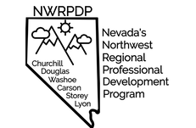
Northwestern Nevada Regional
Professional Development Program

Introduction

The 70th Session (1999) of the Nevada State Legislature passed Senate Bill 555, which, under Sections 16 and 17, authorized the establishment of four Regional Professional Development Programs (RPDPs) in the state. Since that 1999 session, the four programs have been reduced to three. Their collective charge is to support the state’s teachers and administrators in implementing Nevada’s Academic Content Standards (NVACS) through regionally determined professional development activities. Although the essential mission has remained unchanged, legislative mandates and the pedagogical needs of teachers continue to broaden the program’s scope and responsibilities; the programs’ expertise is called upon to assist with district and statewide educational committees and assist in statewide efforts to improve instruction through the Nevada Educator Performance Framework (NEPF).
The planning and implementation of professional development services in each region is overseen by a governing body consisting of superintendents in the respective regions, master teachers appointed by the superintendents, representatives of Nevada’s higher education system, and the State Department of Education. A nine-member Statewide Coordinating Council, consisting of members appointed by the Governor or legislators, the Superintendent of Public Instruction, and one member from each of the RPDP governing boards oversees the three regional programs.
As outlined in Standards for Professional Learning (Learning Forward, 2011), there is a relationship between professional learning and student results:
1. When professional learning is standards-based, it has greater potential to change what educators know, are able to do, and believe.
2. When educators’ knowledge, skills, and dispositions change, they have a broader repertoire of effective strategies to use to adapt their practices to meet performance expectations and student learning needs.
3. When educator practice improves, students have a greater likelihood of achieving results.
4. When student results improve, the cycle repeats for continuous improvement (p. 16).
Figure 1 below is a visual representation of the relationship between professional learning based on the Professional Learning Standards and improved student learning. (Desimone, 2009).
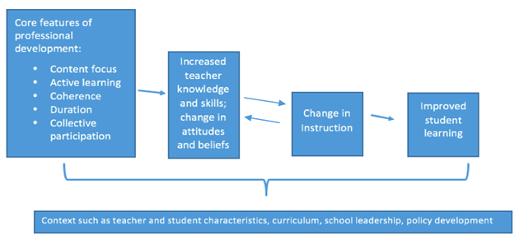
Figure 1: Conceptual Framework for Studying Effects for Professional Development on Teachers and Students
The updated Standards for Professional Learning from the national professional development organization, Learning Forward, were adopted by the Regional Professional Development Programs in 2011. In 2017, Nevada included two additional standards to address equity and cultural competency to become the Nevada Professional Development Standards. These nine standards are used synergistically in order to increase educator effectiveness thereby improving students learning. The standards provide a framework for planning and leading professional learning opportunities.

Part I: NRS 391A.190 1c Evaluation of Regional Training Program

- The priorities for training adopted by the governing body pursuant to NRS 391A.175
[391A.175 (a) Adopt a Training Model, taking into consideration other model programs, including, without limitation, the program used by the Geographic Alliance in Nevada.]
After conversations with our service requestor to establish the outcome(s) of the professional learning and alignment with the standards for professional development adopted by the State Board, a training model that is best matched to the work is chosen. Training models may include, without limitation, action research, critical friends/professional learning communities, personal learning networks, coaching, mentoring, instructional rounds, lesson study, and educational courses.
391A.175 (b) Assess the training needs of teachers and administrators who are employed by the school districts within the primary jurisdiction of the regional training program and adopt priorities of training for the program based upon the assessment of needs. The board of trustees of each school district may submit recommendations to the appropriate governing body for the types of training that should be offered by the regional training program.
391A.175 (c) In making the assessment required by paragraph (b) and as deemed necessary by the governing body, review the plans to improve the achievement of pupils prepared pursuant to NRS 385A.650 for individual schools within the primary jurisdiction of the regional training program.
The assessment of training needs of teachers and administrators is determined through a request for service model. This model takes into consideration the needs of our districts and includes a combination of planning tools and strategies, including but not limited to the following:
- Request for services from district personnel or principals based on School Performance Plans (SPP) and needs of teachers on staff;
- Collaborative meetings with superintendents and/or key district personnel to identify priorities and needs on an annual basis guided by District Performance Plans (DPP);
- Collaborative planning meetings with principals and leadership teams to determine goals and objectives for designing a professional development plan;
- Formal and informal needs assessments as needed with districts, departments, and/or schools;
- Input from the RPDP Governing Boards; and/or
- Collaborative work with the Nevada Department of Education on initiatives to design and implement support or roll-out plans for the NVACS as well as other state initiatives.

Table 1. 391A.190 1c (8) An evaluation of the effectiveness of the regional training program, including, without limitation, the Nevada Early Literacy Intervention Program, in accordance with the method established pursuant to paragraph (a), and (10) An evaluation of the effectiveness of training on improving the quality of instruction and the achievement of pupils:
Table 1: RPDP State Approved Evaluation
RPDP State Approved Evaluation  (5-point scale) | 2022-23
1. The training matched my needs. | 4.63
2. The training provided opportunities for interactions and reflections. | 4.80
3. The presenter’s/facilitator’s experience and expertise enhanced the quality of the training. | 4.78
4. The presenter/facilitator efficiently managed time and pacing of activities. | 4.77
5. The presenter/facilitator modeled effective teaching strategies. | 4.77
6: This training added to my knowledge of standards and/or my subject matter content. | 4.68
7. This training will improve my teaching skills. | 4.70
8. I will use the knowledge and skills from this training in my classroom or professional duties. | 4.73
9. This training will help me meet the needs of diverse student populations. | 4.69

Table 2. 391A.190 1c (2) Type of training offered through the regional training program in the immediately preceding year.
Table 2: Type of Training
 | Aggregate | Carson | Churchill | Douglas | Lyon | Storey | Washoe
Total Trainings | 162 | 13 | 2 | 15 | 16 | 1 | 45
Instructional | 148 | 13 | 2 | 12 | 16 | 0 | 40
Observation and Mentoring | 6 | 0 | 0 | 3 | 0 | 1 | 0
Consulting | 8 | 0 | 0 | 0 | 0 | 0 | 5
Note: Aggregate total trainings equals the total of all 2022-2023 NWRPDP trainings. Because educators from different districts often attend the same trainings, totals by district may exceed the aggregate total.

Table 3. 391A.190 1c (3) The number of teachers and administrators who received training through the regional training program in the immediately preceding year.
Table 3: Number of Teachers and Administrators Who Received Training
 | Aggregate | Carson | Churchill | Douglas | Lyon | Storey | Washoe
Total Regional Teachers | 4,237 | 410 | 137 | 325 | 470 | 30 | 3,190
Unduplicated Teachers | 1,722 | 218 | 43 | 198 | 201 | 11 | 1,038
Duplicated Teachers | 2,914 | 343 | 57 | 430 | 479 | 16 | 1,575
Total Regional Administrators | 656 | 35 | 13 | 31 | 57 | 4 | 516
Unduplicated Administrators | 138 | 14 | 2 | 13 | 13 | 1 | 93
Duplicated Administrators | 226 | 23 | 4 | 18 | 25 | 1 | 153

Table 4. 391A.190 1c (4) The number of administrators who received training pursuant to [NEPF] in the immediately preceding year.
Table 4: Number of Administrators Receiving Training
 | Aggregate | Carson | Churchill | Douglas | Lyon | Storey | Washoe
Unduplicated Administrators | 138 | 14 | 2 | 13 | 13 | 1 | 93
Duplicated Administrators | 226 | 23 | 4 | 18 | 25 | 1 | 153

Table 5. 391A.190 1c (5) The number of teachers, administrators, and OLEP who received training [specific to correct deficiencies in performance identified per NEPF evaluation] in the immediately preceding year.
Table 5: Number of Teachers, Administrators, and OLEP
 | Aggregate | Carson | Churchill | Douglas | Lyon | Storey | Washoe
Teachers, Admin, OLEP | 62 | 27 | 0 | 2 | 20 | 0 | 13

Table 6. 391A.190 1c (6) The number of teachers who received training in [family engagement] in the immediately preceding year.
Table 6: Teacher Training in Family Engagement
 | Aggregate | Carson | Churchill | Douglas | Lyon | Storey | Washoe
Unduplicated Teachers | 117 | 21 | 5 | 9 | 7 | 0 | 72
Duplicated Teachers | 131 | 23 | 5 | 9 | 9 | 0 | 82

Table 7. 391A.190 1c (7) The number of paraprofessionals, if any, who received training in the immediately preceding year.
Table 7: Paraprofessional Training
 | Aggregate | Carson | Churchill | Douglas | Lyon | Storey | Washoe
Para-  professionals | 20 | 8 | 1 | 0 | 1 | 0 | 9

Table 8. 391A.190 1c (9) I & II Trainings that included NVACS in the immediately preceding year; III Trainings that included NEPF in the immediately preceding year; IV Trainings that included culturally relevant pedagogy in the immediately preceding year.

Table 8: NVACS, NEPF, and Culturally Relevant Pedagogy Trainings
 | Aggregate | Carson | Churchill | Douglas | Lyon | Storey | Washoe
Total Trainings | 162 | 13 | 2 | 15 | 16 | 1 | 45
NVACS | 122 | 12 | 2 | 11 | 8 | 1 | 35
NEPF | 96 | 6 | 2 | 4 | 12 | 1 | 25
Culturally Relevant Pedagogy | 96 | 7 | 2 | 3 | 10 | 0 | 27
Note: Aggregate total trainings equals the total of all 2022-23 NWRPDP trainings. Because educators from different districts often attend the same trainings, totals by district will exceed the aggregate total. The proportions of NVACS, NEPF, and Culturally Relevant Pedagogy will not add to 100% because there were other types of trainings included in the total.
391A.190 1c (12) The 5-year plan for the regional training program prepared pursuant to NRS 391A.175 and any revisions to the plan made by the governing body in the immediately preceding year.
NWRPDP
Northwestern Nevada Regional Professional Development Program

Five Year Plan

Establishment
The Northwestern Nevada Regional Professional Development Program (NWRPDP) is one of three state-funded professional development programs in the state. The 70th Session (1999) of the Nevada State Legislature passed Senate Bill 555, which, under Sections 16 and 17, authorized the establishment of four Regional Professional Development Programs (RPDPs) in the state; since that 1999 session, the four programs have been reduced to three. Their collective charge is to support the state’s teachers and administrators in implementing Nevada’s Academic Content Standards (NVACS) through regionally determined professional development activities. The planning and implementation of professional development services in each region must be overseen by a governing body consisting of superintendents in the respective regions, master teachers appointed by the superintendents, and representatives of Nevada’s higher education system and the State Department of Education (Section 16.1-16.8).
The NWRPDP work targets three broad categories: 1) Meeting district requests for services (e.g., NVACS, differentiation, student engagement), 2) Fulfilling legislated mandates (e.g., NVACS, NEPF, Parent Engagement), and 3) Supporting individual teachers and schools (e.g., coaching, credit classes, modeling, instructional rounds).
The NWRPDP Five-Year Plan is a living document and is routinely examined and revised according to changing needs and focus within the region as well as changes in personnel.

Service Area
The NWRPDP serves over 4900 teachers and administrators in schools across six counties in Northwestern Nevada. The NWRPDP services Carson City, Churchill, Douglas, Lyon, Storey, and Washoe County School Districts. Among districts there is considerable disparity in the number of students, ranging from approximately 445 in Storey County to 61,000 in Washoe County.
Measurement
In order to measure progress of the plan, multiple measures will be used. First, the statewide evaluation form will continue to be collected and reported. Second, the five-level evaluation of professional development framework (Guskey, 2002; Desimone, 2009) will guide the assessment of the professional development provided in our region. Third, qualitative documentation of stakeholders and specifically created as-needed surveys will provide measures of progress and success.
The Statewide Coordinating Council approved an outline structure for RPDP evaluation purposes to include the number of teachers and administrators affected by professional development in the region according to requirements set forth in NRS 391A.190.

Northwest Regional Professional Development Five-Year Plan 2022-27
Northwestern Nevada’s Regional Program Development Program services the following school districts: Carson City, Churchill, Douglas, Lyon, Storey, and Washoe.

Vision and Mission
Our Vision: Nevada’s Northwest Regional Professional Development Program, in accordance with the Nevada Revised statutes, is committed to elevating teaching and learning by providing sustained professional development and building regional partnerships.
Our Mission: Nevada’s Northwest Regional Professional Development Program (NWRPDP) collaborates with stakeholders to provide high-quality learning opportunities that are aligned with the Nevada Professional Learning Standards and the Nevada Academic Content Standards. NWRPDP offers diverse professional learning opportunities and support based on current empirical research on effective instruction for student learning. We are committed to increasing communication between regional members and families in order to develop capacity among all partnerships and to increase student achievement.

Professional Development Standards
The goals, strategies, and outcomes in this five-year plan are guided by the professional learning standards outlined by the Nevada Professional Learning Standards (based on the Learning Forward Standards for Professional Learning). When professional learning is standards-based, educator effectiveness has greater potential for change.
Goals
The mission and vision of the NWRPDP guide the goals of the organization by providing a framework around which services are provided. An important aspect of the goals is to meet our organization’s charges while continuing to honor and respect the individual regional districts’ initiatives, strategic plans, and identities. Ultimately, there are four major goals to improve our performance and meet the needs of our region along with bulleted strategies identified to meet these goals:
Goal 1:
Accelerate and deepen professional learning for teachers that increases their content knowledge of the Nevada Academic Content Standards, maximizes their implementation of empirically research-based instructional strategies, and ensures their ability to understand and use a variety of classroom assessments to make instructional decisions and changes based on data.
- Provide ongoing leadership and support for understanding the Nevada Academic Content Standards.
- Create robust professional development and implementation plans with specific outcomes in collaboration with stakeholders.
- Provide professional development that improves teaching and learning through the Standards.
- Provide and communicate professional development choices for teachers.
- Develop and provide professional development training to teachers on how to use data effectively to change and/or enhance student instruction.
- Provide professional development in the uses of technology integration for the purposes of teaching, learning, and college and career readiness.
- Provide professional development that has an immediate and sustained impact on teacher effectiveness and student achievement.
- Provide professional development that will increase the knowledge and understanding of evaluation and supervision expectations.
- Provide professional development opportunities for the NWRPDP Facilitators in order to stay current in their areas of expertise and to meet the needs of the region.
Goal 2:
Accelerate and deepen professional learning for school administrators by increasing their instructional leadership skills, improving their ability to ensure teacher effectiveness, and maximizing their ability to make sure all classrooms are based on the Nevada Academic Content Standards.
- Partner with administrators in order to develop positive relationships and trust.
- Provide ongoing leadership and support for understanding the Nevada Academic Content Standards.
- Encourage administrators to participate actively with teachers in content specific professional development.
- Provide professional development that improves teaching and learning through the Standards.
- Provide professional development on instructional leadership that has an immediate and sustained impact on teacher effectiveness and student achievement.
- Develop and provide professional development that trains administrators on how to use data effectively to change and/or enhance student instruction.
- Provide professional development in the uses of technology integration for the purposes of teaching, learning, and college and career readiness.
- Provide professional development that will increase the knowledge and understanding of evaluation and supervision skills.
- Provide professional development opportunities for the NWRPDP Facilitators in order to stay current with meeting the needs of administrators in the region.
Goal 3:
Measure the impact of professional development work on teacher effectiveness and student learning.
- Strategically collect and use data to provide direction for and assess professional development effectiveness.
- Apply appropriate models of measurement required for evidence, which may include but are not limited to: the State RPDP evaluation, case studies, post-reflective surveys, and other formative assessments and surveys.
- Continue to update data management systems to analyze evaluation data for decision-making for future services (Access, Google, work with UNR, etc).
- Design professional development goals for and with NWRPDP Facilitators that are based on assessment and meet the needs of the region.
- Communicate findings to stakeholders.
Goal 4:
Develop partnerships and enhance our public profile to support the expanded work of the NWRPDP.
- Solicit partnerships to enhance the resources and services of the NWRPDP with teacher and administrator support.
- Identify common services, actions, and practices of the six districts in Northwestern Nevada as well as with the remaining districts and RPDPs across the state.
- Continue collaboration with systems of higher education and the Nevada Department of Education.
- Where appropriate, develop partnerships to secure financial resources to support expanded work of the NWRPDP.
A Two-Year Focus (2022-24)
NRS 391A.175 section 1
(d) (1) An assessment of the training needs of teachers and administrators who are employed by the school districts within the primary jurisdiction of the regional training program;
The assessment of training needs of teachers and administrators is determined through a request for service model. This model takes into consideration the needs of our districts and includes a combination of planning tools and strategies, including but not limited to the following:
- Request for services from district personnel based on School Performance Plans (SPP) and needs of teachers on staff;
- Collaborative meetings with superintendents and/or key district personnel to identify priorities and needs on an annual basis guided by District Performance Plans (DPP);
- Collaborative planning meetings with principals and leadership teams to determine goals and objectives for designing a professional development plan;
- Formal and informal needs assessments as needed with districts, departments, and/or schools;
- Input from the RPDP Governing Boards; and/or
- Collaborative work with the Nevada Department of Education on initiatives to design and implement support or roll-out plans for the NVACS as well as other state initiatives.

(d) (2) Specific details of the training that will be offered by the regional training program for the first 2 years covered by the plan including, without limitation, the biennial budget of the regional training program for those 2 years.
Biennial Budget for the NWRPDP for 2021-23: $2,172,984.00

NWRPDP Sponsored Training Programs
The Northwest Regional Professional Development Program (NWRPDP) is a service organization providing professional learning opportunities to districts and schools within our region. Training programs offered each year vary depending upon the needs and requests of the districts we serve; the NWRPDP does not solely determine those training programs without significant input from our stakeholders. In addition to serving the requests of our districts and schools, the NWRPDP has developed and provided the training listed below for teachers and administrators during the 2021-23 biennium.
- Northern Nevada Novice Teacher Network-
  - Regional workshops- Novices teachers participated in professional learning designed specifically for new teachers. Content consisted of building positive relationships, effective lesson planning, teacher clarity, and collective efficacy.
  - Impact Schools- One elementary and one middle school with a large number of novice teachers, were selected to receive intensive site support that also included 1:1 coaching/mentoring.
- Gifted and Talented Education (GATE) endorsement courses- The NWRPDP, in collaboration with the Washoe County School District, facilitated courses for four cohorts of educators, with approximately 30 educators enrolled in each cohort, throughout the 2022-23 school year.
- Early Childhood Learning Series- Kindergarten and 1st grade educators participated in various workshops focused on developmentally appropriate practices facilitated by the NWRPDP.
- Early Childhood Endorsement Project- This was a statewide collaborative project to design four courses required for an Early Childhood endorsement for teachers who hold a K-8 Elementary license.
- NVACS K-12 Computer Science Standards implementation and professional learning opportunities including Computer Science Endorsement courses, Python Programming with Raspberry Pi, Programming C with Robots, and Code.org courses. Additional endorsement courses were developed this year and will be offered in the fall of 2024.
- NVACS Social Studies implementation and instructional resource support.
  - Various book clubs were facilitated with a focus on content and lesson development as a support in social studies classrooms.
  - ECON Summit
- (NELIP) Early Literacy Cadre/Literacy Cohorts:
- Year 1 and year 2 of the Early Literacy Cadre was held for PreK-third grade teachers. Classroom observation and feedback, peer observation, lesson study, and video self-analysis are included. Content to include: strategies for teaching and learning in reading and writing, guided reading, running records, choice of literature, speaking and listening, assessment.
- Phonological Awareness training
- Phonics
- Decodable books
- Computer Science
  - K-5 Computer Science Fundamentals- Introductory course designed for elementary educators using resources from Code.org.
  - K-5 Computer Science scope and sequence and assessment planning
  - Computer science endorsement courses
- Math professional learning opportunities
  - Math support will include a variety of models
    - Math Routines for Reasoning Building Thinking Classrooms
    - Math Workshop Model 1 & 2
    - Building Thinking Classrooms
    - Productive Math Struggle Book Study
    - Using state rotation in math
- Teacher Clarity-
  - School teams were selected to attend a one-day workshop focused on content from the Teacher Clarity Playbook. These teams will continue working with RPDP staff with the implementation on content during the 2023-24 school year.
- Science of Reading- Educators engage in a book study with the text Shifting the Balance and participated in new learning and discussions regarding new trends and research in reading instruction.
- STEM Program
  - Teachers across the region participated in an Introduction to STEM course.
  - Site based support to implement project-based learning and requirements state STEM designation.
- National Board Certification (NBC) - continuation
  - Teachers meet throughout the year in a cohort model to learn the NBC process, work on submissions, receive feedback from facilitators and colleagues, as well as provide feedback and support to other candidates. Teachers are responsible for practicing the NBC expectations in their classrooms and bringing student samples to share and analyze. Classroom observation, peer observation, and video analysis are included.
- NVACS Science training for three content areas: Life, Earth, and Physical
  - Teachers receive training in science standards, cross-cutting concepts, science and engineering practices, and disciplinary core ideas.
  - Supports for all areas of science standards were provided on an ongoing basis. Integrated opportunities will be provided as follow up.
  - Nevada CONNECTS year 2
- Parent and Family Engagement
- Multicultural Education
  - Educators receive training on the foundations of multicultural education and culturally responsive teaching practices.

Professional Development Standards Recommendations
Nevada State Board of Education Adopted 7/19/18
Recommendation 1(a):
The Legislature should direct the State Board of Education (SBE) to adopt (either by regulation or policy) professional development standards to be used by all school districts and Regional Professional Development Programs (RPDPs).
Recommendation 1(b):
When adopting standards, the SBE should consider the nine standards below. These mirror the Seven Learning Forward Standards and include two additional standards, which have been adopted as is or with modifications by many other states. Two additional standards, Equity and Cultural Competency, are modeled after those adopted in California and Connecticut, respectively.
Standard #1 (Learning Communities):
Professional learning that increases educator effectiveness and results for all students occurs within learning communities committed to continuous improvement, collective responsibility, and goal alignment.
Standard #2 (Leadership):
Professional learning that increases educator effectiveness and results for all students requires skillful leaders who develop capacity, advocate, and create support systems for professional learning.
Standard #3 (Resources):
Professional learning that increases educator effectiveness and results for all students requires prioritizing, monitoring, and coordinating resources for educator learning.

Standard #4 (Data):
Professional learning that increases educator effectiveness and results for all students uses a variety of sources and types of students, educator, and system data to plan, assess, and evaluate professional learning.
Standard #5 (Learning Designs):
Professional learning that increases educator effectiveness and results for all students integrates theories, research, and models of human learning to achieve its intended outcomes.
Standard #6 (Implementation):
Professional learning that increases educator effectiveness and results for all students applies research on change and sustains support for implementation of professional learning for long-term change.
Standard #7 (Outcomes):
Professional learning that increases educator effectiveness and results for all students aligns its outcomes with educator performance and student curriculum standards.
Standard #8 (Equity):
Professional learning that increases educator effectiveness and results for all students focuses on equitable access, opportunities and outcomes with an emphasis on addressing achievement and opportunity disparities between student groups.
Standard #9 (Cultural Competency):
Professional learning that increases educator effectiveness and results for all students facilitates educator’s self-examination of their awareness, knowledge, skills, and actions that pertain to culture and how they can develop culturally responsive strategies to enrich educational experiences for all students.

Part Two: Individual RPDP Information

391A.190 1c (11) A description of the gifts and grants, if any, received by the governing body in the immediately preceding year and the gifts and grants, if any, received by the Statewide Council during the immediately preceding year on behalf of the regional training program. The description must include the manner in which the gifts and grants were expended.

The Nevada Regional Professional Development Programs revised two gifts and grants in the 2022-2023 academic year: 1) TESLA (Computer Science) and). The Southern RPDP served as the fiscal agent for the TESLA award and the Northwest RPDP for the Developmentally Appropriate Practices for Kindergarten (DAP K) professional learning sub-grant award.
TESLA
Fifty-three elementary teachers received a stipend for participating to attend a one-day workshop with emphasis on code.org computer science curriculum. The workshop was offered on weekends by a certified code.org computer science trainer. Participants were introduced to the K-5 Computer Science standards and had an opportunity to learn to implement a free resource for students in their classrooms.
Developmentally Appropriate Practices for Kindergarten (DAP K) Professional Learning
One hundred and thirty-five teachers participated in professional learning offered through a series of in-service and/or workshops offered throughout the Northwest region and state. In collaboration with the Nevada Department of Education, the NWRPDP staff designed two cohorts of professional learning targeted for kindergarten and first grade teachers with a focus in developmentally appropriate practices in schools. In April and May, 68 teachers participated in the “May is About Play” workshops. Each workshop offered focused on best practices in supporting a child’s academic and social-emotional goals through play in the classroom. Finally, six master teacher leaders worked along RPDP staff to develop four required courses for the Early Childhood Endorsement. All courses were vetted and approved by the Nevada Department of Education. Two cohorts of educators statewide will be selected to take the course beginning in the fall of 2023.

Regional Projects: NWRPDP Case Studies
Self-Evaluation Procedures
As outlined in NRS 391A.190, Director Sara Cunningham, directs the in-house evaluation, assisted by support staff who coordinate data collection and compilation. The Director and an outside consultant, Dr. Pamela Payne from UNR, provide support for the rest of the team as they develop logic models, design instruments to gather and analyze data, and create, implement, and write their evaluative case studies. The case studies, based on the Killion (2002) staff development evaluation model, and aligned with prominent teacher professional development frameworks (Desimone, 2009; Guskey, 2002), provide in-depth analysis of specific professional development projects, while showcasing the diversity and scope of the support provided by the NWRPDP to schools and educators in the region. These evaluation projects employ both qualitative and quantitative designs and incorporate mixed-methods data collection strategies to assess training outcomes. Collectively, they help to ‘tell the story’ and document the impacts of the diverse NWRPDP professional development activities this past year. An inclusive logic model depicting NWRPDP activities is shown in Figure 2. This conceptual model presents the overall professional development resources (inputs) and training activities (outputs), and links them to the short, medium, and long-term outcome objectives of the NWRPDP.
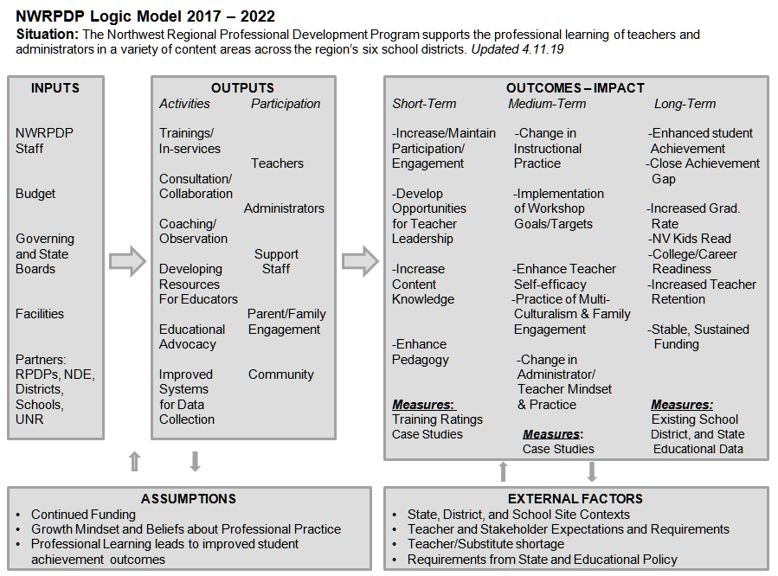
Figure 2: NWRPDP Logic Model

Key Findings from 2022-2023 NWRPDP Evaluation Activities:
Professional development services were conducted in all six districts that comprise the
NWRPDP, reaching a total of 1,880 unique educators during 2022-23. Because
professional development covers varied training topics and consulting services, and
educators often attend multiple trainings, the total number of duplicated educators
receiving services was 4,893. Elementary teachers (unique total served = 2,327) again were
the largest educator group served this past year; followed by High school teachers (1,341);
Others, which include substitutes, counselors, paraprofessionals and district personnel
(277); Middle school teachers (948); and Administrators (268). Overall, 32% of the
approximate 5,751 educators employed in the region (as reported by each district)
participated in programs provided by the NWRPDP during 2022-23. Remarkably, the
numbers of unduplicated participants are greater than 2021-22, despite lower numbers of duplicated participants in 2021-22 than last year suggesting a change in the impacts of
of the ongoing COVID-19 pandemic.

Case study evaluation data reveal a variety of positive outcomes across the 9 NWRPDP
2022-23 case study projects. The diverse foci of case studies this past year included continuing to help teachers develop new Nevada centric resources to meet NVACS-S Science
standards: the development of a teacher academies focused on teacher retention, building thinking classrooms in mathematics, scaffolding explanations and arguments in science, leading collaborative teams, national board maintenance certification (MOC) cohort participation, writing in content areas, impacts of science of reading professional learning on instructional practices, and early childhood development knowledge. All programs showed significant (.001) increase in knowledge and behavior gains for participants. Beyond showing statistically significant change for all participants in all areas, which goes to suggest the breadth and depth of learning that takes place for participants and educators providing these courses.
This year, case studies focused on demonstrating the stories that show the ways in which the NWRPDP program is making lasting impacts in classrooms and on students throughout the state of Nevada. For instance, one participant noted the programs provided collaboration, support and tangible products/tools/techniques that could be utilized in classrooms with students immediately and in an ongoing fashion. Further examination of the case studies shows that information disseminated from the NWRPDP is being utilized in classrooms with students benefiting directly from the knowledge that their teachers are receiving from participation in these programs. Case studies presented below demonstrate both statistically significant change in teacher knowledge and that the learning is making its way directly to the students in our schools through increased teacher efficacy in a variety of domains.
While the COVID-19 pandemic has seemingly eased, it has continued to impact all public educational activities throughout the 2022-23 school year—including NWRPDP professional development and trainings. NWRPDP facilitators, however, flexibly completed their ongoing case study and training activities. The leaders and educators who participated in NWRPDP programs continue to demonstrate that they are dedicated to their programs, their communities, and the students who will benefit from this program and the knowledge gained by those participating.

The Case Study Model
Over several years, the NWRPDP has employed a case study model to document professional development training. The NW regional program engages in an ongoing internal evaluation for all training activities, which incorporates case studies from projects throughout the region to document the diversity and wide-ranging impact of professional development activities. Evaluation results are then used to inform practice and help document the long-term effects of the support provided to teachers in the region. Evaluative case studies facilitate exploration of complex phenomena within their contexts—in this case, professional development (PD) within schools and districts—often using a variety of data sources. This ensures that PD is not explored through one lens, but rather through a variety of perspectives, which allows training effectiveness to be revealed and understood more fully (Desimone, 2009; Guskey, 2002; Killion, 2002; Yin, 2003). NWRPDP staff actively design and implement each evaluative case study that seeks to illustrate changes in teacher practice and student learning as a result of the diverse professional learning activities employed over the past year. Thus, the following case studies are focused evaluation investigations that incorporate mixed-method research designs to illustrate the breadth of training, variety of topics, and depth of consultation employed by NWRPDP staff over the past year. Each case study also is guided by a logic model framework--developed to link the case study training activities to the short, medium, and long-term outcomes expected from the professional development project.

Lyon County School District New Teacher Academy

Introduction
In his book, Visible Learning for Teachers: Maximizing Impact on Learning, John Hattie writes, “My role, as a teacher, is to evaluate the effect I have on my students…what does matter is teachers having a mind frame in which they see it as their role to evaluate their effect on learning.” Teachers play an invaluable and irreplaceable part in helping students learn and grow as individuals and scholars. This case study focuses on a New Teachers’ Academy in a rural school district in Nevada as they complete professional development around the Nevada Educator Performance Framework Instructional Standards and Professional Responsibilities.
In 2011, Nevada's legislators passed Assembly Bill 222, which created the Teachers and Leaders Council (TLC) and required the State Board of Education (SBE) to establish a statewide performance evaluation system for teachers and building-level administrators based upon recommendations from the TLC. This system is now known as the Nevada Educator Performance Framework (NEPF).
The NEPF was created to ensure that educators have a positive impact on student learning, are able to grow professionally through ongoing professional learning and support, identify and use high-leverage teaching practices, reflect on teaching practices, and receive specific and constructive feedback.
After multiple observations and a review of the evidence collected, teachers are given a score of 1-4 based on five Instructional Practice Standards and five Professional Responsibilities Standards. Student performance is also taken into consideration. The scores and weights are listed in the table below:
Table 9: Nevada Educator Performance Framework Breakdown
Category | Weight
Instructional Practice Standards | 65%
Professional Responsibilities Standards | 20%
Student Performance (SLGs) | 15%

This case study will offer teachers the opportunity to explore the NEPF Instructional Practices and Professional Responsibilities and choose options that best suit individual needs.

Instructional Context
The Lyon County School District Teacher Academy was created for teachers new to Lyon County School District and consisted of five sessions offered one to two months apart. In addition to the five sessions, participants could request individual support through a menu of support options. This case study follows 37 participants of varying grade levels and content areas who attended two or more sessions. The demographics of the participants are shown in the figures below.
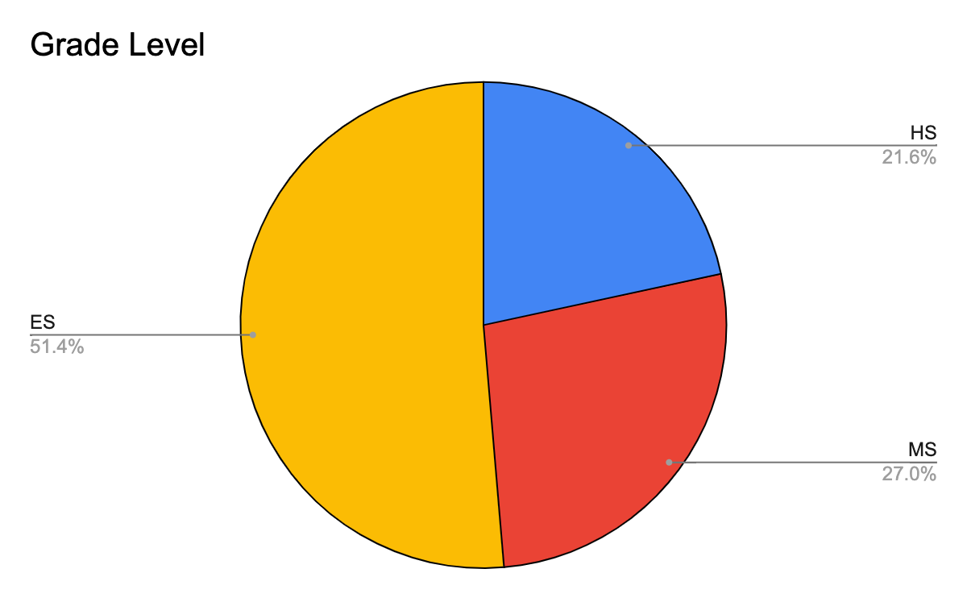
Figure 3: Grade Level
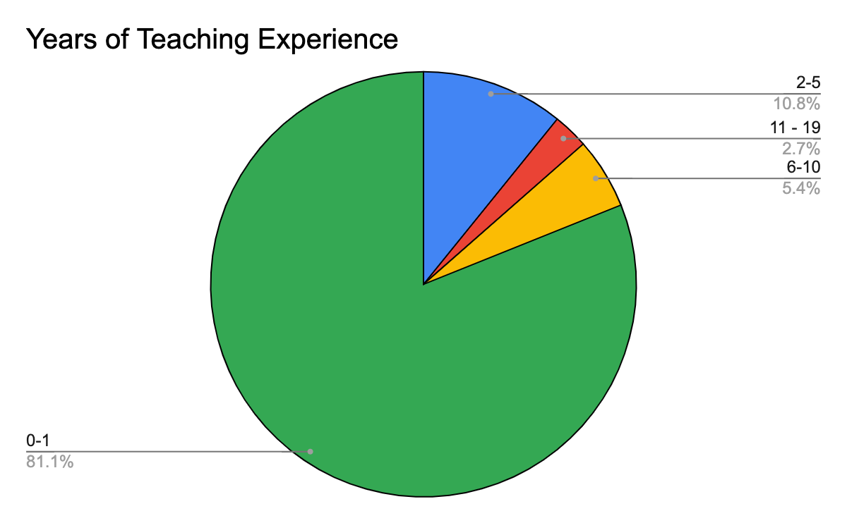
Figure 4: Year of Teaching Experience

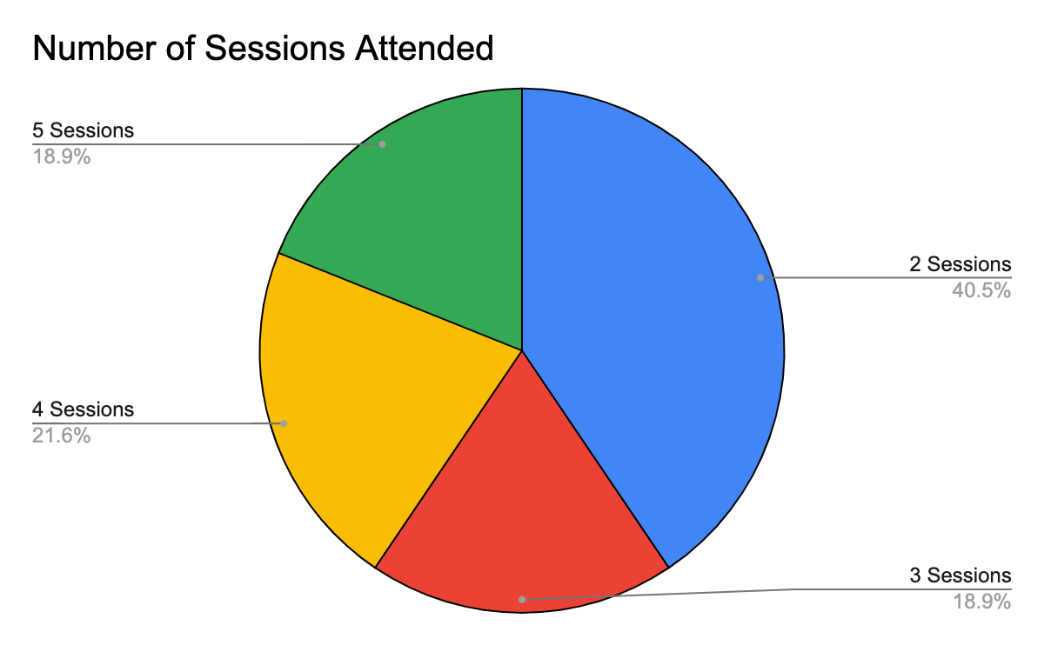
Figure 5: Number of Sessions Attended
Participants were given a menu of support options between each module. Options offered were based on common needs that were determined across grades and subject areas. Several teachers took advantage of the support and worked with trainers on their individual needs. Most participants wanted general support and help with classroom management. The menu responses were also used in the initial planning as well as the NEPF standards and indicators.
Table 10: Menu of Support
Demonstration  Let me show you an example of what a particular instructional practice looks like. | Co-Planning  Let’s plan a lesson or unit together. | Lesson Feedback  Let me watch a lesson for a particular focus you want to work on and give praise and possible suggestions. | Gather Resources  Let’s find some good resources for a particular lesson or unit you are hoping to teach.
Assessment  Let me help you administer an assessment and kid-watch. | Co-Teaching  Let’s teach together for an instructional block or a whole school day. | Data Analysis  Let’s look at data to determine progress monitoring, create student groups, or plan lessons. | Brainstorm Strategies  Tell me about an area in which you are struggling and let’s come up with some possibilities!
General Support  This job is rewarding but really hard sometimes. If you need to just talk to another teacher about things we are here for you. | Organization  Let me help you find a way to keep important paperwork organized or make a routine you are struggling with more efficient. | Environment  Let me be another set of eyes on the layout of your classroom or a particular area of the room. | Classroom Management  Let’s talk about rules, routines, structures, and relationships to decrease teacher and student frustration and increase independence.
Classroom Visit
Is there a teacher, grade, or subject you would like to see in action?

Initial Data and Planning
In August 2022, two NWRPDP trainers collaborated with the professional development coordinator in Lyon County School District to develop a year-long professional development program for new teachers. A menu of options was used to collect participant feedback and requests as well as to direct the content of each meeting. The data from the menu of options was connected the NEPF standards and indicators.

Delivery of Services
Dates of service were 8/11 from 8:30-10:30 and 9/13, 12/6, 2/7, and 3/7 from 8:30-2:30. Educators participated in one two-hour training and four all-day trainings. Areas of foci included: the NEPF standards and criteria with an emphasis on teacher clarity, engagement strategies, Kagan strategies, discourse, higher-level questioning, student voice and choice, classroom environment, and professional responsibilities. Connections were made to the Nevada Academic Content Standards based on teacher requests. To conclude each session of training, the instructors asked participants for feedback to guide and modify subsequent trainings. A guest speaker presented on Trauma Sensitive Instruction and self-care.
Individual support was provided through a needs request form. Of the 37 participants, 21 requested individual support for the categories listed in the figure below.
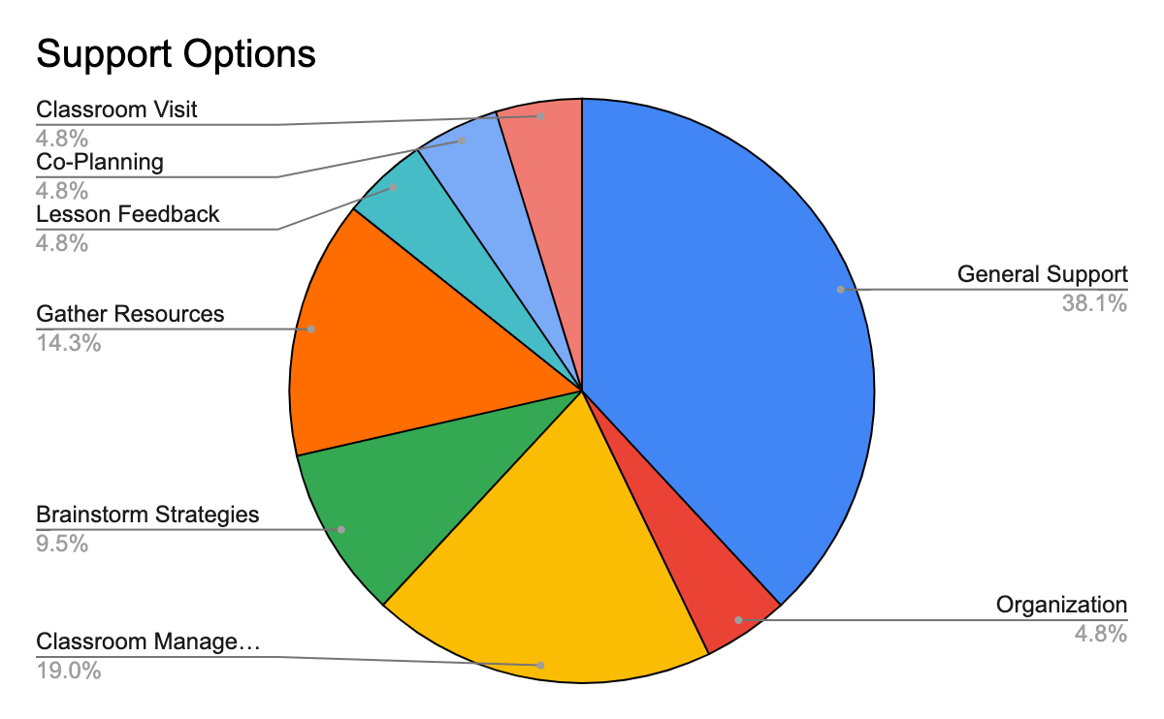
Figure 6: Individual Support through Menu of Support Options

Results and Reflection
Data were collected in the form of a pre- and post-survey for the topics listed in the table below using a scale of 1-5 (1 = Poor, 5 = Excellent). The teacher survey results in the table below reflect the effectiveness of the training, pre- and post-assessment feedback about specific information about the usefulness of the course.
Table 11: Results
 | Knowledge  Before | Knowledge  After | Change | *P Value
Overview of the NEPF Instructional Practices | 2.3 | 4.2 | 1.9 | < 0.001
Overview of the NEPF Professional Responsibilities | 2.4 | 4.1 | 1.7 | < 0.001
Teacher Clarity (Learning Intentions/Success Criteria) | 3 | 4.1 | 1.1 | 0.002
Discourse and Collaboration Strategies | 2.9 | 4 | 1.1 | < 0.001
Metacognition and Thinking Strategies | 2.6 | 4 | 1.6 | < 0.001
Trauma-Informed Practices | 2.6 | 3.9 | 1.4 | < 0.001
Classroom Management Ideas | 3 | 4.2 | 1.1 | < 0.001
Formative Assessment Practices | 2.6 | 4.3 | 1.6 | < 0.001
*P Values show significant growth in all areas.
Next Steps
The teachers were also surveyed about the usefulness of the training and the likelihood of idea and strategy implementation using the NWRPDP training evaluation. The teachers were asked to rate each of the statements on a Likert scale of 1= Very unlikely to 5= Very likely on the following statements and questions.
Table 12: Results
Questions | Mean
How likely are you to use ideas and strategies from this course? | 4.5
This course offered useful and important information about Parent Involvement and Family Engagement. | 4.4

Participants were asked to comment about the most beneficial part of the course, and it was apparent that breakout room collaboration and information from guest speakers were valued and led to changes in knowledge and practice.
The most beneficial aspect(s) of the course:
- A-ha that formative assessment includes many things that are already happening, not just tests.
- Different Strategies and Tools given that I can apply to my classroom.
- Hearing all strategies available, and that others use, to implement into my own classroom.
- Having opportunities to discuss with other educators from different places and share ideas.
- Talking to fellow new teachers and mentors.

Responses to the survey provide evidence that the quality of the course was excellent and that teachers found the instructional and material valuable. Teachers wrote the following comments about the quality of the class:
- …the ladies who taught and led the events were wonderful and super helpful! I hope new teachers can continue to have so much support.
- This was a great pathway to helping me become a better educator.

Conclusion
It is evident from the data collected that the New Teacher Academy had a significant impact on teacher implementation, educator mindset, and confidence in working at their school sites. Teachers felt that the course requirements had a positive effect on their instruction and relationships with students. Participants appreciated the style and delivery of the course and reflecting on the material with their peers. Written responses indicated that educators intended to use the information from the trainings within their classrooms and that students gained quality conceptual understanding from the strategies implemented.

References
Fisher, D., Frey, N., Amador, O., & Assof, J. (2019). The teacher clarity playbook: a hands-on
guide to creating learning intentions and success criteria for organized, effective instruction; Grades K-12. Corwin, A Sage Company.
Hattie, J. (2012). Visible learning for teachers: maximizing impact on learning. Routledge.
Jennings, P. A., & Siegel, D. J. (2019). The trauma-sensitive classroom: Building resilience with
compassionate teaching. W.W. Norton & Company.
Nevada Educator Performance Framework (NEPF). (2022, April). Nevada Department of
Education.https://doe.nv.gov/Educator_Development_and_Support/Nevada_Educator_Performance_Framework(NEPF)/
Pelletier, C., Radford, & Dewitt, P. M. (2017). The first years matter: becoming an effective
teacher: a mentoring guide for novice teachers. Corwin, A Sage Publishing Company.
PZ’s Thinking Routines Toolbox | Project Zero. (2023, April 14). Pz.harvard.edu; Harvard College. https://pz.harvard.edu/thinking-routines

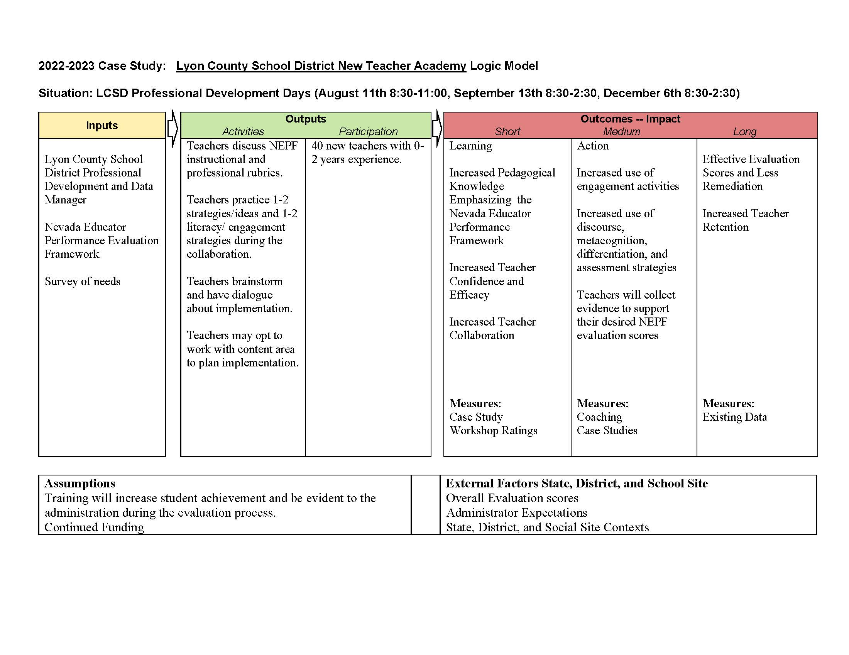
Figure 7: Lyon County School District New Teacher Academy Logic Model

New Teacher Training, Support and Retention

Introduction
“More than half of all public schools in the country reported that they were understaffed at the start of the 2022-23 school year, according to the National Center for Education Statistics, the research arm of the Education Department, and 69% reported that too few teacher candidates applying for open positions was the primary challenge (Camera, 2022).” TNTP, an agency that partners with schools and districts to help them reach their goals for students, conducted a survey of 21 school districts representing over 630,000 students in twelve states following the pandemic. They found that across the districts responding, both hiring new teachers and finding substitute teachers was becoming increasingly difficult (Cato Czupryk, 2022). The key findings were:
- 100% said it was harder to hire substitute teachers than in previous years.
- 86% said it was harder to hire classroom teachers than in previous years.
- 76% reported fewer applications for their vacancies than in previous years.
Northern Nevada school districts are also experiencing teacher shortages. Douglas County School District hired approximately 70 new teachers for the 2022-23 school year and approximately 35 new teachers for the 2021-22 school year. These 100 new teachers make up about one third of the total teachers in Douglas County School District. Several positions as classroom teachers remain open or are filled with long term substitutes.
There is a need, not only to recruit and hire the most qualified classroom teachers, but also to retain them year after year. Since its opening in 1981, the Douglas County School District Professional Development Center has offered training and support for all new teachers over their first two years as employees of the district.

Instructional Context
Douglas County School District (DCSD) is a rural school district located in Northern Nevada. DCSD is comprised of fourteen schools, including seven elementary schools, two middle schools, four high schools and one online school. Approximately 5,380 students were enrolled in DCSD during the 2021-22 school year. The student population is comprised of 66.68% white students, 23.47% Hispanic students, 3.16% American Indian students and 5.68% students who are more than one race. DCSD has an Average Daily Attendance rate of 94.6%. It has a cohort graduation rate of 84.53%% as reported in the Nevada Report Card (2022). Chronic absenteeism for the 2021-2022 school year was 22.6%, which increased from 16.9% in 2020-2021 (www.nevadareportcard.nv.gov).
Douglas County School District employs just over 350 teachers. Over one third of Douglas County School District’s teachers are in their first or second year working in the district. For the 2022-2023 school year, DCSD hired sixty-two new teachers. Of the new hires, forty-nine hold a Nevada teaching license with varying levels of experience from first year teachers to two retired teachers returning to fill critical shortage positions. Seven of the new hires are pursuing an alternate route to licensure path and six are long term substitute teachers. All of these teachers participated in DCSD’s Teacher Academy, Level 1 during the 2022-2023 school year. For the 2021-2022 school year, DCSD hired 34 new teachers. These teachers participated in Teacher Academy, Level 1 during the 2021-2022 school year and participated in Teacher Academy, Level 2 during the 2022-2023 school year.
Douglas County School District’s Teacher Academy is designed to provide teachers in their first and second year in DCSD with professional learning and support. The focus of the Teacher Academy is to support teachers in the implementation of Douglas County School District’s instructional model and creating a rigorous, learner-centered experience for students.

Initial Data and Planning
Given the nation-wide teacher shortage and the fact that there are multiple paths that teachers can now take to become licensed to teach in the classroom, an investment in professional development seems critical. Douglas County School District has always believed that high quality professional learning is central to high quality instruction in classrooms. DCSD’s Professional Development Center (PDC) has five full-time Professional Learning Strategists providing professional learning for their Teacher Academy, as well as in-service classes for teacher recertification and district-wide trainings to support district initiatives.
For the past four years, Douglas County School District has been working to modernize teaching and learning focusing on creating a positive culture within its schools that is learner-centered and responsive to student needs. Supporting these efforts has been the focus of the Professional Development Center in its Teacher Academy.

Delivery of Services
Teacher Academy. Level 1 participants, teachers in their first year working in Douglas County School District, attended four days of training prior to the 2022-23 school year. The focus of these four days was on building a positive culture, understanding the district’s instructional model, and learning about curriculum and teaching resources. Teacher Academy, Level 1 participants also attended a monthly meeting furthering their work with the instructional model and participating in a book study on implementing blended learning in the classroom. Teacher Academy, Level 2 participants only attended monthly meetings and participated in a book study. Both Teacher Academy, Level 1 and Level 2 participants received in class coaching by one of the Professional Learning Strategists and were able to participate in peer observations across the district.
At the end of the school year, all participants in Teacher Academy completed a post-reflective survey asking about their knowledge gain in areas like Douglas County School District’s Instructional Model, building a positive culture in the classroom, the Nevada Educator Performance Framework, and other district initiatives like implementing station rotation and using Thinking Maps. They were also asked retention questions asking which elements of the Teacher Academy were the most beneficial to them.

Results and Reflection
When asked about gains in knowledge as a result of the Teacher Academy, both Level 1 teachers and Level 2 teachers showed statistically significant improvement in all areas. Teacher Academy, Level 1 results are summarized in Table 1. Teacher Academy, Level 2 results are summarized in Table 2.
Table 13: Knowledge Gains in Teacher Academy, Level 1
 | Mean before | Mean after | t-score | p-value
Instructional Model | 2.17 | 4.05 | -9.09 | < .001
Building a Positive Culture | 3.25 | 4.30 | -5.99 | < .001
Creating a Learner Centered Environment | 3.08 | 4.18 | -5.83 | < .001
Nevada Educator Performance Framework | 2.33 | 3.68 | -7.06 | < .001
Using Thinking Maps | 2.73 | 4.05 | -7.34 | < .001
Implementing Station Rotation | 2.85 | 4.25 | -7.55 | < .001

Table 14: Knowledge Gains in Teacher Academy, Level 2
 | Mean before | Mean after | t-score | p-value
Instructional Model | 3.05 | 4.36 | -5.693 | < .001
Building a Positive Culture | 3.55 | 4.59 | -4.039 | < .001
Creating a Learner Centered Environment | 3.32 | 4.50 | -5.266 | < .001
Using Responsive Instruction | 3.05 | 4.27 | -4.533 | < .001
Nevada Educator Performance Framework | 2.50 | 4.14 | -5.238 | < .001
Using Thinking Maps | 2.41 | 4.23 | -6.580 | < .001
Implementing Station Rotation | 2.82 | 4.36 | -5.923 | < .001

Teachers were also asked questions about the different support elements they received and how beneficial they felt each was to their work. Teachers reported the benefit of each element on a five point scale ranging from 1-not helpful to 5-extremely helpful. The average responses collected are shown in Table 3.
Table 15: Support Elements for Teacher Academy, Level 1 and Level 2
 | Before School Training Days | Monthly Google Meets | Instructional Model Learning Plans | Book Study | Coaching | Peer Observations | On-site Mentor
Level 1  n=40 | 3.25 | 2.86 | 3.03 | 2.89 | 4.14 | 4.05 | 3.8
Level 2  n=22 | 3.18 | 2.77 | 3.00 | 3.04 | 4.11 | 3.94 | 3.81

All teachers felt that the coaching provided and observing peers in their classrooms were the most beneficial. They also felt that the monthly google meets that took place outside the work day were the least beneficial. For the 2023-24 school year, the monthly google meets will be replaced with trainings that take place in small groups during the work day. All Teacher Academy, Level 1 teachers will continue to attend the training days prior to the start of the school year. Teachers in both Level 1 and Level 2 for the 2023-24 school year will also continue to receive coaching from Professional Learning Facilitators, continue to have an on-site mentor, and continue to observe peers at least one time during the school year.
In their written feedback, teachers reported that the collaboration with and connection to other new professionals was very beneficial to them as participants in the Teacher Academy. They reported wanting more information on how to handle challenging behaviors. This feedback will be incorporated into the content for the 2023-24 school year. One teacher commented, “Good times, great ideas to make teachers better. Not all teachers have their masters degree and this program makes teachers better overall and the students are the ones who benefit . Every school district needs a Teacher Academy!”

Conclusion
Teacher recruitment and retention are very real problems across the nation. The solutions to these problems require work beyond the scope of this case study. However, the results found in this case study seem to indicate that new hires in Douglas County School District gain knowledge that is helpful for them in their positions when they attend the Teacher Academy for two years. New teachers also indicate that the coaching, mentoring, and face-to-face training days before the school year are effective in supporting them and their success in the classroom.
In a study published in the Journal of Educational Leadership and Policy Studies of three districts on improving teacher retention in highly effective school districts, the researchers found several common themes that improved teacher retention (Schuls & Flores, 2020). Two of the key findings were personalized professional development programs that focus on personal growth and high quality new or beginning teacher induction programs. They found that “induction programs set new teachers up for success by bringing them into the culture of the district and schools and familiarizing them with their new roles and settings (p.12).” Based on the findings of the results in this case study, teachers in Douglas County School District are being offered professional learning opportunities consistent with retaining teachers over time.

References
Camera, L. (2022). New Federal Data: Too few applicants in K-12 schools. US News and World Report.https://www.usnews.com/news/education-news/articles/2022-09-27/new-federal-data-too-few-applicants-in-k-12-schools
Cato Czupryk, B. (2022). “it’s harder than ever”: What we’ve been hearing about teacher shortages. TNTP. https://tntp.org/blog/post/its-harder-than-ever-what-weve-been-hearing-about-teacher-shortages?utm_medium=email&utm_campaign=Chief+Talent+Officer+survey+blog&utm_content=Chief+Talent+Officer+survey+blog%2BCID_8ceef1e0d53f714529904028258b7aa9&utm_source=Campaign+Monitor+Master+List&utm_term=READ+MORE
Nevadareportcard.nv.gov. (2022). http://www.nevadareportcard.nv.gov/
Shuls, V. James, Flores, M. Joshua (2020). Improving Teacher Retention through Support and Development, Journal of Educational Leadership and Policy Studies, 4(1)

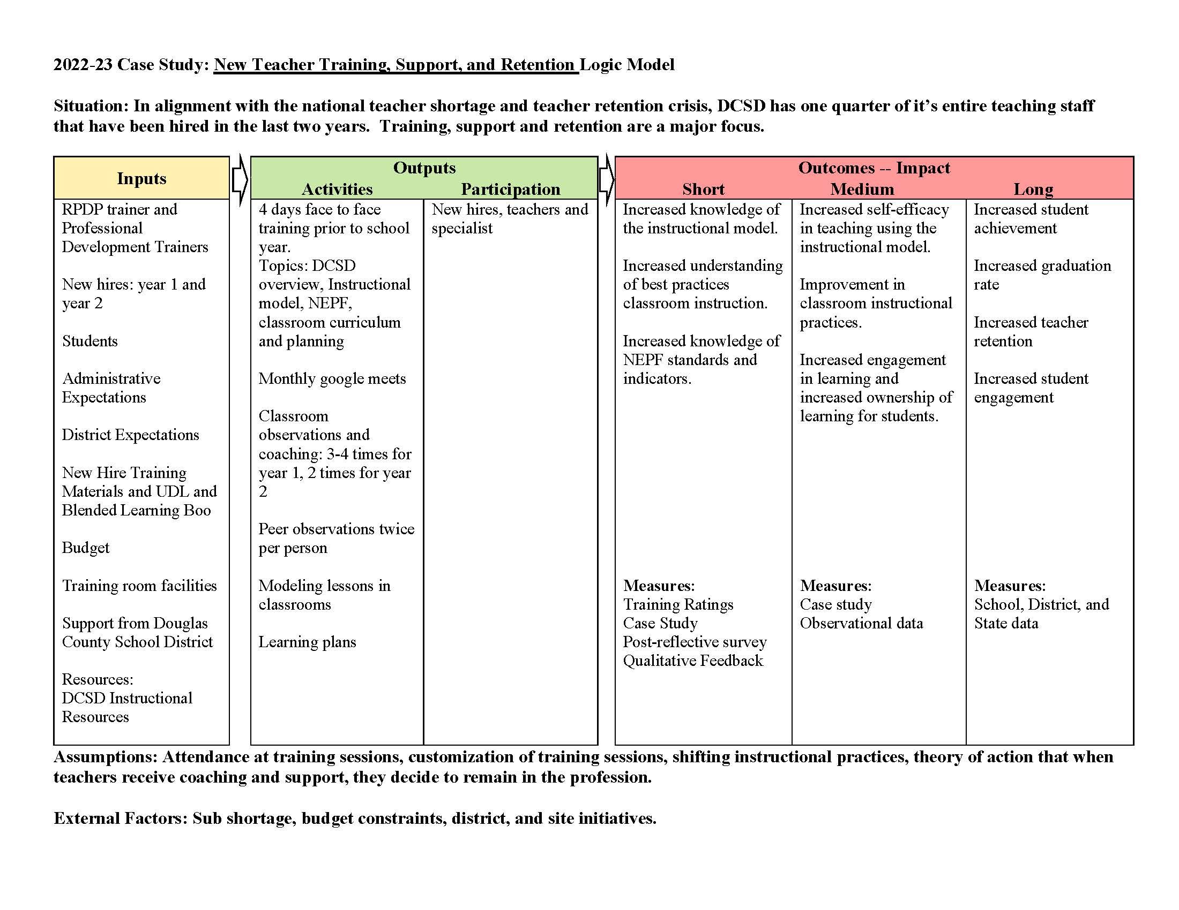
Figure 8: New Teacher Training, Support, and Retention Logic Model

Building Thinking Classrooms in Mathematics

Introduction
In his book, Building Thinking Classrooms in Mathematics, Dr. Peter Lilijedahl writes, “Thinking is a necessary precursor to learning, and if students are not thinking, they are not learning”. Historically mathematics has been seen as a subject of following step by step procedures and answer-getting which leads to a classroom of students mimicking mathematics instead of thinking quantitatively and creatively to solve mathematics problems. The introduction of the Common Core Mathematical Standards addressed this misunderstanding of mathematics by including Eight Standards for Mathematical Practice. The Standards for Mathematical Practice set forth expectations for how students engage with mathematical content and do mathematics. Unfortunately, math instruction has seen little change since the adoption of these standards. According to Dr. Peter Lilijedahl, this is due to institutional norms and pedagogy dating back to the introduction of the industrial-age model of public education (Lilijedahl, 2021, pg. 11). While the world has evolved with a vast amount of discoveries in neuroscience and technological advances, math instruction has not. Addressing this lack of evolution in mathematics instruction will require different strategies than in the past and a nation willing to improve public education (Kober, 2020).
After fifteen plus years of research and visiting over 400 classrooms, Dr. Peter Lilijedahl identified fourteen strategies that were developed to challenge the normative structures found in many classrooms today. Each strategy focuses on disaggregating teaching into discrete factors, such as random grouping, working at vertical whiteboard spaces, questioning techniques, neuroscience supported notetaking, consolidating a lesson and assessment. Each of these act as individual variables in the pursuit of building a thinking classroom.
This case study followed 23 brave educators who had the desire and will to challenge these norms and improve education by applying Dr. Lilijedahl’s findings into their classrooms. The educators in this study have implemented anywhere from six to fourteen of Lilijedahl’s Fourteen Learning Practices to create better learning experiences for their students.

Instructional Context
The Building Thinking Classroom in Mathematics Part 2 Cohort was offered to kindergarten-12th grade educators in the Northwest Nevada region. This region includes urban, suburban, and rural areas with a broad range of socioeconomic statuses and student ethnic representations. Participants in this study represented ten elementary schools, three middle schools, and four high schools. The elementary educators (kindergarten - 5th grade) who participated in this course are responsible for teaching all core subjects and devote, on average, 75-90 minutes of mathematics instruction into their daily schedule; the secondary educators (6th-12th grades) teach the subject of mathematics exclusively, one of which serves special education mathematics instruction.

Table 16: Grade Level or Current Role of Participants
Grade Level/Current Assignment | Number of Participants
Kindergarten - 2nd Grade | 6
3rd - 5th Grade | 8
Middle School | 3
High School | 3
Teacher Leaders | 2
Administrator | 1
Total | 23

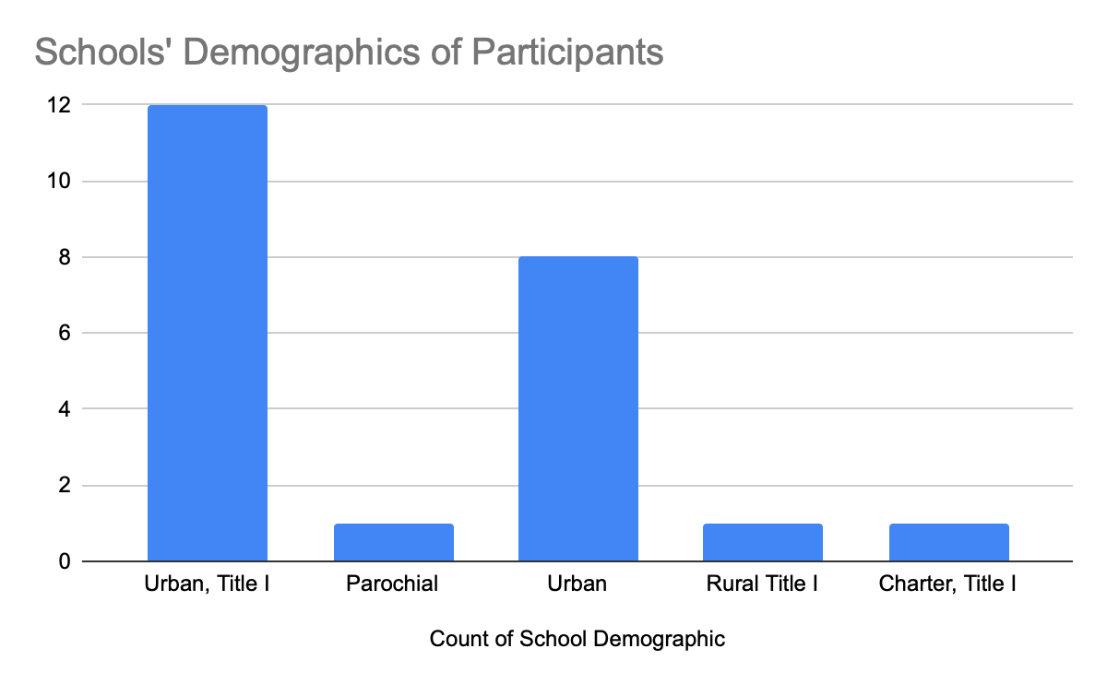
Figure 9: Demographics of Participants' Schools

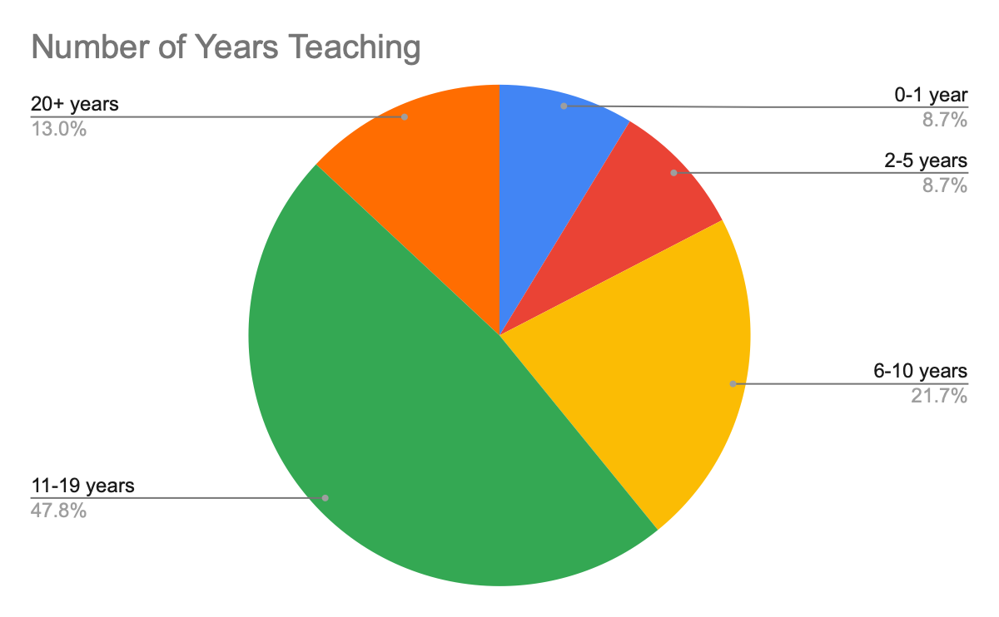
Figure 10: Years of Teaching Experience

Initial Data and Planning
Data for both Nevada and Washoe County School District indicate a lack of growth in Mathematics. The 2022 National Assessment of Educational Progress (NAEP) data shows only 29% of 4th grade Nevada students were proficient while 21% of 8th grade students showed proficiency in mathematics. The NAEP data also indicates that students in both 4th and 8th grade did not show significant growth between the 2017 and 2022 testing years which shows a trend of slow growth predating the pandemic (NAEP report card: Mathematics 2021). Data from Smarter Balanced Assessment (SBA) also support NAEP’s findings when looking at students who showed proficiency in mathematics. During testing years 2015-2019 mathematics proficiency rates for 3rd through 8th graders hovered between 32.7 % and 37.5%. In 2022, the average mathematics proficiency rate dropped to 29.8%. In addition, multiple studies have shown the learning impact of mathematics is greater than that of other subjects such as ELA which only dropped from 48.5% (2019) to 43.7% (2022) (Nevada State - Nevada Accountability Portal, 2023).
Additionally, observations of educators show a lack of understanding/knowledge of how to teach through problem solving. Students learn mathematics best through real contexts, problems, situations, and models that help them build meaning for the concepts rather than apply mathematics after it is learned (A., V. de W. J., & A., V. de W. J., 1998, pgs. 13-14) which is found in direct instruction and teaching students to follow and/or memorize steps. This lack of a problem-solving approach is detrimental when helping students to connect concepts and transfer knowledge across mathematical content.
Classroom observations showed many teachers use the “Gradual Release Model: I Do, We Do, You Do” when teaching mathematics. While this structure is powerful in other content areas, in mathematics it led to students mimicking and following a prescribed set of steps as opposed to thinking creatively to solve problems. Teachers were often taught mathematics using the Gradual Release Model which made sense as to why they were using this structure to teach mathematics to their students. Furthermore, many mathematics programs use elements of this structure including the mathematics programs adopted by districts of participants in this cohort.
This cohort was created at the request of educators who felt the need for a collaborative professional learning community to refine their craft and help to support implementation of the practices from Building Thinking Classrooms in Mathematics: 14 Teaching Practices for Enhanced Learning (Liljedahl, 2021). To aid in this journey, participants were given a needs assessment pre-survey as seen in Figure 3 which helped guide planning.
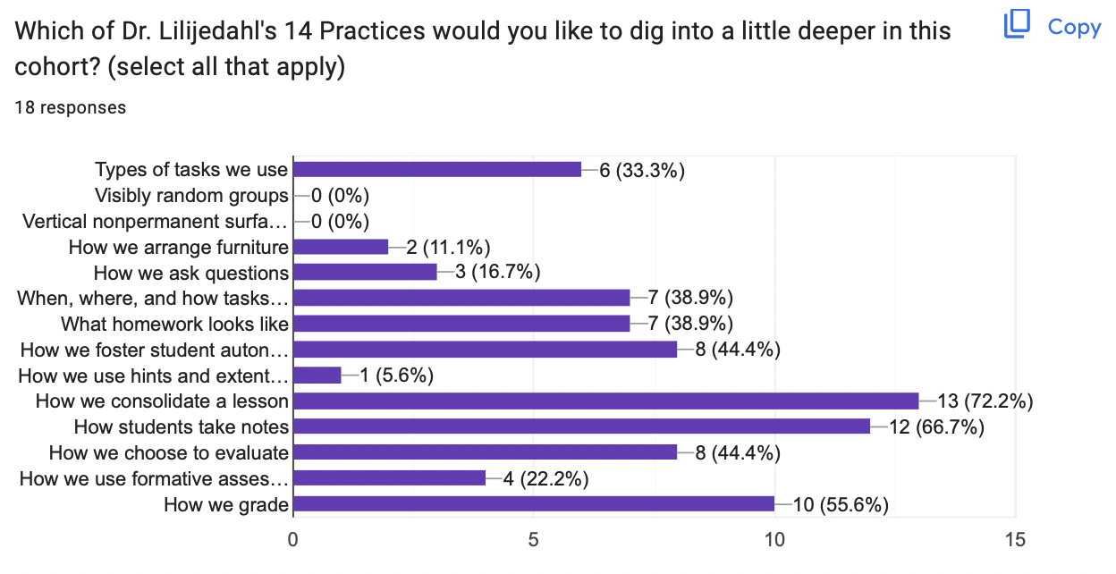
Figure 11: Results of Pre-Survey Needs Assessment

Delivery of Services
The Pre-Survey Needs Assessment, Figure 3 showed that participants’ needs varied; however, most participants who completed the survey felt that spending time focused on the following Learning Practices would be most beneficial:
Table 17: Building Thinking Classrooms in Math Practices of Focus
Practice 6 | When, where, and how tasks are given
Practice 8 | How we foster student autonomy
Practice 10 | Consolidating from the Bottom
Practice 11 | How students take notes
Practice 12 | How we choose to evaluate
Practice 14 | How we grade

This course was set up as a collaborative support cohort for educators who had implemented some or all the Learning Practices from Building Thinking Classrooms in Mathematics: 14 Teaching Practices for Enhanced Learning (Liljedahl, 2021). The cohort consisted of the following elements; a Saturday eight hour in-person class, a Teams platform for participants to collaborate, and classroom visits to observe and model Building Thinking Classroom practices.
The Saturday in-person class began with participants engaging in a learning task that revisited how to utilize Building Thinking Classrooms Framework when solving multiple math problems increasing in complexity. This task served several purposes. First it gave participants the opportunity to experience Practices 6, 8, 10, 11, and 12 as seen in Table 2 from both the student and educator’s perspective as well as provided a common experience in which to ground future discussions.

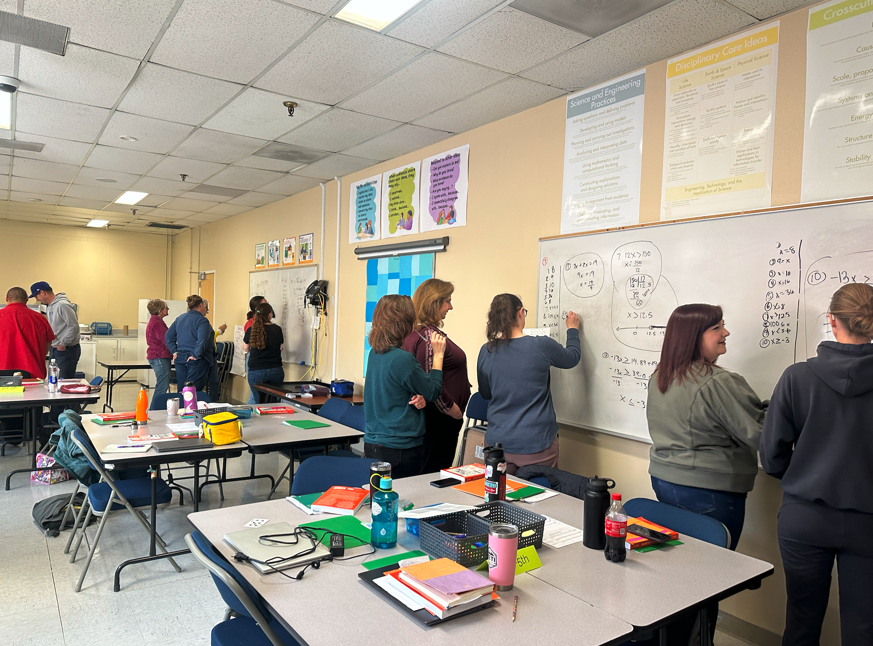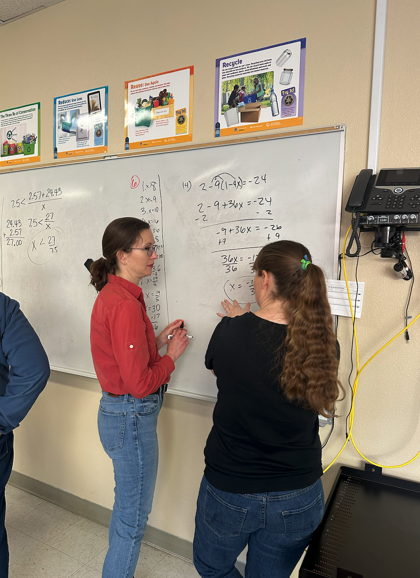
Figure 12: Cohort Participants Engaging in Saturday Learning Task
Participants were also given the opportunity to analyze the lesson and identify where the Eight Standards for Mathematical Practice were present in the learning task. This highlighted how when students engaged with mathematical content using the Building Thinking Classrooms Framework many of the Eight Standards Mathematical Practices occured organically. This is shown in Figure 5 below. Dr. Liljedahl’s 14 Learning Practices are noted in black, and the Eight Standards for Mathematical Practices are noted in green.

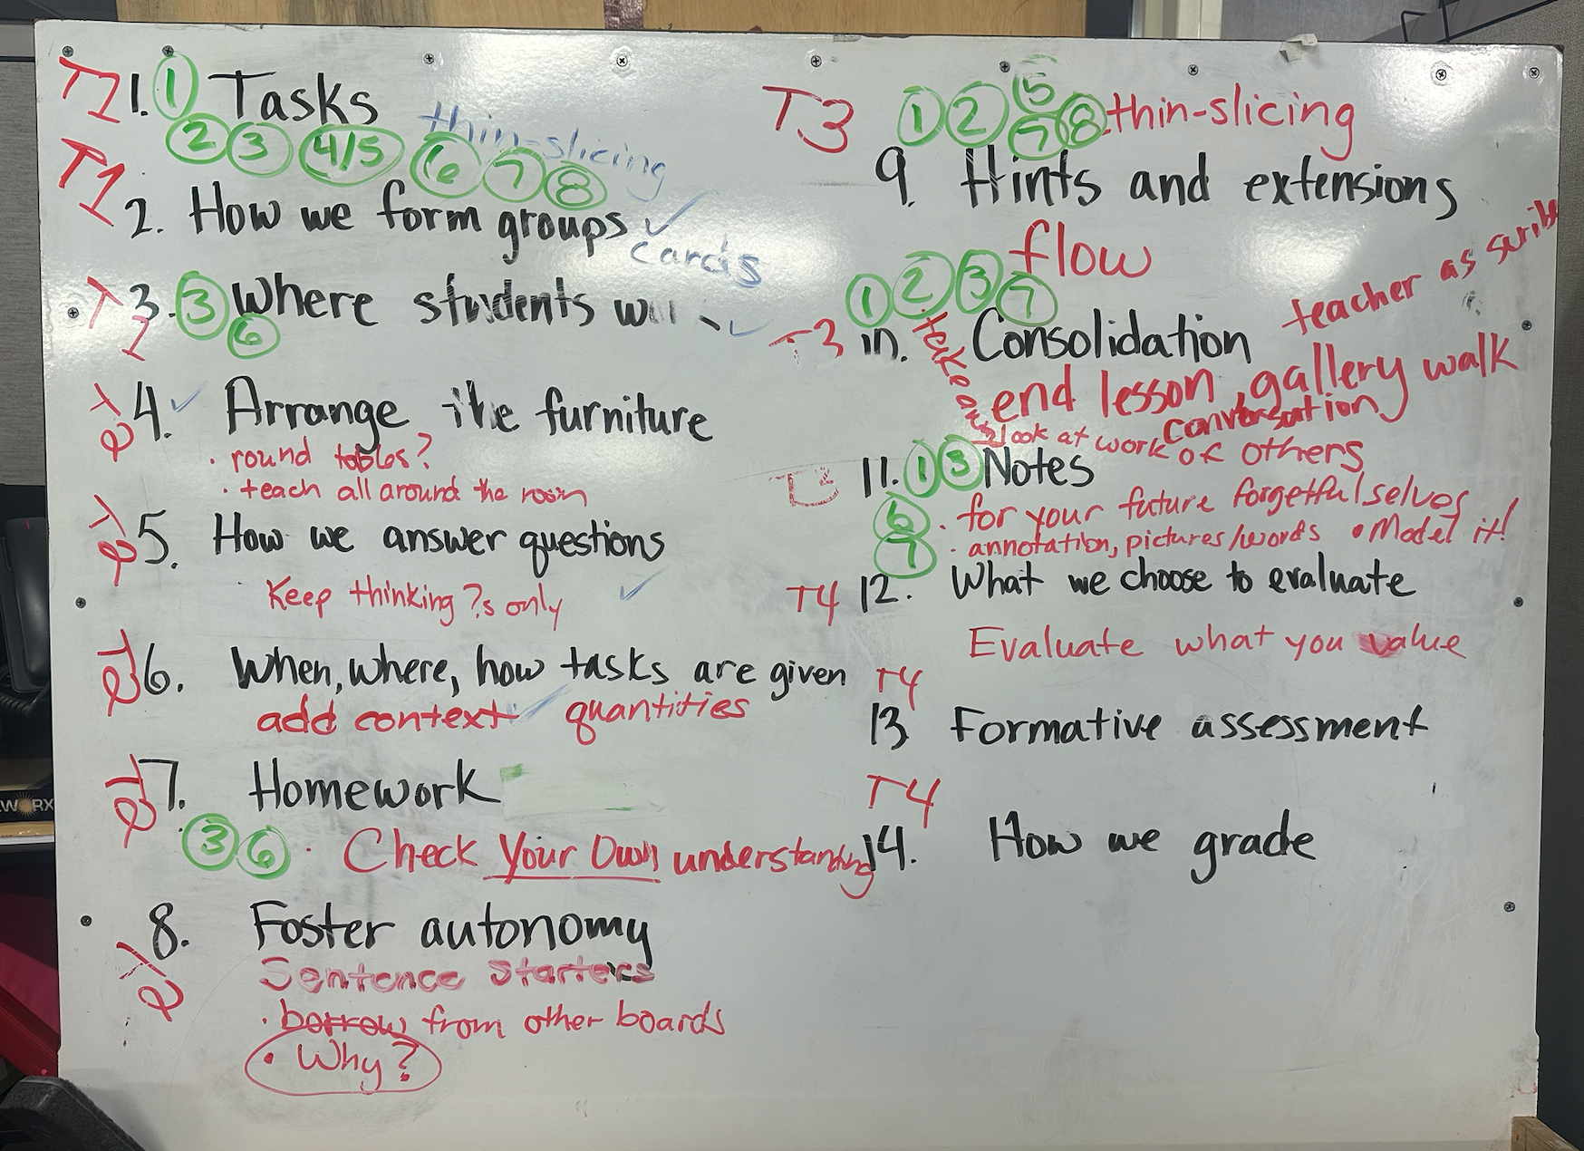
Figure 13: Learning Task Analysis
Furthermore, this learning task provided participants with an example of how using multiple questions, which gradually increased in depth and complexity during a lesson, could foster both student autonomy and content differentiation while using the Building Thinking Classroom Practices and Framework.
The Microsoft Building Thinking Classrooms in Mathematics Team offered a place for cohort participants to ask questions, share successes and resources, as well as upcoming webinars and professional learning opportunities. Participants found this a valuable tool when developing their capacity in the following practices:
- Practice 1: What types of tasks we use
- Practice 10: How we consolidate a lesson
- Practice 11: How students take notes
- Practice 14: How we grade
Cohort participants were able to seek advice as well as share resources with colleagues in a timely manner using Teams.
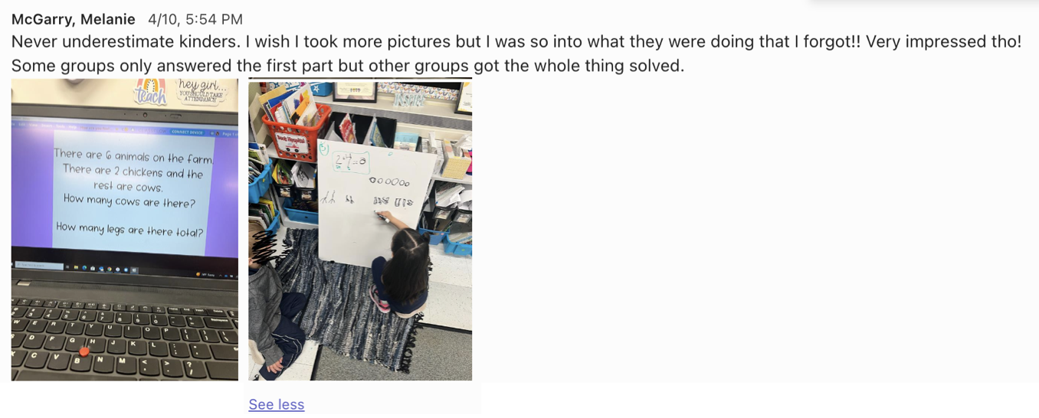

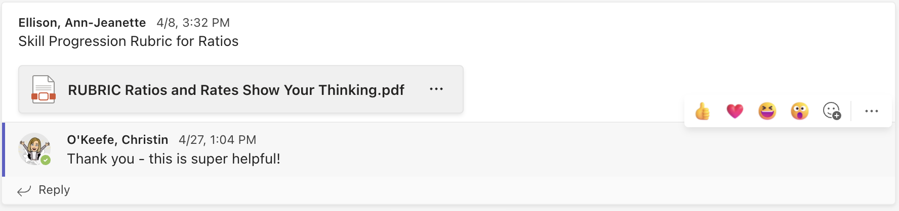
Figure 14: Microsoft Teams Collaboration Examples
A final element of this cohort was participants engaging in classroom visits and observations of colleagues. Eight participants requested classroom observations. During classroom observations, the trainer would observe the lesson focusing on the participant’s predetermined area(s) of focus and utilize a cognitively guided coaching approach for the follow up discussion. An additional four participants observed a Building Thinking Classrooms lesson. During the observation, the trainer whisper coached focusing on highlighting the Building Thinking Classroom Practices, teacher questioning techniques, and students’ engagement in the task.

Results and Reflection
At the completion of the course, all participants were asked to complete a post-reflective survey. This survey focused on how Dr. Liljedahl's Practices affected student identity, classroom culture, and engagement. Participants rated their classroom communities and students from 1 (strongly disagree) to 5 (strongly agree). The results are shown below in Table 3.
Table 18: Post Reflective Survey Data
 | Before implementing (mean) | After implementing (mean) | Difference | t-score | Significance (p-value)
1. Classroom Community: improved students’ willingness to collaborate. | 3 | 4.43 | 1.43 | -7.682 | <.001
2. My students view their peers as resources during math instruction. | 2.43 | 4.39 | 1.96 | -9.614 | <.001
3. My students focus on the problem-solving process vs. finding the answer. | 2.22 | 4 | 1.78 | -8.986 | <.001
4. My students take initiative to solve problems instead of relying on the teacher to show them how to solve the problem (Thinking vs. Mimicking). | 2.22 | 4.22 | 2 | -9.592 | <.001
5. My students have a positive math identity. | 2.69 | 4.09 | 1.4 | -7.955 | <.001
6. My students persevere (productive struggle). | 2.39 | 4 | 1.61 | -8.656 | <.001

The results reveal that significant growth occurred in all six areas because of this cohort. Questions two and three showed the largest increase which indicated a shift to a student-centered classroom where the teacher takes on the role of a facilitator and students see both themselves and their peers as the holders of knowledge as opposed to relying on the teacher to do the heavy lifting. While questions one and six showed significant growth, both these questions involved students’ belief in themselves individually and as part of the classroom community as contrary to student behavior, therefore the results were as expected and will inevitably take more time and practice. In addition to the quantitative data seen in Table 3, the following observations were also provided by participants who participated in the survey:
- Random grouping is giving all students an opportunity to share a variety of skills in our class.
- Problem solving was approached with enthusiasm and confidence; sharing ideas improved and increased.
- My student engagement generally and specifically with the math content is much higher. Their ability to persevere is also much better.
- Student collaboration increased significantly, also understanding of and use of math concepts.
- Students ask to work on the board in groups now and students that were thought to be incapable are known as good at math and good at working with teammates.

While participants showed significant growth in their practices, the insight gained from this case study also showed how implementation of these practices positively impacted students. Participants were asked to survey their students. The purpose of the survey was to capture students' perspective of utilizing peers as resources as well as mobilization knowledge and strategies which could be seen in their peers' vertical workspaces. Tables 4 and 5 show that both elementary and secondary students benefited, however, the impact was greater in elementary classrooms. In the future, something to consider would be to survey students from traditional classrooms and compare the results.
Table 19: Elementary Student Surveys Results
 | Dislike | Neutral | Like
Visibly Random Groups | 12% | 18% | 70%
Non-Permanent Vertical Spaces | 4% | 14% | 82%

Elementary Student Comments:
- I like the verticle [sic] spaces because I can have the math conversations [sic] I need.
- What I like the best about math is the mathamatic [sic] conversation, and how we get to agree and disagree on people’s work.
- I like that we can talk to other people in the classroom and some time we can walk around and see other peoples work.
- What I like best about math class is working with a partner or group because sometimes I don't understand.

Table 20: Secondary Student Surveys Results
 | Dislike | Neutral | Like
Visibly Random Groups | 27% | 24% | 49%
Non-Permanent Vertical Spaces | 7% | 23% | 69%

Secondary Student Comments:
- My teacher engages us and doesn’t just talk forever.
- When I realize how problems work. The click in my brain is very satisfying.
- I like how we get a lot of opportunities to work with our peers.
- That we get the opportunity to work with other people’s ideas.
- Group work, they help you understand the subject better.
- There is not only one way to solve a problem.

Next steps for this case study were determined as a direct result of three questions participants answered in the post-cohort survey seen in Table 6.
Table 21: Participant Post Cohort Survey
Do you see yourself continuing to use any of Liljedahl’s practices 2-5 years from now? | 100% (Yes)
Have you used any of Dr. Liljedahl’s 14 Learning Practices in other content areas? | 61% (Yes)
Have you shared this new learning with colleagues? | 91% (Yes)

The first question indicated that all participants planned on continuing to use Practices found in the book, Building Thinking Classrooms in Mathematics; therefore, a Building Thinking Classroom Professional Learning Community was created for the 2023-24 school year. This Professional Learning Community will continue to collaborate through Microsoft Teams and meet in person at the start of each quarter.
The second question showed a desire to transfer the Learning Practices found in this book to other content areas. During the next school year, a class will be offered focusing on how to utilize nine of Dr. Liljedahl’s practices in other content areas.
Since administrators have begun to take notice of the impact of this framework, seven schools will focus on bringing in these practices sitewide into math instruction. This will be supported by the trainers and most importantly participants of this cohort and past Building Thinking Classrooms in Mathematics courses.

Conclusion
To guide students to understand mathematics fully and conceptually, it is imperative that educators are provided with the training and resources to effectively and systematically shift the focus of mathematics instruction from following a prescribed set of procedures to creatively solving problems.
When participants utilized Liljedahl’s 14 Practices, many positive outcomes emerged. First and foremost, the Nevada Academic Content Standards for the Eight Mathematical Practices materialized organically which is the foundation for creating student-centered learning. Second, students developed a positive mathematical mindset and built confidence in their ability to solve complex problems, both individually and in collaboration with peers. Next, Teachers were given the resources in addition to a well-researched action plan to implement practices and lessons that help students go beyond rote memorization and repetitive calculations.

References
A., V. de W. J., & A., V. de W. J. (1998). Elementary and middle school mathematics: Teaching
developmentally. Longman.
Kober, N., & Rentner, D. S. (2019, November 30). History and evolution of public education in
the US. Center on Education Policy. Retrieved March 7, 2023, from
https://eric.ed.gov/?id=ED606970
Liljedahl, P. (2017, October 17). Building a thinking classroom in math. Edutopia. Retrieved
December 15, 2021, from
https://www.edutopia.org/article/building-thinking-classroom-math
Liljedahl, P. (2021). Building Thinking Classrooms in Mathematics: 14 teaching practices for
enhancing learning: Generel note Til Beskrivelsen (sumdelfelt). Corwin.
NAEP report card: Mathematics. The Nation's Report Card. (2023, March 7). Retrieved
April 13, 2022, from https://www.nationsreportcard.gov/mathematics/states/achievement/
Nevada State - Nevada Accountability Portal. Welcome to Nevada accountability portal. (n.d.).
Retrieved April 11, 2023, from http://nevadareportcard.nv.gov/DI/nv/2022
SanGiovanni, J., Katt, S. K., & Dykema, K. J. (2020). Productive math struggle a 6-point action
plan for fostering perseverance. Corwin Press Inc.
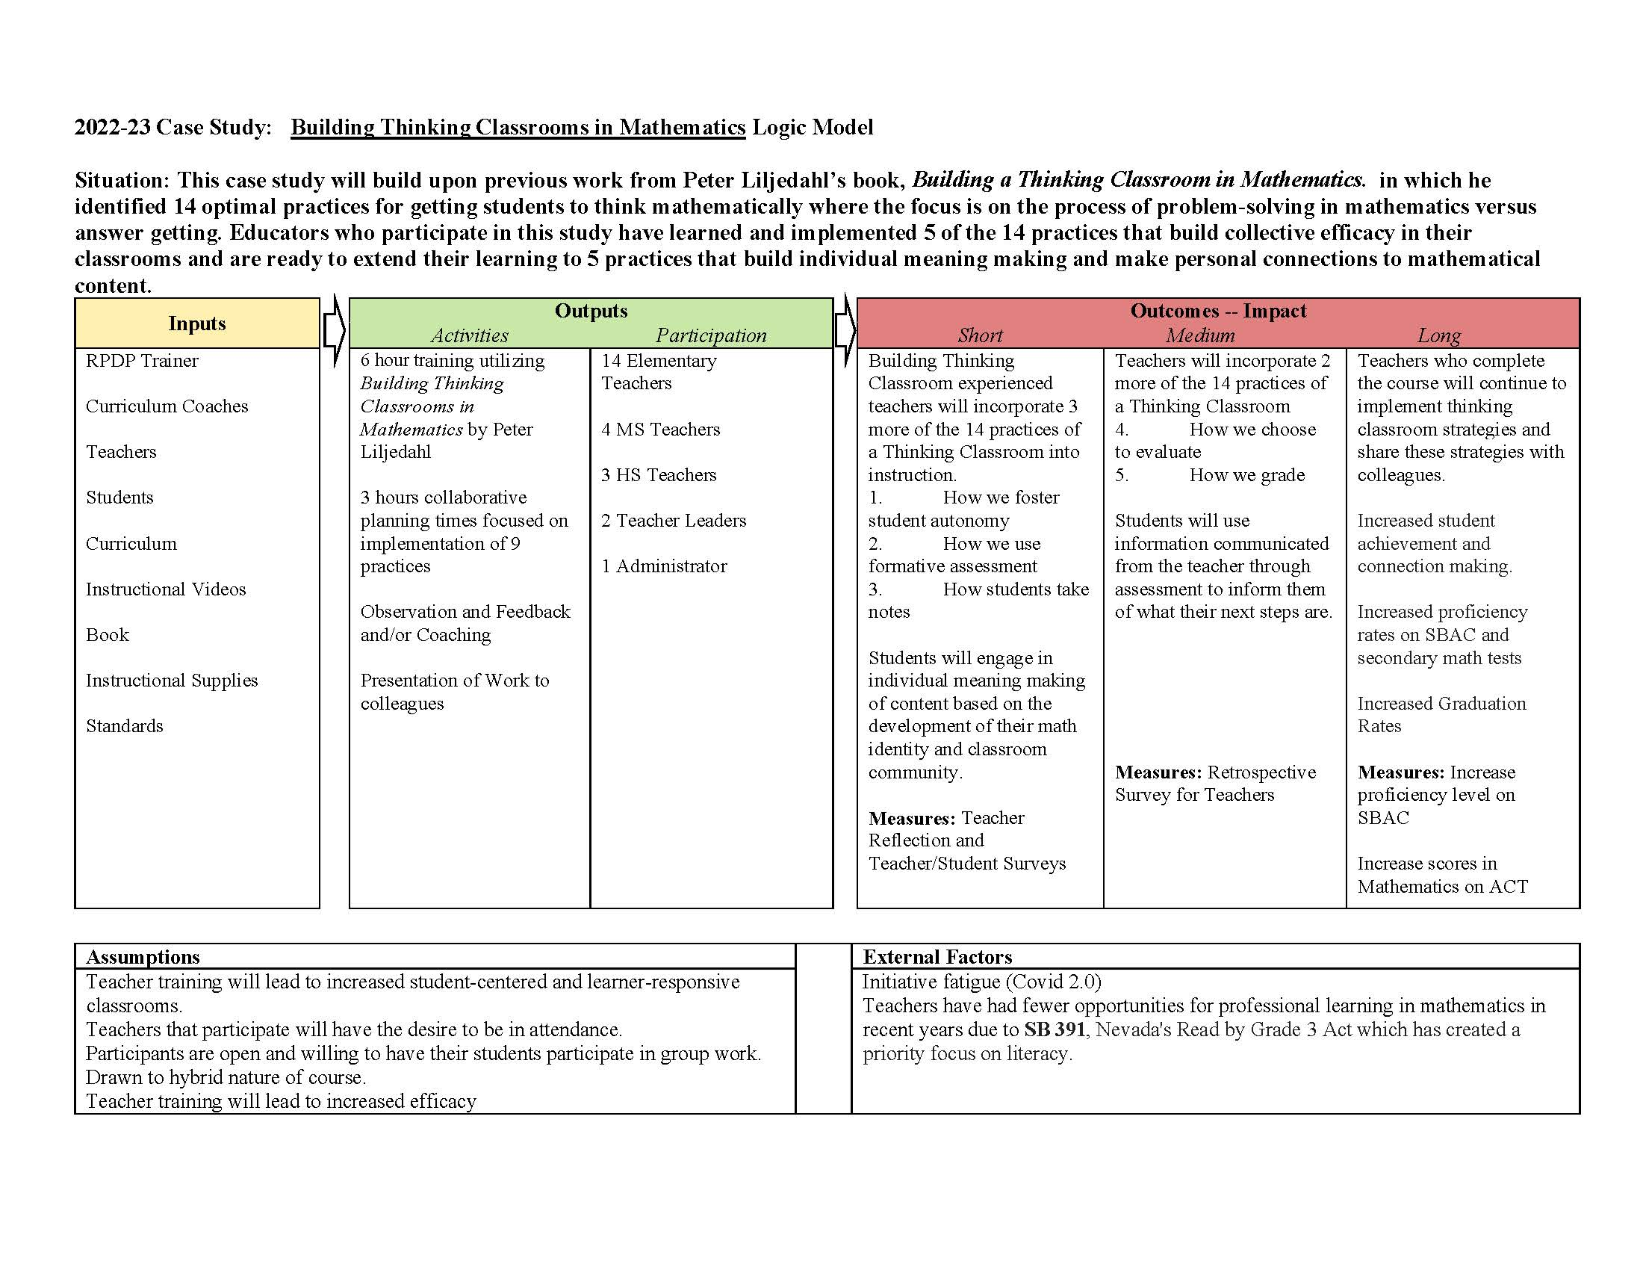
Figure 15: Building Thinking Classrooms in Mathematics Logic Model

Scaffolding Explanations and Arguments in Science

Introduction
“The goal of science is to develop a set of coherent and mutually consistent theoretical descriptions of the world that can provide explanations over a wide range of phenomena” (National Research Council [NRC], 2012, p.48). This goal, outlined in A Framework for K-12 Science Education, positions students making sense of puzzling phenomena at the forefront of how science instruction is taught and learned. Students are expected to engage in the nexus of the three-dimensions (Science and Engineering Practices, Disciplinary Core Ideas, and Crosscutting Concepts) outlined in the Next Generation Science Standards (NGSS) to explain naturally occurring phenomena and how or why they occur. The three-dimensions weave together requiring students to engage in the Science and Engineering Practices (SEPs), to investigate the phenomena and underlying scientific principles known as the Disciplinary Core Ideas (DCIs), while using the Crosscutting Concepts (CCCs) a set cognitive tools to help them understand how the data collected explains the phenomenon under investigation. Constructing Explanations is one of eight SEPs and lies at the core of what science as a discipline is about. Explanations in science answer how or why questions about a scientific phenomenon and provide the causal account that links scientific theory to the specific observations of the phenomenon and under what conditions it occurs (Schwarz, Passmore & Reiser; 2017).
Developing explanations is critical at all grade levels, kindergarten through twelfth, as it supports students in capturing what progress has been made towards understanding a phenomenon and reveals gaps making clear where future investigations need to focus. However, scientific explanations differ from the everyday use of the term. For example, students may be asked to ‘explain the procedure we need to use to solve the math problem?’ This illustrates a request to follow a set of directions or a procedure rather than a causal account of why an event occurs (NRC, 2005). As a result of the discrepancies in definitions and uses across disciplines, teachers need to engage in professional learning to support and scaffold students’ understanding of the characteristics of explanations and how those characteristics differ across disciplines.

Instructional Context
This study takes place in a small rural elementary school serving kindergarten through sixth grade. The school has applied to be on the Governor’s STEM Designated School list. One criterion within the designation guide focuses on various attributes displaying the level at which students apply their learning in authentic, age-appropriate problem-solving contexts. Two of the attributes within this criterion are (1) disciplinary integration and (2) standard alignment (Office of Science, Innovation, and Technology [OSIT], 2023). These two attributes are areas of focus for this study. The description level for the two attributes can be found below (Figure 1), with the goal of the school reaching either “developing” or “establishing” for each attribute. As a result, the school performance plan includes goals for the integration of content with a foundation of science to support student learning.
Attribute | Exploratory | Developing | Established | Model
2.1.4 Disciplinary Integration | Students experience disciplinary instruction, wherein content areas are learned separately, or learned within a topical theme. | Students occasionally experience multidisciplinary instruction that crosses two or more subjects/courses. | Students experience interdisciplinary instruction that crosses two or more subjects/courses throughout the year. | Students experience transdisciplinary instruction that crosses subject areas/courses most of the time
2.1.5 Standard Alignment | STEM learning prioritizes themes or projects rather than grade-level expectations (standards, grade-appropriate rigor, NGSS 3 Dimensions). | Instruction is aligned to grade-level standards and has grade-appropriate rigor, but STEM learning is not yet 3Dimensional | STEM instruction is aligned to grade-level standards, has grade-appropriate rigor, is 3Dimensional | Comprehensive grade-level standards have been meaningfully organized into year-long pacing that ensures all students the opportunity to work toward mastery of all grade-level NGSS expectations through STEM experiences.
Figure 16: OSIT Category II The Classroom (OSIT, 2023)
At the school, there are three teachers in each grade, kindergarten through fourth, and two teachers in each fifth and sixth grade. Professional learning opportunities were planned for the 2022-23 school year with four required full staff sessions totaling eight hours, four required grade level sessions totaling four hours, and additional optional work within the classrooms of individual classrooms in second, third, fourth, and sixth grades ranging from two to four hours each.

Initial Data and Planning
Over the course of the 2022-23 school four full staff professional learning sessions totaling eight hours were held to present the practices, tools, and tasks which have shown significant impacts on student learning of science and STEM. The focus of these whole staff sessions included presenting strategies that positioned high-quality science and engineering education as a foundation for integrating the Common Core State Standards in English Language Arts (CCSS-ELA). The decision was made to position STEM content, specifically science and engineering, as the basis for integration while utilizing CCSS-ELA as a tool to support the overarching goals for the school. Specifically, determining how to incorporate writing scientific explanations into each grade level. There is evidence of writing across content areas, but the focus of this work surrounded how to write explanations specific for the discipline of science, while maintaining grade appropriate requirements for planning, This includes scaffolding students’ abilities in the scientific practices outlined in the NGSS of develop scientific explanations, modeling, arguing from evidence, designing investigations and solutions, and problem-solve with one another. A requirement of integrating different content areas includes attention to rigorous, grade-level standards as both a tool for making sense of a content area, and as a purpose to learn the required content. Commonly, when integrating language (reading, writing, speaking, and listening) into other content areas such as science, the specific language standards are more broadly implied rather than explicitly tied to grade-level standards during planning. As a result, the purpose of the language is not developed and therefore does not provide students with the tools to explain the science adequately. An example would be a fifth grader writing an explanation of a scientific phenomenon, but without explicit planning and scaffolding for integration of the grade level writing standards, the result is writing more reflective of a third-grade student. To remedy this type of situation, sessions were planned to provide teachers with strategies to maintain grade-level standards in both science and ELA and use ELA as a tool to support student sense-making of science content.
To determine changes to teaching and planning several sources and methods of data were proposed. Teacher efficacy is a strong indicator of what is happening in the classroom. Teachers who are confident in their science teaching tend to have strong pedagogical content knowledge in science, and are willing to improve their practices and implement new strategies into classrooms. The Teacher Efficacy and Attitudes Toward STEM (T-STEM) Survey (2012), a revised survey based on the Science Teachers Efficacy and Beliefs Instrument (STEBI-A; Riggs & Enochs, 1990) was used to gather changes in teacher’s self-efficacy in science and changes to how often students engaged in scientific practices such as creating explanations, engaging in scientific dialogue with peers, modeling, etc. Additionally, anecdotal and observational data was collected while working with individual teachers or moving through classrooms.

Delivery of Services
Over the course of the academic school year the staff engaged in a range of professional learning. Each quarter the whole staff met to bolster their understanding of the Science and Engineering Practices from the NGSS and how to leverage these practices to promote student learning and understanding of scientific phenomena. The first of these sessions was three hours with the remainder being one hour each. These whole staff sessions allowed us to dive into the importance of having students develop scientific investigations and how the process iterates throughout a unit of instruction. Scientific explanations are not the same as explanations in other academic disciplines, requiring teachers to develop an understanding of the complex nature of domain specific language and its use. During these sessions teachers were presented with structures to promote the need to write an explanation – students asking specific “why?” and “how?” questions about a science phenomenon including developing a type of driving question board formatted as an ‘I Notice…./I Wonder…’ board. Once appropriate questions were identified the use of investigation and modeling to gather data was introduced with the idea that an explanation can’t be developed until data is collected. At this point teachers could begin to see how developing explanations fit into an instructional unit meaningfully, but were not sure of the specific elements and format for explanations within science. In science, an explanation is a series of linked cause and effect statements based on data collected through investigations that lead to answering how or why a phenomenon occurs. The general format presented to all grades was [factual statement, causal link, factual statement…] until enough facts were included to explain the phenomenon. During these sessions, there was limited time for grade specific adaptations or application of the big ideas. Instead, the strategies were more generalized for all grades.
In order to determine how these strategies and big ideas fit into individual grades, teachers used their weekly one-hour PLC time to work on building them into units of instructions. The grade-level PLC time was spent building strategies into a unit at a time and then trying it over the week to debrief the next PLC time. The progression started with introducing a phenomenon to students and developing an I Notice/I Wonder Board from which the class would choose questions to investigate. This was planned to be very guided by the teacher to support students in recognizing the types of questions that lead to explanations. The next PLC built in what a student model should include and how to support students developing the model, including identifying components of the model, labeling, and verbally explaining how the components are linked. Although the SEP of modeling was not the focus of the professional learning experiences, modeling is an integral component to combine with developing an explanation as the two practices are closely linked. The discussion around developing explanatory models steered towards how much could students do on their own versus how much support did the teacher need to provide. Since explanatory modeling was new to almost all the teachers and students, it was decided that modeling would be done as a class developed consensus model, with the teacher guiding the development of the model through class discussion and identifying the appropriate components and interactions to help guide the students’ written explanations. Finally, the discussion of how to support students in developing an explanation fit into the PLCs. At each grade, what could that look like and how could it be scaffolded effectively? Early elementary grades decided upon either written words within sentence frames, or verbal explanations that used the same structure of a singular [factual statement, causal link, factual statement]. Whereas upper grades planned to use more open-ended structures, requiring more writing and causally linked statements that supported the class consensus model.
The finalization of these components rounded out the project for the year. Unfortunately, due to weather conditions cancelling school and training days, lack of subs to cover classes during PLC time, state and district testing windows opening, and spring break the argumentation piece was not touched on. Upcoming years could provide opportunities to continue the work and focus on the practice of argumentation and how it weaves into science instruction.

Results and Reflection
To determine changes to teachers’ self-efficacy and confidence in teaching science, and how often students in their class engaged in the various science and engineering practices during instructional time, the Teacher Efficacy and Attitudes Toward STEM (T-STEM) Survey was used (Friday Institute for Educational Innovation, 2012). The survey was based on the Science Teachers Efficacy and Beliefs Instrument developed in 1990 by Riggs and Enochs, and has been used extensively to determine changes for science education research. Data were collected as a pretest/posttest format and a paired samples t-test was applied to the data to determine if changes were found over the course of the year. There are two parts to the survey that were used. The first measured changes to teachers’ self-efficacy and confidence in teaching science and consisted of eleven statements each with a five-point Likert scale ranging from “Strongly disagree” to “Strongly agree” with a neutral option in the middle. The second part measured teachers perceived changes to how often students would engage in various aspects of the Science and Engineering Practices and had fourteen statements also with a five-point Likert scale ranging from “Never” to “Every time” with “about half the time” as the middle option. The results of the paired samples t-test can be found in Table 1.

Table 22: Results of Teacher Efficacy and Attitudes Toward STEM Survey
 | Pre | Post | N | t | p-value
Efficacy and Beliefs | 3.340 | 3.707 | 18 | 8.811 | <0.001
Engagement in SEPs | 3.201 | 3.373 | 16 | 2.881 | 0.011
Create explanations | 2.813 | 3.313 | 16 | 2.449 | 0.027
Engage in content-driven dialogue | 3.438 | 3.313 | 16 | 1.464 | 0.164

In addition to the paired samples t-test on the groups of data, a separate analysis was run just on two separate statements of how often students engaged in (1) “Create reasonable explanations of results of an experiment or investigation”, and (2) “Engage in content-driven dialogue” since those related directly to the professional learning that was provided. Results (found in table 1) indicate teachers did engage students more in creating explanations from pretest to post survey (t = 2.449, p = 0.027, d = 0.612), but did not necessarily engage students more often in content-driven dialogue (t = 1.464, p = 0.164, d = 0.366). These results suggest teachers intentionally integrated developing explanations into instruction, however, may not have used those opportunities to verbally explain. This aligns with teachers planned their units of instruction during PLC time. Teachers, especially in the upper grades, built written explanations into lessons, but did not plan in time for discussion around the explanations. Had the professional learning covered more argumentation components this may have changed how often teachers engaged students in using dialogue to support developing those explanations.

Conclusion
Providing professional learning focused specifically on integrating language standards from the CCSS into science instruction can contribute to increased self-efficacy in teaching science for teachers, and also increase the perceived opportunities for students to engage intentionally with SEPs from the NGSS. When engaged with specific strategies for classroom use, teachers are able to transfer the strategies into planning and instruction. The explicit strategies to support students in engaging in developing explanations in science can encourage rigorous language development outside of language arts instruction and help students and teachers see the natural connectedness of various content areas. Although teachers were able to connect developing explanations to science, more work needs to be done surrounding the connection between scientific argumentation and explanations in planning for instruction and in the classroom.

References
Friday Institute for Educational Innovation (2012). Teacher efficacy and beliefs toward STEM survey. Raleigh, NC.

National Research Council. (2005). How students learn: Science in the classroom. Washington, D.C.: The National Academies Press. https://doi.org/10.17226/11102.

National Research Council. (2012). A framework for K-12 science education: Practices, crosscutting concepts, and core ideas. Washington, D.C.: The National Academies Press. https://doi.org/10.17226/13165.

Office of Science Innovation and Technology (2023). Designation action guide. https://osit.nv.gov/uploadedFiles/osit.nv.gov/Content/STEM/Designation%20Action%20Guide%20Spring%2023.pdf

Riggs, I., & Knochs, L. (1990). Towards the development of an elementary teacher’s science teaching efficacy belief instrument. Science Education, 74 625-637.

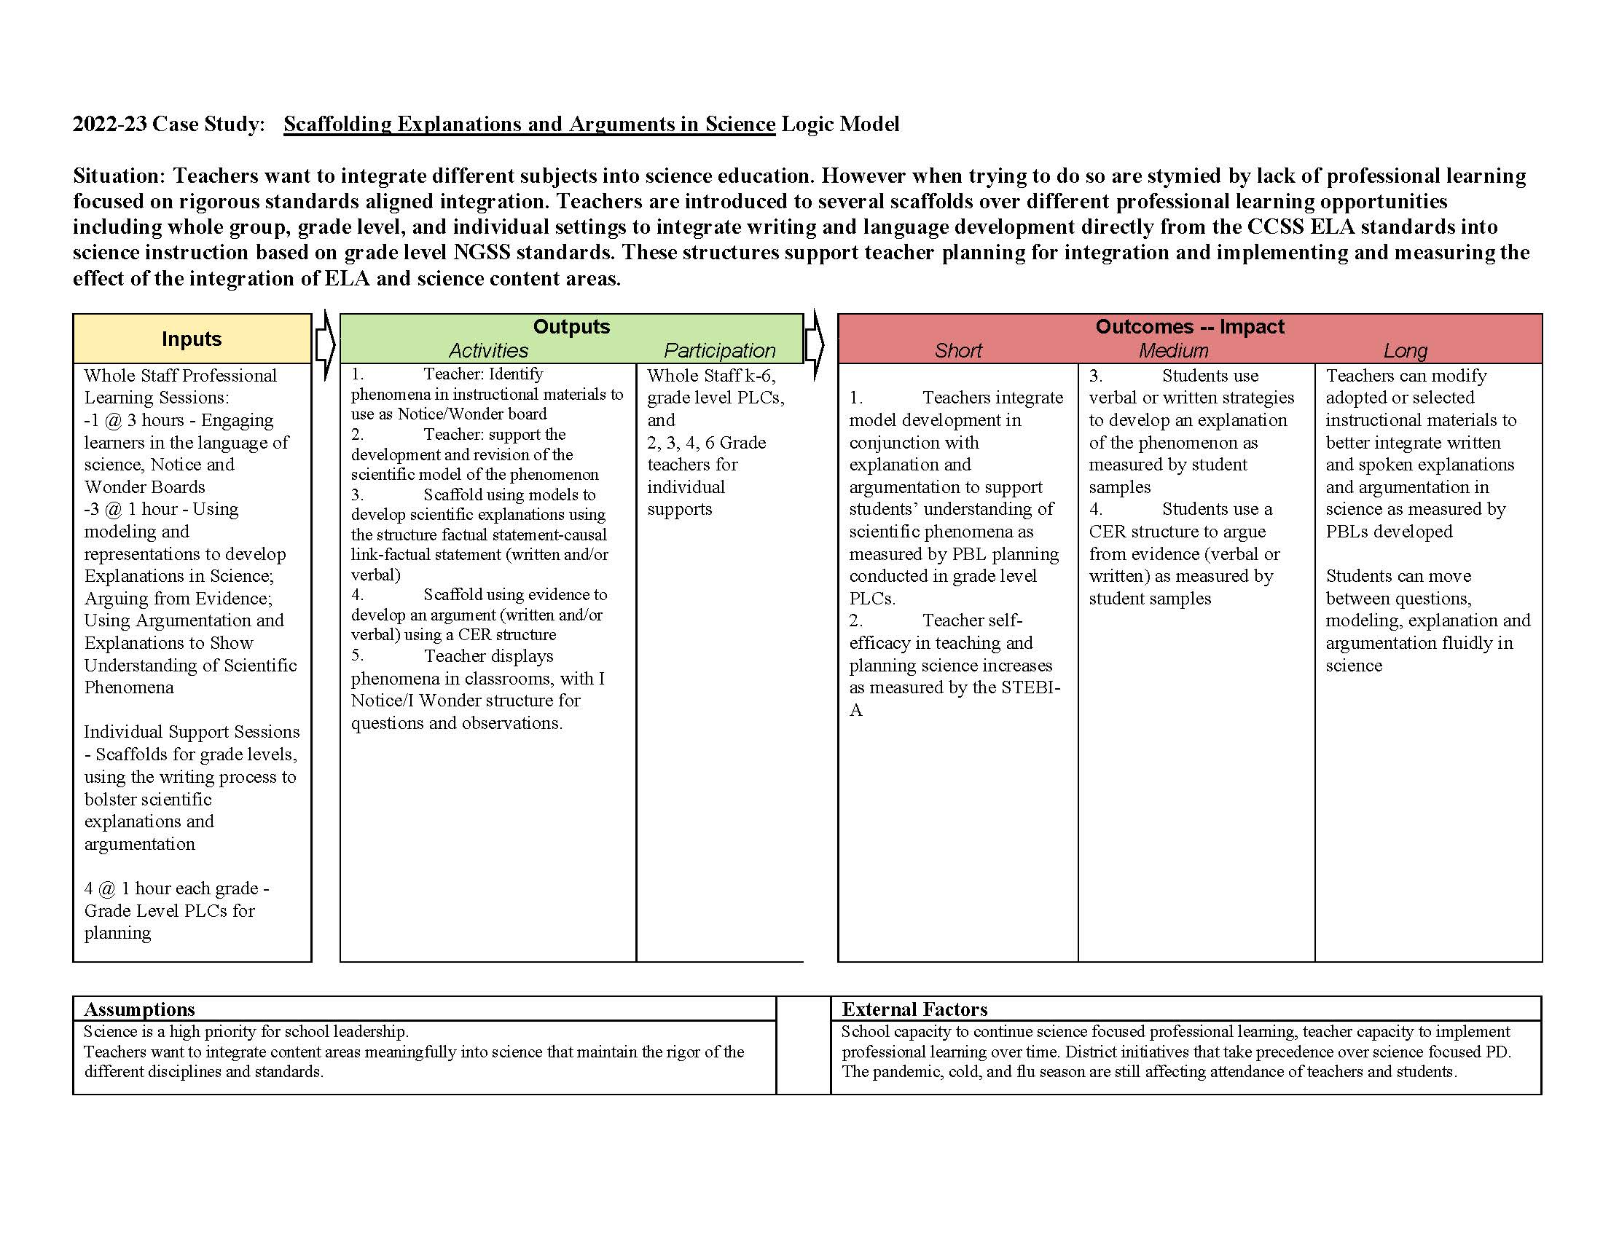
Figure 17: Scaffolding Explanations and Arguments in Science Logic Model

Leading Collaborative Teams

Introduction
The post-Covid educational climate has been marred by teacher burnout. The near constant call for teachers to cover other classes during their prep time on top of steadily climbing class sizes has led to a major crisis in teacher retention nation-wide (Westphal et al, 2022). Because of these circumstances, professional learning for these educators has shifted to the back burner. Research has shown that ongoing professional development focused on teacher quality and capacity building leads to increases in student achievement (Learning Forward, 2022). However, professional development and opportunities to collaborate with staff members are often understood to be an extra burden rather than essential building blocks of educator efficacy. A recent EdChoice survey of 686 teachers found that roughly 45% of educators spent between 3-5 hours every week in required committee or staff meetings while 43% stated they spent 3-5 hours a week on professional development (McShane, 2022). This shows the degree to which teacher time is stretched outside of instructional minutes, but whether the time spent in meetings or professional learning was productive varied. What if there was a structure to maximize group interactions (meetings and/or professional learning)? How can we make staff collaboration more meaningful and impactful for strapped educators? How can we make professional learning beneficial to educator efficacy rather than robbing educators of their precious time? The answers to these questions were the basis for the design of Leading Collaborative Teams.
The goal of Leading Collaborative Teams in-service course was to build the capacity of teacher leaders to effectively lead staff meetings and professional learning through intentional design and meaningful collaboration. Through the determination and delivery of clear expectations and skills and strategies that support those expectations, teacher leaders learned to develop collaborative structures and practices that better utilized time (Lipton & Wellman, 2011). Additionally, participants learned ways to build equity of voice within their working groups to increase belonging and collegiality at their sites.

Instructional Context
The Washoe County School District (WCSD) is the second largest school district in Nevada and encompasses Reno-Sparks and its surrounding areas. The district houses 110 schools and serves approximately 61,599 students and over 3,900 teachers (Public School Review, 2023). The student-to-teacher ratio is 16:1 and with a graduation rate of 85% (Public School Review, 2023). The minority enrollment for the district is currently at 58%, and most of that population is Hispanic (Public School Review, 2023).
The Leading Collaborative Teams in-service course participants were comprised of four teachers and eight Teachers on Special Assignment (TOSAs). Of the eight TOSAs, seven were Building Learning Facilitators and one was an English Language Development (ELD) facilitator. The 12 participants also represented three Title Schools and one Alternative School.
It should be noted that the Building Learning Facilitator role for TOSAs was part of the Elementary and Secondary School Emergency Relief (ESSER III) funds and will be sunsetting in June 2023 (WCSD, 2023).

Initial Data/Planning
Based on WCSD’s prioritization of district-wide implementation of Professional Learning Communities (PLCs), the addition of a Building Learning Facilitator at each elementary school site with ESSER III funds, and the continued need for educators to collaboratively problem-solve the trainers designed an in-service professional learning course to meet this need. It was determined the participants would each be given a copy of Groups at Work and engage in professional learning based on Laura Lipton and Bruce Wellman’s research. The challenge with this group of educators was the varying levels of knowledge, skills, and experience. The trainers designed the professional learning based on Nevada’s nine Standards for Professional Development by incorporating implementation and evaluation expectations with feedback surveys between each session (2018). The standards served as a guidepost for professional learning and a way to emphasize links to the Nevada Educator Performance Framework (NEPF) and how designing professional learning and meeting outcomes for adult learners mirrored best instructional practices for our teachers and students (2019). In order to mitigate the challenge of differentiating the professional learning for the varying levels of experience, knowledge, and skills, the NWRPDP facilitators outlined learning intentions that acknowledged the diversity of the groups’ understanding.

Delivery of Services
Leading Collaborative Teams met for six, in-person, sessions consisting of two hours and 45 minutes. During each session, trainers led participants through one or two of the seven Practices and Premises developed by Laura Lipton and Bruce Wellman. The premises serve as guiding principles for leading groups. They include: groups develop and their development can be positively influenced, human behavior has a biological and sociological legacy, there are predictable dynamics in groups, work sessions should be learning sessions, investing energy in design saves energy in delivery, shaping the discourse determines the direction, and you can’t lead where you won’t go (Lipton & Wellman, 2011). Participants engaged in activities from Groups at Work to help them understand the premises for leading teams. Then, trainers would guide them through practices aimed at fostering the premises in their own leadership and instructional design. Practices included activities aimed at building relationships within groups, processing learning as a group, and collaborating on tasks centered around furthering student learning (Lipton & Wellman, 2011). Time was set aside at each session for participants to report and reflect on any practices they had tried with the groups they led. By the final session, participants were expected to have tried at least one of the practices.
Participants chose a variety of types of groups to lead and test out these premises and practices. Some classroom teachers decided to implement this learning with their students while some participants were part of school leadership teams and implemented this learning within their professional learning communities (PLCs).
Trainers led participants through strategies to develop learning intentions and working agreements for the group to help maintain focus and foster safe conditions for collaboration. Participants agreed on the following learning intentions:
- Develop collaborative skills for ourselves and others.
- Understand and apply premises and practices for leading groups.
- Engage in professional learning content to affirm, develop, and/or enhance our skills in supporting the educators we serve.
- Identify practical strategies we can use tomorrow.

To measure these learning outcomes the trainers designed the professional learning to incorporate strategic collaboration in understanding the practices and premises for leading groups. The activities selected for relationship building, processing, or completing a task related to the professional learning were captured on a “Pedagogical Moves and Strategies” chart that was displayed during the training and revisited at the end of each session to discuss how teachers could use similar strategies with their teams or in their classrooms with students.
Participants also developed and stayed true to the following working agreements as outlined in Table 23:
Table 23: Leading Collaborative Teams Working Agreements
We agree to holding a safe learning space for ourselves and others.

We agree to ask for clarity and to listen to understand.

We agree to be present and thoughtfully engaged.

We agree to maintain confidentiality (“stories stay-lessons leave”).

These working agreements were posted and reviewed at each session. At any time, they could be amended to fit the needs of the group. One of the participants used the process of establishing working agreements with her grade-level team to apply the first premise of leading teams; groups develop and their development can be positively influenced (Lipton & Wellman, 2011).

Results and Reflection
Participants were asked to reflect on their learning after our last session in December of 2022. They were given a post-reflective survey to measure their increase in knowledge around the Practices and Premises and their efficacy in implementing the strategies they learned throughout the in-service course. The results are outlined in Table 24:

Table 24: Post Reflective Survey Data
 | Mean Before | Mean After | Increase | t-score | p-value
My knowledge of the Practices and Premises for Group Development. | 1.40 | 4.30 | 2.9 | -12.429 | <.001

The self-rating for “My knowledge of the Practices and Premises for Group Development” changed from a mean of 1.40 before the course to 4.30 after the course which was an increase of 2.9. The t-score was –12.429 and the p-value <.001. These values show statistically significant improvement.
Also, participants were asked about how much they were continuing to use the strategies they learned in the course with their groups several weeks after the course completed. When asked, “Did you utilize the vocabulary, structures, and/or strategies shared from Groups at Work?” 100% of participants answered “yes”.
In the same survey, participants were asked, “Please share about your implementation of the strategies shared during our course. With which group did you implement? What strategies did you try? How do you feel the process went?” Examples of participant responses are outlined in Table 25:
Table 25: Participant Responses about Implementation of the Strategies
“In PLC’s: Looking Back/Looking Forward. It was a great way to get conversations rolling. It opened up the discussion which then authentically led to desired changes in the PLC format.”
“I used the strategies with students, and planned to use the strategies with a group for whom I was providing professional development. The process with students has been excellent. I have created valuable opportunities for equity of voice, specifically with English learners which is really, one of the most important elements of their language development.”
"I used Go to Your Corners with a fifth-grade class and Synectics with a leadership group. I feel like it went well both times. Easy to implement, lots of interaction, and positive feedback.”

Participants were also asked, “How has participation in this course influenced your design practice?” Examples of participant responses are outlined in Table 26:
Table 26: Participant Responses on Design of Practice
“Heightened my awareness of others’ perceptions and preferences to better design inclusive group discussions.”
“The course has given me many strategies to use and ways to think about group dynamics and different types that bring different approaches to group work.”
“I have truly learned to consider group dynamics, individual personality types, and work towards equity of participation within groups as I plan learning sessions.”
“I have a much deeper understanding of what it takes to lead a collaborative group and will continue to reflect on my current leadership as well as implement these newly learned strategies into my future leadership.”

In March, three months after the end of the in-service course, participants were sent a follow-up survey. The survey was completed by 40% of the course participants and all of them indicated they were still using the structures and strategies for leading teams. Another question asked if the participants would recommend the course to a colleague and 100% said yes. Based on this feedback and the need for effective collaboration in education, the trainers will again offer this course to the Northwest region during the fall of 2023.

Conclusion
The design of this professional learning experience provided participants with an in-depth understanding of design theory and application of practices and premises for leading groups. The course trainers were focused on helping those in leadership positions, both within and outside the classroom, deliver more meaningful professional learning experiences for their colleagues. Based on the data collected from the participants at the close of this training and in the weeks and months that followed, it was clear that participants felt more efficacious in the delivery of professional learning through the grounding and intentionality that the Premises and Practices provide.

References
Learning Forward. (2022) Standards for Professional Learning. Author.
Lipton, L. & Wellman, B. (2011). Groups at work: Strategies and structures for professional
learning. MiraVia.
Lipton, L. & Wellman, B. (2011). Leading groups: Effective strategies for building professional
community. MiraVia.
Nevada Department of Education. (2018). Nevada’s standards for professional development.
Retrieved from https://doe.nv.gov/uploadedFiles/ndedoenvgov/content/Educator_Licensure/NVStandardsforPD.pdf
Nevada Department of Education - NEPF. (July 2019). Rubric with evidence and descriptions –
Teacher professional responsibilities standards and indicators. Retrieved from https://doe.nv.gov/uploadedFiles/ndedoenvgov/content/Educator_Effectiveness/Educator_Develop_Support/NEPF/Teacher/Teacher-Professional%20Responsibilities%20Rubric.pdf
Public School Review. (2023) Washoe County School District quick stats. Retrieved from https://www.publicschoolreview.com/nevada/washoe-county-school-district/3200480-school-district/elementary
Westphal A, Kalinowski E, Hoferichter CJ, Vock M. (September 2022) K-12 teachers' stress and burnout during the COVID-19 pandemic: A systematic review. Frontiers in psychology, 13,920326. https://doi.org/10.3389/fpsyg.2022.920326

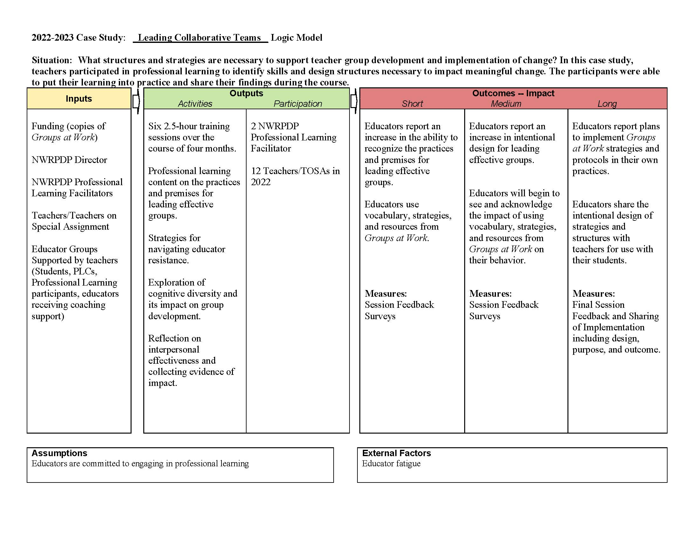
Figure 18: Leading Collaborative Teams Logic Model

National Board Maintenance of Certification (MOC) Cohort: Becoming a More Efficacious Teacher Leader Through the National Board MOC Cohort

Introduction
As teachers set out to start their National Board journey, little do they know that their life as an educator will forever change. Spending anywhere from 250-450 hours over the course of 1-5 years to become Nationally Board Certified, many teachers express that their initial driving force to become an accomplished teacher is the 5-8% financial incentive that they receive from the state of Nevada once they certify. However, once they earn the recognition from their family and friends, prestige and the ability to add those four letters…..NBCT to their email signature, they soon realize that in “completing” the process, “You can never be accomplished enough.” (Eladia Serna, NBCT California). Achieving certification becomes a way of life and teachers become even more dedicated to providing the highest quality education to their students and continue to seek out opportunities for ongoing professional development. With less than five years until their certification expires, the start of the Maintenance of Certification begins, and they find themselves resuming their journey to further themselves professionally. Knowing that Certified teachers must renew their certification every five years by participating in the Maintenance of Certification process (MOC), the National Board Certification process is designed to ensure that accomplished teachers maintain a positive impact on student learning and become more efficacious leaders at their school sites. While becoming accomplished themselves, this raises the question; How do MOC candidates leverage their knowledge from the National Board Certification process to directly impact educators at their school sites and/or at a district level beyond themselves?

Instructional Context
The 2022-23 MOC participants included: 45 teachers from elementary, middle school and high schools located within districts around Northern Nevada (Douglas, Carson, Washoe County, Churchill and Lyon County). Within our cohort, teachers exhibited a variety of diverse roles and experience levels, ranging from 10 years to 36 years as an educator. Roles included: 24 Elementary Generalists who taught in grades first-fifth grade, two-K-5 music teachers, two building learning facilitators, one dean of students, two English as a second language teachers, three English Language Arts Teachers, three Social Studies Teachers, one Chemistry teacher, one Psychology Teacher, one AP Human Geography Teacher, two AP American Government teacher, two English Language Facilitators and a Librarian. Within our MOC Cohort, teachers originally certified over 10 years ago, or within the last five years and seek out the Northern Nevada MOC/Renewal cohort to network with other educators around Northern Nevada, build their capacity around the MOC process and obtain support, coaching and feedback throughout their MOC journey.

Educators have a variety of reasons why they Maintain their National Board Certification:
- Professional Growth: As part of their ongoing journey, the National Board process is designed to provide professional development and ongoing learning throughout an accomplished teacher’s career. Therefore, to keep their certification active, teachers are empowered to continue collaborating with their colleagues, participate in reflective practices, and stay abreast the latest research and best practices within their educational field.
- Career Opportunities: Many NBCT’s work towards career advancement opportunities, as Maintaining National Board Certification opens pathways, which include leadership roles within their schools or district (i.e., Administrators, Facilitators, Mentors, Clubs and Organization Chairs, Department Leads, Coaches, Curriculum Creators, Specialists, etc.).
- Increased Earnings: In Nevada, teachers continue to receive a 5% salary incentive for maintaining their certification (WCSD educators earn an additional 3%). Maintaining certification provides educators with the ability to extend their financial NBCT incentive, which provides more opportunities for them to pursue their personal and professional goals.
- Recognition: National Board Certification has been recognized as one of the most distinguished professional developments designed for teachers. NBCT’s who continue to maintain their certification, demonstrate their continued devotion to their profession and ensure that students receive the highest quality education.
- Student Learning Improves: Educators who continue to maintain their National Board certification are better equipped with tools/knowledge to create student-centered classrooms and become more diagnostic and reflective with their practices to empower and critical thinkers and confident learners.

Initial Data and Planning
Between May 2022-August 2022, 45 NBCT’s expressed interest in joining the Northern Nevada MOC/Renewal Cohort, as 17% of their National Board Certificates were due to expire in 2023 and 83% in 2024. Teachers voiced through MOC information meetings and emails that they needed support navigating through the MOC requirements and process, which is vastly different from their initial certification. To support this need, a virtual Cohort was created, so teachers in each of the six counties could participate in each of the eight class sessions, held once a month. In addition, two optional in-person support sessions were offered to participants. Three CSP’s (candidate support providers) facilitated the classes and provided coaching sessions and feedback to candidates as they worked on their written commentary, SOP’s (samples of products/evidence) and videos. At the end of each class session, participants completed an exit ticket with reflections about their take-aways, and goals in moving forward. Exit tickets also provided CSP’s with valuable information about the participants’ needs, so we could adapt our sessions to meet the needs of our diverse learners. On the last class session, participants completed a final self-assessment about their impact as NBCT’s.

MOC Requirements for Renewal:
- MOC candidates must complete Component One, which requires teachers to write an eight-page written commentary and reflect upon two professional growth experiences since their initial certification.
- MOC candidates are required to collect Samples of Products (SOP’s) to show evidence of their professional growth. For example, evidence may include note-takers, blogs, clips of research papers, Power Point slides, or lesson plans to show evidence of professional learning, emails, letters and/or agendas to show evidence of collaboration, etc.
- MOC candidates must complete Component Two, which requires teachers to submit a video with three segments teaching a lesson within their original certificate area. In addition, candidates will submit a five-page written commentary reflecting how the lesson went, next steps with students and goals as a professional.
- MOC candidates are encouraged to show evidence of the Architecture of Accomplished Teaching Helix, their original certificate area standards and the five core propositions throughout their MOC portfolio.

Delivery of Services
Eight virtual sessions were held during the 2022-23 school year. On the first-class session in September 2022, exit tickets revealed that participants wanted a pacing guide to keep them on track throughout the year. To meet this request, a pacing guide was created with homework assignments broken down in a manageable schedule for MOC candidates to use in addition to their busy schedules during the school year. This also ensured continuity within our cohort sessions because homework aligned with the MOC content that was covered.
Excerpt of Pacing Guide for 2022-2023:
Table 27: MOC Meeting Dates and Homework 2022-2023
As part of candidate’s MOC portfolio, the Maintenance of Certification requires them to come up with two Professional Growth Experiences to highlight their work since their original certification. On the September class session, MOC candidates brainstormed possible Professional Growth Experiences in breakout rooms with other candidates (mixed K-12 educators) and contributed their ideas on a Padlet board. Exit tickets showed that 87% of participants felt more confident about selecting their PGE’s after participating in this collaborative activity.

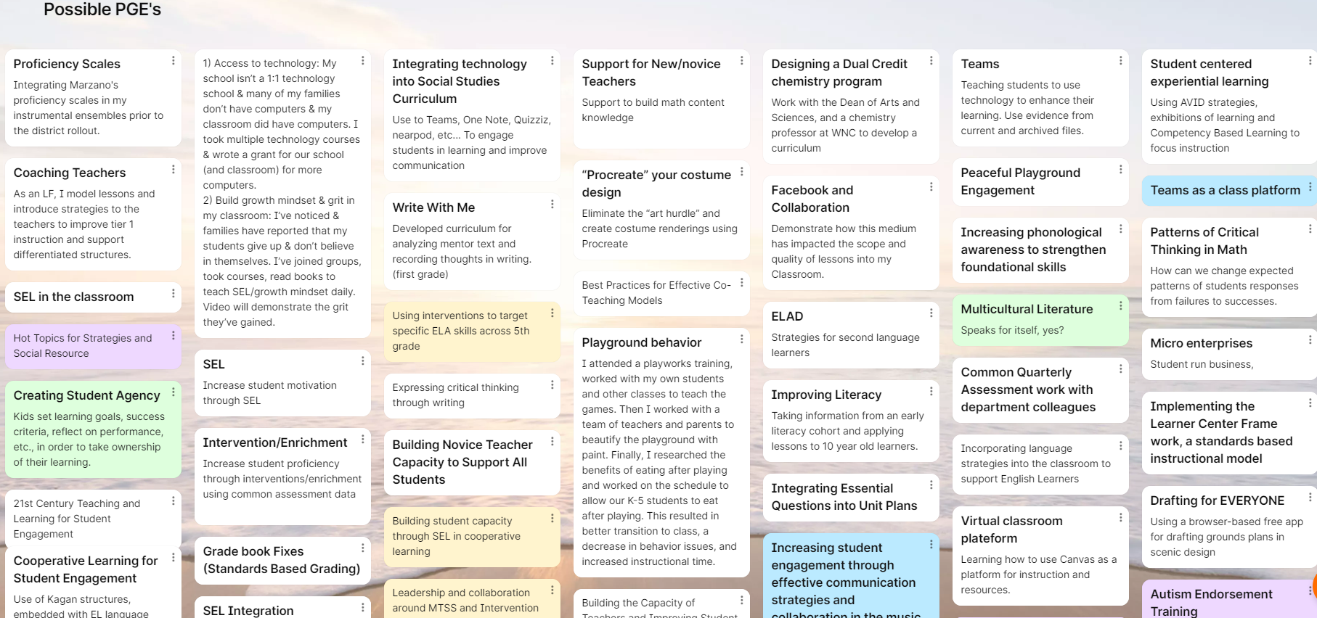
Figure 19: Padlet

Later in the cohort, on the November exit ticket, participants requested samples of the SOP’s (samples of products/evidence) they could use for Component One. To help with this need, MOC candidates received examples of possible artifacts they could use that aligned with the Maintenance of Certification rubric. They were reminded that their SOP’s should exemplify a direct/or indirect positive impact they have made since their original certification on student learning. Candidates could choose evidence such as student work, indirect evidence stemming from their collaborative work with school staff, families, or their community. SOP’s also needed to align with one of their PGE’s (Professional Growth Experience) and demonstrate a positive impact on students. Samples of products could include: student work samples, photographs, Power Point slides, data from student test scores or measures of students’ performance or student growth, testimonials from educators related to implementation of training/mentoring that was provided, quantitative or qualitative data related to student engagement or attitudes toward learning, excerpts of a website, a blog, an article, or a paper that was created, and a summary of the outcomes of a project that was implemented.

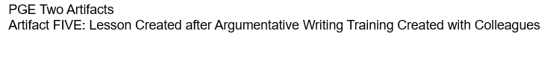

On a December exit ticket, participants expressed uncertainty with understanding the difference between fairness, equity, and appreciation of diversity. To support participants with this need, they participated in a Padlet board discussion, which helped them decipher between the three concepts that must be addressed within their written commentaries. After the Padlet board was created, we created a PDF document with a compilation of the plethora of examples candidates brainstormed.
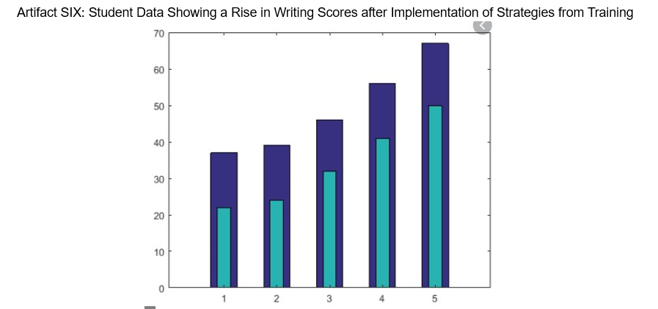
Figure 20: Artifact

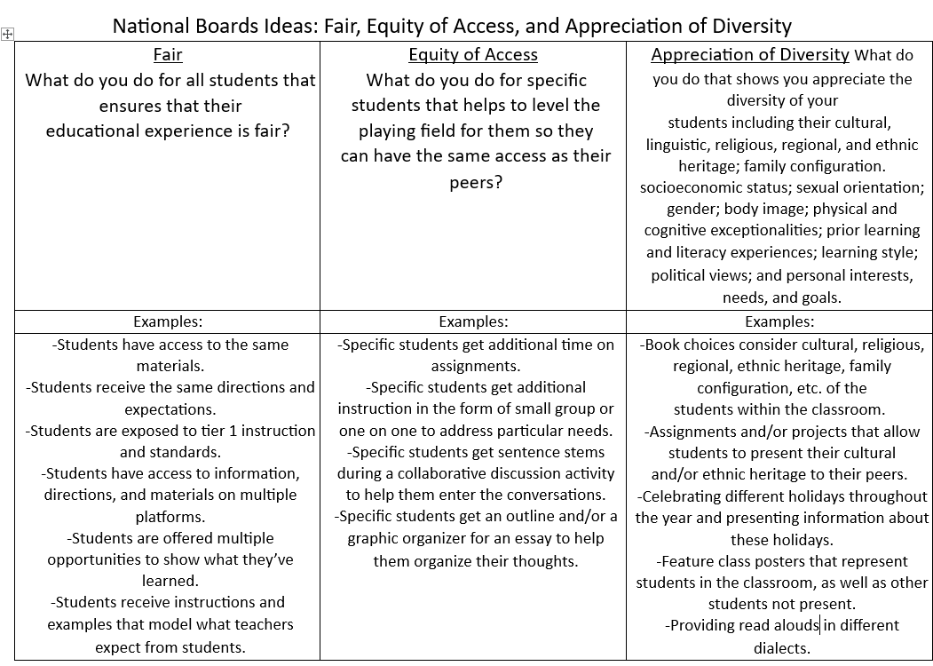
Figure 21: National Boards Ideas: Fair, Equity of Access, and Appreciation of Diversity

Results and Reflection
Through the MOC process, including collaborations with their peers in the cohort and a deep personal reflection throughout the process, National Board-Certified Teachers (NBCTs) support other educators in several ways, including:

- Mentoring: 74% of the MOC participants have served as mentors to other teachers, sharing their expertise, successful instructional strategies, and best practices. They have provided guidance on effective lesson planning, differentiation techniques, assessment strategies, and classroom management approaches. Through observation and feedback, NBCTs have helped teachers refine their teaching methods, incorporated research-based practices, and improved student engagement and achievement.

One fifth grade teacher who works at a Title I school, centered her Professional Growth Experience (PGE) around a year-long Master Lead Teacher Program. This opportunity offered her support in coaching other educators, mentoring two student interns, and a novice teacher. As part of her Master Lead Teacher work, she participated in tasks and assignments such as reflecting on recorded coaching conversations, which prepared her to problem-solve challenges with her interns and move through challenges in a productive way, benefiting student learning. The student intern she supported during the Master Lead Teacher project is now a full-time second grade teacher, commenting, “To this day my students are still benefiting from the mentorship I was given during my student internship. Many of the components (e.g., boundaries, procedures, and clear communication) needed for successful student learning were taught and modeled by my lead teacher, Mrs. G.” Students benefit from having teachers with confidence in their practice and a support system behind them. Next Steps for this fifth-grade teacher will be to join the Teacher Leadership pool so she will be eligible for additional coaching and mentoring opportunities in her district. She is facilitating a book study for educators at her school site about coaching conversations and hopes to grow the number of mentors in her building.

- Professional Development: 71% of MOC candidates have facilitated professional development opportunities for other teachers, including workshops, trainings, and peer-to-peer learning opportunities. They share their expertise on specific topics such as assessment, data-driven instruction, integrating technology, or supporting diverse learners. By designing and delivering professional development opportunities, NBCTs help teachers expand their knowledge and skills, fostering a culture of continuous learning and professional growth.

One third grade teacher from a Title I school took part in a teacher leadership cohort called Teachers Leading Change Cohort. In this cohort, she engaged in an action research project where she focused on the use of student driven self-assessments to promote growth in her classroom. She led a school wide professional development and began meeting regularly with other teachers in her building, encouraging them to observe her use of self-assessment tools across the curriculum. She taught teachers to look deeper at the objectives they had for student learning to create standards based, student driven rubrics that the students used to set goals and analyze their own learning. One teacher commented, “Ms. W. taught me through examples in her own classroom and through, truly, hours spent with me, on in-depth analysis of my students’ work samples, guiding my ability to engage my training. She helped me put the pieces together to engage my students in the most meaningful and powerful learning I have ever experienced as a teacher.” Next Steps for this third-grade teacher will be to continue to share her work with her third grade level colleagues in a PLC setting. She has taken the student self-assessments one step further and created peer feedback opportunities with her students, commenting, “I am seeing my students develop strong communication and self-reflection skills. I think it is important to share the strides my students are making using peer feedback. Showing student samples of peer feedback forms and different ways to utilize it in different subject areas will help my peers feel more open to taking on the challenge of trying something new.
- Collaboration: 97% of MOC participants reported that they are now more often sought-out members of collaborative teams within their schools or districts. They contribute their knowledge, experience, and expertise to collaborative planning sessions, professional learning communities, and school improvement initiatives. They work collaboratively with administrators, teachers, and other stakeholders to develop and implement strategies to improve student achievement and enhance teaching practices.

One tenth grade teacher at an online high school, focused her Professional Growth Experience (PGE) on improving interventions and supports for ALL students at her school. As part of this focus, she collaborated with students, families, and teachers to meet the evolving needs of her growing student population. Her school had increased from 175 students to over a thousand students in just a couple of years due to the pandemic. As a result, there was a need for her school to prioritize and establish a schoolwide commitment to the MTSS framework with instruction and interventions designed to meet the needs of a diverse student population. Through this collaboration with all stakeholders, her team focused on targeted support which required them to learn about each student and apply that knowledge to implementing interventions. supporting students based on knowledge of their strengths and difficulties, along with their hobbies, peer relationships, family situations, which became a crucial focus to the multi-tiered system of supports (MTSS) process. As a result, a greater number of students have passed classes, earning the credits needed towards graduation. Through the implementation of a more in-depth MTSS process, she reported that her colleagues have a higher confidence in their ability to better know their students and apply the correct intervention to best meet the need of the individual student. Next Steps for this 10th grade teacher will be to continue to develop the MTSS team and also include training to the expanded staff, which has already increased by 300% to ensure interventions are implemented with fidelity for a sustainable system. Knowing that overall, students are increasingly struggling with mental health issues, so to better support these students, she will pursue an endorsement in Social, Emotional, and Academic Development and incorporate strategies she learns to support their social and emotional development, physical and
mental health, and identity development along with cognitive and academic levels.
- Advocacy: 39% of the MOC candidates reported that they have recently participated in advocating for policies and practices that support the teaching profession, including increased funding for education, improved working conditions, and recognition for the important work that teachers do.

One 11th grade ELA teacher in a middle-class neighborhood school reported that through his reflection on the MOC process and the commitment that it requires to be a master teacher, he needed to find ways to recruit and retain educators in our state and community, which is struggling to do both. He educated himself on the proper channels in which he could leverage the State Legislators and other lawmakers in Nevada to listen to his ideas and how he could encourage others to help have their voices heard as we entered the 2023 legislative session. He found that many law makers were willing to listen to the concerns of those that took the time to reach out and that these individuals shared similar concerns and were looking to help fight for educational funding and changes. Through this, he took the time to share how his students could also share their voices and reach out to law makers and help in making a positive change for students.
Next steps and future goals for this 11th grade teacher include working closer with the local teachers’ union to continue finding ways to support and retain the new teachers that we are able to recruit. Knowing that a high number of new teachers do not make it past their third year in education, focusing efforts on finding ways that we can support these teachers will greatly assist in staffing efforts and improve upon the climate and culture of the buildings within our school district.

- Leadership: 97% of MOC candidates reported that they now find themselves serving in leadership roles within their schools or districts, sharing their expertise and helping to drive positive change in the education system.

A third-grade teacher from a school in an affluent neighborhood noticed a significant increase in her students’ negative self-talk, giving up easily, and their lower self-esteem compared to students in previous years. She sent home a parent survey which resulted in 83% of parents describing that their children “gave up too easily,” “put little effort into their work,” “have low self-esteem,” and “show little to no perseverance.” Parents also expressed concerns that the challenges their students faced within the last few years
through Covid and distance learning, have negatively impacted their growth mindset,
thus, perpetuating the need for SEL. Due to these results, this third-grade teacher used strategies she learned from district SEL trainings to create daily lessons and empowering videos to teach Growth Mindset and social emotional learning with her students. After consistently integrating SEL lessons throughout the day, students and families noticed the positive impact increase in their self-esteem, self-efficacy, and grit. One parent wrote a letter saying, “because of you, our entire family says struggling makes us stronger!” developed SEL curriculum and daily affirmations to accompany each of her lessons. Next steps for this third-grade teacher include designing SEL instruction for other teachers at her school sight to improve their current schoolwide PBIS (positive behavior intervention system). Next year, she will be conducting a staff book study on “The Growth Mindset Coach: Month by Month Guide for Teachers” at her school to further deepen their SEL capacity.

Conclusion
Overall, Nationally Board-Certified Teachers have a wealth of knowledge and expertise that can benefit other teachers and support the teaching profession as a whole. By sharing their skills, offering support, and advocating for the profession, NBCT’s can help create a stronger, more effective education system for all students.
In summary, NBCT’s leverage their knowledge from the National Board process to directly impact educators by assuming leadership roles, providing instructional coaching, contributing to curriculum development, advocating for effective policies, participating in professional learning communities, and mentoring aspiring NBCT’s. Their expertise and experiences can positively influence teaching practices, professional development opportunities, and educational outcomes at the school site and district levels.

References
Bobbie Faulkner, (2021) Navigating Certification. Success With the National Board for Professional Teaching Standards Process for Maintenance of Certification. Rowman and Littlefield.
National Boards for Professional Teaching Standards. (2023). Maintaining Your Certificate
https://www.nbpts.org/certification/candidate-center/maintaining-your-certification/
National Boards for Professional Teaching Standards. (June 2022) MOC Guide, Instructions and Forms. https://www.nbpts.org/certification/candidate-center/maintaining-your-certification/moc-guide/
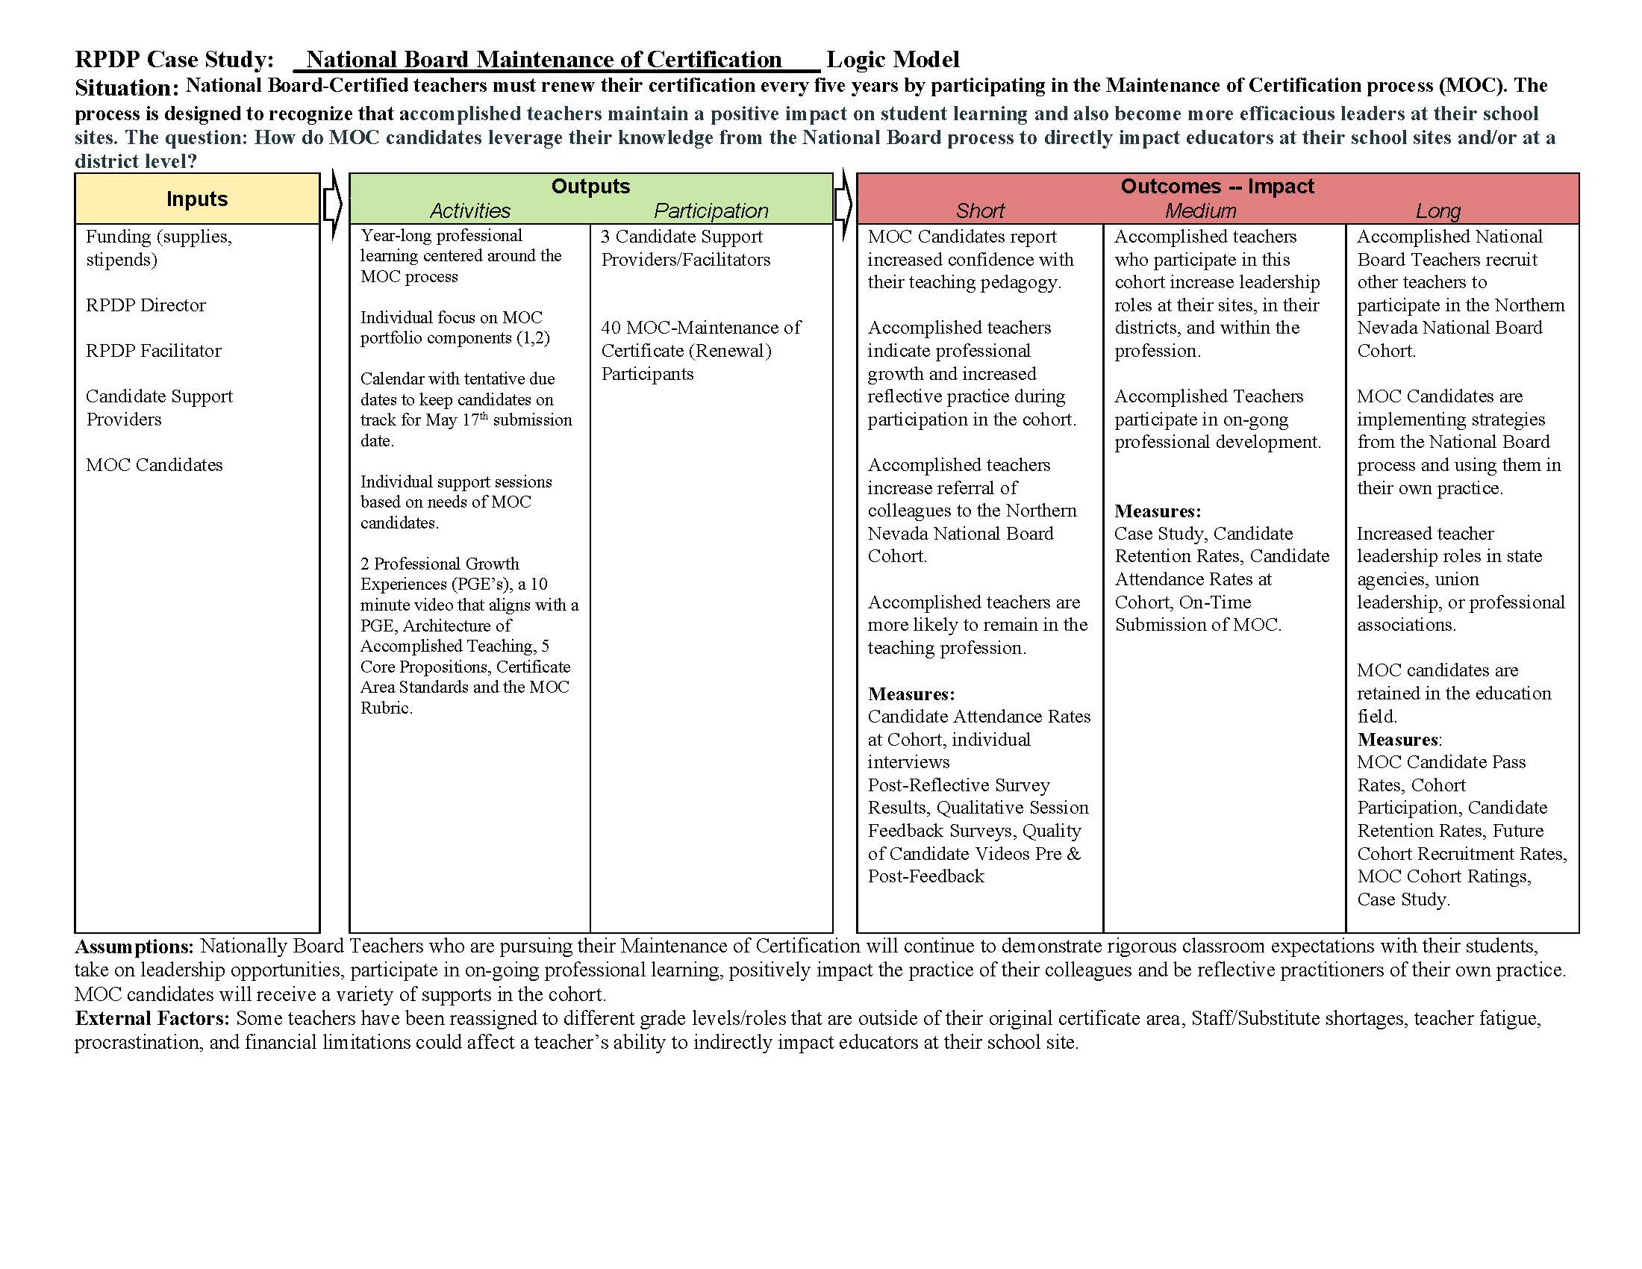
Figure 22: National Boards Maintenance of Certification Logic Model

Writing in the Content Area

Introduction
When Matilda started the 2022-23 school year, her writing skills were minimal. Despite the challenges of disrupted school years, Matilda had learned to read well enough to get by in fourth grade. However, writing in fourth grade seemed beyond her, and when asked to write an informative paragraph by the Northwest Regional Professional Development Program (NWRPDP) Literacy Facilitator, she wrote one simple sentence, “Botley has a button on top.” Matilda’s teacher stated that she believed Matilda was capable of more, but often seemed lost when it came to writing. The teacher noted that Matilda’s lack of writing skills impacted her in content areas such as science and social studies, where students are often asked to write to show comprehension and thinking.
Unfortunately, Matilda is far from alone. According to the most recent report card from the National Assessment of Educational Progress (NAEP), only “one-quarter of students in the United States perform at the Proficient level in writing.” After consultation with the Director of Equity in Curriculum and Instruction in one of the school districts in the Northwest region, it was determined that the NWRPDP Literacy Facilitator would provide professional learning based on the research and the work of Judith Hochman and Natalie Wexler who state, “Writing isn’t just a skill, it’s also a powerful method of teaching content.” (Hochman, 2017) Additionally, the NWRPDP Literacy Facilitator would support K-8 teachers in the region to improve writing in the content area through coaching, mentoring, and modeling in classrooms. This case study outlines the learning sequence and outcomes of this work.

Instructional Context
Two regional professional development classes on writing in the content area were offered by the NWRPDP Literacy Facilitator. The forty-eight participants in the professional development classes were teachers from four different regional districts: Carson City School District, Douglas County School District, Lyon County School District, and Washoe County School District. Six individual teachers were identified to receive one on one coaching support.
The participants who received additional support teach in Carson City School District and Lyon County School District. Carson City School District is a rural school district made up of 451 teachers at 13 schools supporting 7,787 students (Public School Review, 2022). For the 2023 school year, there are 20 public schools serving 8,817 students in Lyon County School District. This district's average testing ranking is 4/10, which is in the bottom 50% of public schools in Nevada. (Public School Review, 2022).
Six teachers from Carson City School District participated in the study and one teacher from Lyon County School District. The educators who participated in this case study serve 250 students. The support to educators varied because of the varying levels of experience and content areas. Table 28 shows the various assignments, areas of identified need, and years of experience of the participating teachers.
Table 28: Carson City School District and Lyon County School District Teacher Cohort
Name | Assignment | Years of experience | Area of Need
Teacher A | 4th Grade Bordewich Bray Elementary | 2-5 | The Writing Process
Teacher B | 4th Grade Bordewich Bray Elementary | 20+ | The Writing Process
Teacher C | 4th Grade Bordewich Bray Elementary | 2-5 | Research Writing
Teacher D | 7th Grade Eagle Valley Middle School | 15 | Essay Writing
Teacher E | 5th Grade Fremont Elementary | 0-1 | Essay Writing
Teacher F | 2nd Grade Dayton Elementary | 0-1 | Phonemic Spelling

Initial Data and Planning
Most classroom teachers assign many writing tasks over the course of a year with the assumption that students know how to organize thoughts and information and engage an audience. When teaching reading, math, or science, educators begin with a well-researched best practice plan. There is explicit instruction in the discrete skills of the discipline and carefully sequenced activities to scaffold the learning. Unfortunately, writing instruction does not always follow this pattern.
In order to effectively enact instructional change, the NWRPDP Literacy Facilitator planned a learning sequence grounded in best practices and conditions for high quality professional learning. First, she planned to deliver professional learning sessions on writing in the content area. Second, she created a one on one coaching plan to mentor educators in implementing best practice writing instruction. A core value of the facilitator is to listen to educator voice and adjust the focus of the lesson accordingly. Teacher voice and engagement in the learning process not only provided investment in the learning, but also fostered a connection between the facilitator and the teacher, providing opportunities for continued growth in the future. Aware that the principles of effective teaching and learning are similar for both students and adults, the facilitator intentionally modeled these conditions and highlighted the metacognitive planning process to assist adult learners in recognizing strategies and utilizing them with students. Table 29 outlines conditions for effective teaching and learning based on the work of Dr. Magdalena Ganias.

Table 29: Conditions and Practices for Effective Teaching and Learning
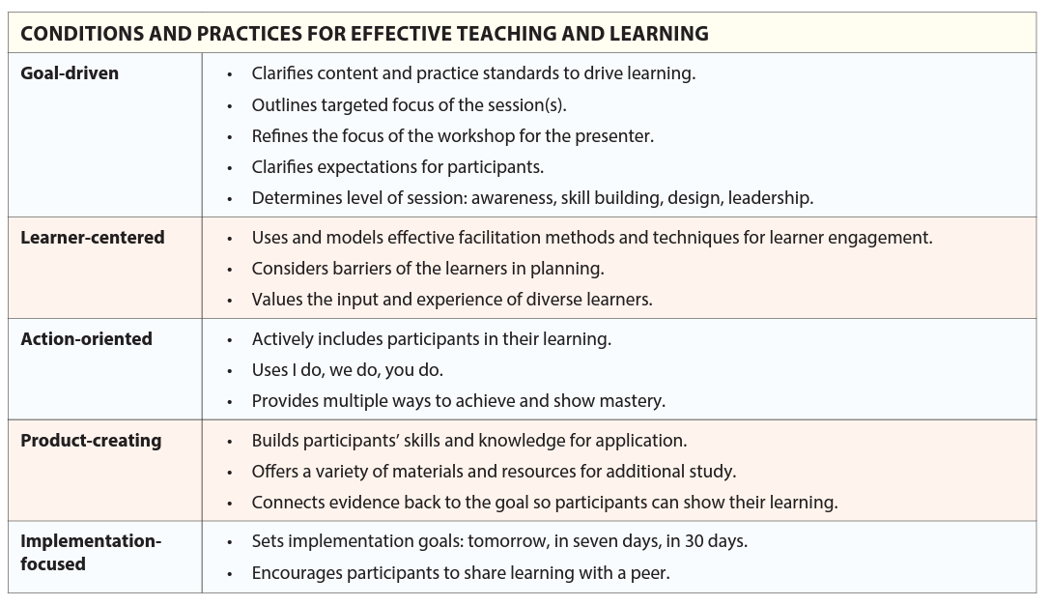
In order to be highly effective, professional learning must meet an additional set of criteria. Learning Forwards’ Standards for Professional Learning (2022) will provide a guide for ensuring positive outcomes for teachers and students. The following examples illustrate how specific professional learning standards will shape the work and therefore teachers’ impact on student learning.
Professional Expertise
Professional learning results in equitable and excellent outcomes for all students when educators apply standards and research to their work, develop the expertise essential to their roles, and prioritize coherence and alignment in their learning.
- The NWRPDP Literacy Facilitator will apply relevant standards and research based on specific district and school based-goals. Learning Forward states, “Those responsible for leading professional learning…bear a particular responsibility to monitor, identify, and apply relevant research and reports containing evidence about information and practices that have an impact on adult and student learning.”
- The NWRPDP Literacy Facilitator will strengthen writing instruction expertise.
- The NWRPDP Literacy Facilitator will lead professional learning by maintaining alignment to a vision focused on educator and student improvement.

Evidence
Professional learning results in equitable and excellent outcomes for all students when educators leverage evidence, data, and research from multiple sources to plan learning opportunities, and measure and report the impact of professional learning.
- The NWRPDP Literacy Facilitator will assess progress toward established goals through qualitative data analysis.
- The NWRPDP Literacy Facilitator will engage educators in cycles of continuous improvement and use evidence to measure and report impact.
- The NWRPDP Literacy Facilitator will sustain coherent and consistent support within a district to build educator capacity.
Learning Designs
Professional learning results in equitable and excellent outcomes for all students when educators set relevant and contextualized learning goals, ground their work in research and theories about learning, and implement evidence-based learning designs.
- The NWRPDP Literacy Facilitator will introduce new knowledge that learners can access at their own pace and then deepen their understanding through discussion with colleagues.
- The NWRPDP Literacy Facilitator will co-teach with teachers in order to provide opportunities to practice new learning and then to reflect, assess, and refine for continuous improvement of classroom instruction.
- The NWRPDP Literacy Facilitator will value the lived experience of diverse learners and use culturally responsive and appropriate materials.
The NWRPDP Literacy Facilitator collected data through pre and post coaching surveys, classroom observations, co-teaching, and student writing samples. The pre-coaching survey asked teachers about their confidence in teaching writing and their areas of strength and weakness. The post-coaching survey asked teachers about their satisfaction with the coaching model and any changes in their teaching practice.

Delivery of Services
The delivery of services was designed to provide comprehensive professional development to strengthen writing instruction expertise based on the work of Hochman and Wexler. Through the professional learning opportunity, participants were identified for further in depth coaching. The professional learning opportunity was conducted both virtually and face to face. This allowed teachers from a wide variety of districts and geographic areas to participate. Six teachers self selected to receive additional writing instructional support from the NWRPDP Literacy Facilitator. The NWRPDP Literacy Facilitator pre assessed the teachers to identify areas of strength and areas for improvement in their writing instruction practice. Teacher B stated, “Writing with my students has been difficult, at best, this year.” Each teacher of the cohort received five coaching sessions where the NWRPDP Literacy Facilitator implemented an instructional cycle of observation, goal setting, modeling, coaching, feedback, and reflection. Teachers collected data on students' writing skills through a variety of assessments, including writing samples and rubrics. Teachers also observed students during writing time and provided feedback and support as needed.

Results and Reflection
As a result of the services provided, Teacher A responded, “It was really informative to watch how Mrs. Croft interacted with my students. I was able to learn and take with me a ton of stuff to use in my classroom.” All of the teachers reported that the writing activity fit their needs and would improve their own writing instruction. Teacher F reported, “The writing activity that Rachel had presented to me has helped me become more confident in the classroom and has allowed me to see how to carry out teacher clarity within the instructional area of writing for my classroom.” Teachers reported feeling more confident in their ability to teach writing after participating in the case study. They also reported improvements in their lesson planning, instruction, and assessment. Figure 23 shows the self-reported growth from each of the six teachers (A-F) in writing instructional skills as a result of the services provided.

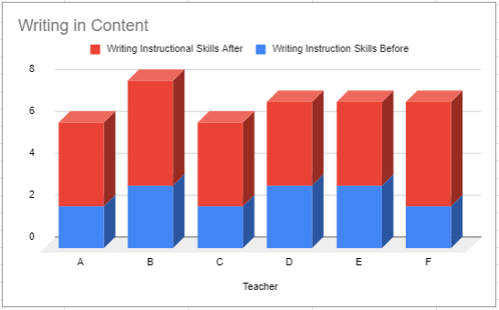
Figure 23: Self-Reported Proficiency in Writing Instructional Skills Before and After the Delivery of Services
Classroom observations by the NWRPDP Literacy Facilitator showed that teachers were using a wider range of instructional strategies and providing more opportunities for student writing practice. Teachers began to incorporate writing strategies into a variety of content areas, which led to improved writing outcomes. Student writing samples showed a significant improvement in quality of writing, with more students demonstrating strong details, voice, and sentence structure.
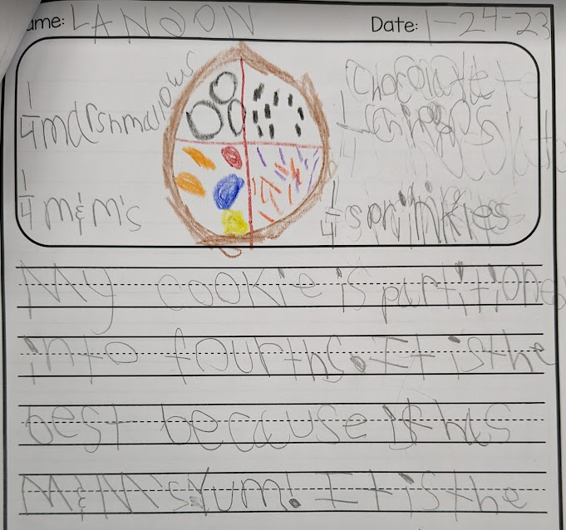
Figure 24: Writing sample from Teacher F’s class showing math content area writing

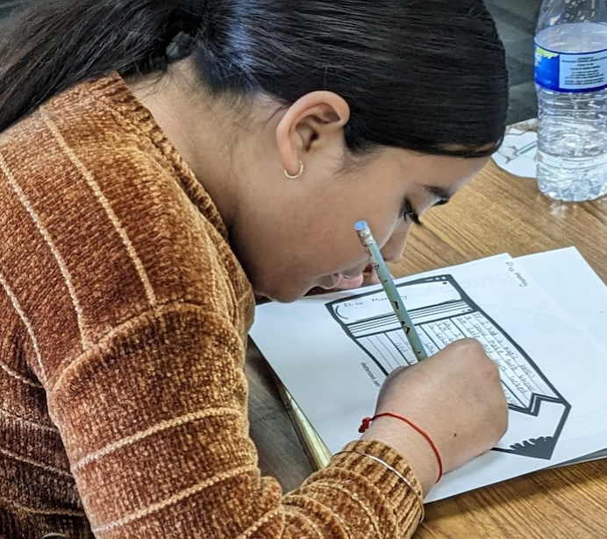
Figure 25: Student in Teacher E’s class showing increased writing opportunities and strategies

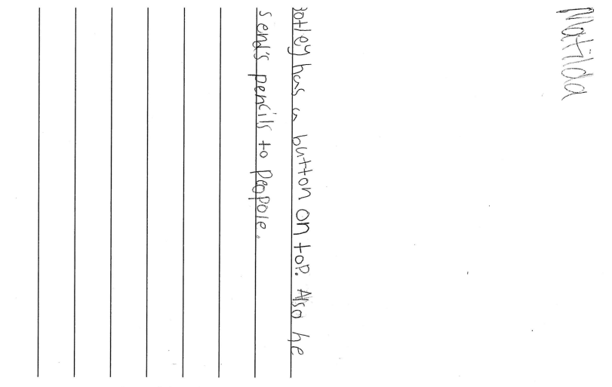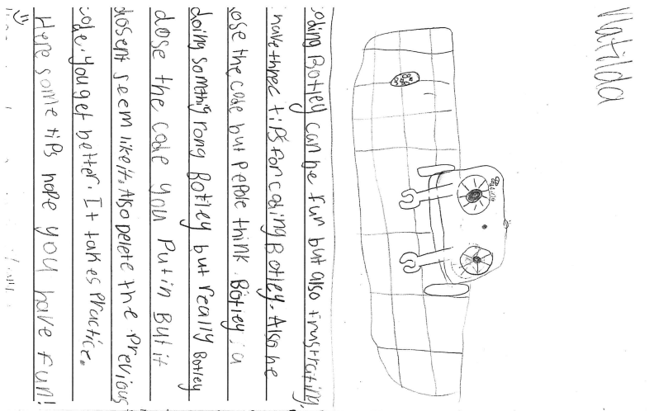
Figure 26: Writing Sample from Teacher B demonstrating improved details and sentence structure.

Figure 27: Writing Sample from Teacher D demonstrating improved details and sentence structure.

Teacher C observed that students were more engaged and motivated during writing time. Students were excited to share their writing with their peers and enjoyed receiving feedback from their teacher. The provided services from the NWRPDP Literacy Facilitator helped to build a stronger classroom community, as students supported and encouraged each other in their writing.
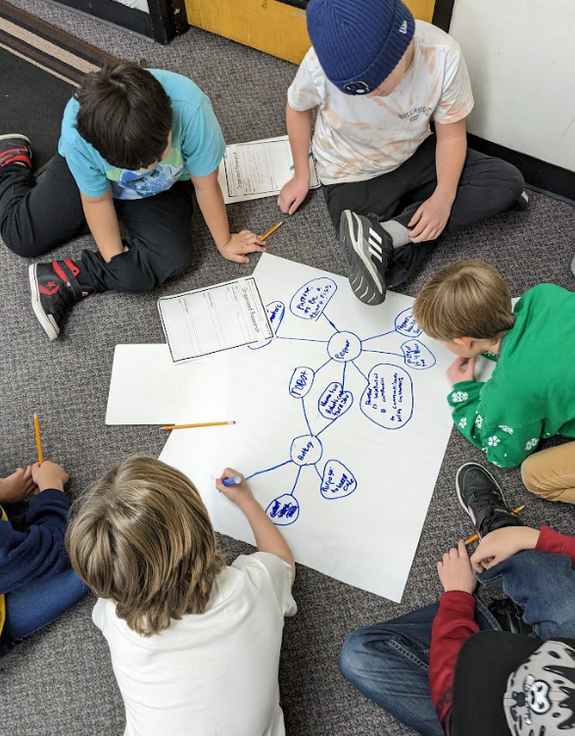
Figure 28: Students in Teacher C’s class working collaboratively to compare research on a thinking map.

The case study demonstrates the effectiveness of a coaching program in supporting teachers in teaching writing in the content area. By providing individualized support and feedback, the NWRPDP Literacy Facilitator helped teachers improve their teaching practice and student writing outcomes. By providing opportunities for writing practice through the content area, teachers were able to help students not only improve writing skills, but also build a positive attitude towards writing. The case study highlights the importance of teacher professional development in improving student learning outcomes and the importance of teacher support and motivation in fostering student success in writing. To sustain growth in writing, the NWRPDP Literacy Facilitator recommends ongoing coaching and professional development for teachers, as well as regular assessments to monitor student progress.

References
Ganias, Magdalena. February 2023. “A ‘ONE, SOME, ALL’ approach wraps educators in layers of support.” The Learning Professional.
Hochman, J. & Wexler, N. (2017). The writing revolution: A guide to advancing thinking through writing in all subjects and grades. Jossey Bass.
Learning Forward. (2022). Standards for Professional Learning. Author.
Nevada Department of Education. (2018). Nevada’s standards for professional development.
Retrieved from https://doe.nv.gov/uploadedFiles/ndedoenvgov/content/Educator_Licensure/NVStandardsforPD.pdf
Nevada Department of Education - NEPF. (July 2019). Rubric with evidence and descriptions –
Teacher professional responsibilities standards and indicators. Retrieved from https://doe.nv.gov/uploadedFiles/ndedoenvgov/content/Educator_Effectiveness/Educator_Develop_Support/NEPF/Teacher/Teacher-Professional%20Responsibilities%20Rubric.pdf
Public School Review. (2022) Carson City School District quick stats. Retrieved from
https://www.publicschoolreview.com/nevada/carson-city-school-district/3200390-school-district
Public School Review. (2022) Lyon County School District quick stats. Retrieved from
https://www.publicschoolreview.com/nevada/lyon-county-school-district/3200300-school-district
The Nation's Report Card: Writing 2011. Retrieved from
https://nces.ed.gov/nationsreportcard/pubs/main2011/2012470.aspx

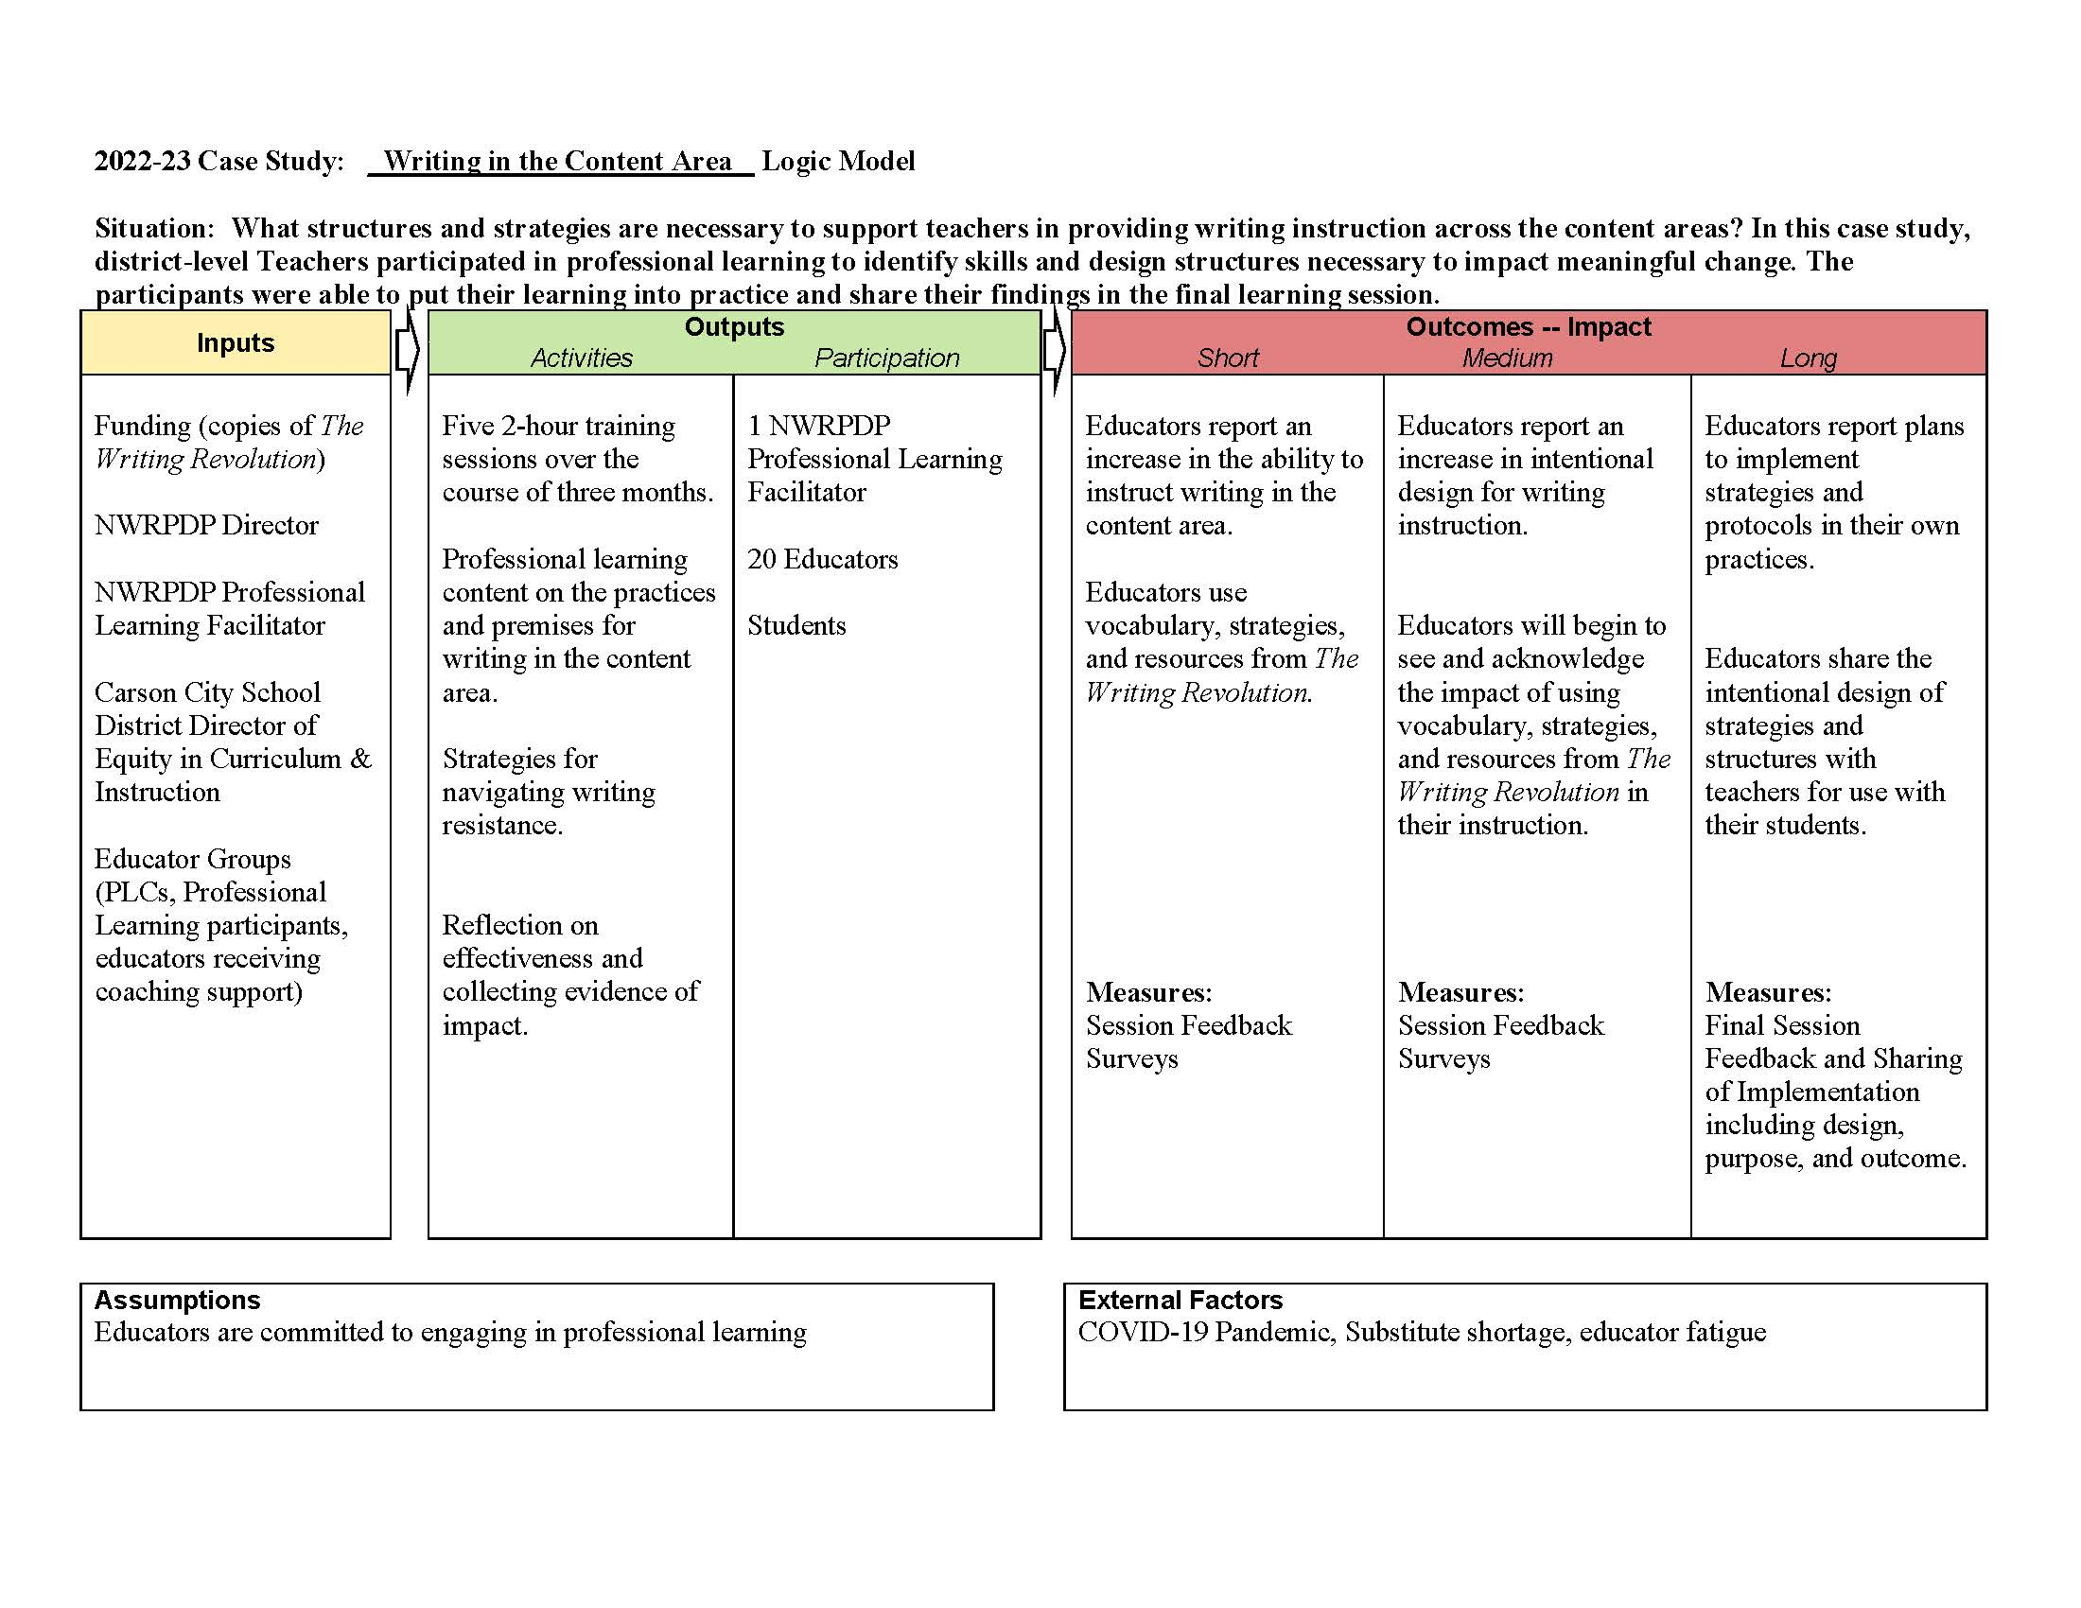
Figure 29: Writing in the Content Area Logic Model

The Second Year Impacts of Science of Reading Professional Learning on Instructional Practice

Introduction
"Once you learn to read, you will be forever free." – Frederick Douglass
Teaching children to read is one of the most central purposes of school, it impacts the whole rest of students' lives. The ability to read is connected to their ability to find and maintain employment, to independently learn about what interests them, and to find connection in the stories of others through literature. Getting the teaching of reading right matters. Yet, in spite of the desire and efforts to get it right, there are a significant number of students who are not learning to read or not learning to read well enough. According to The Nations Report Card, on the 2022 NAEP reading test, 68% of Nevada students scored below proficient in reading.
Teaching students to read is a complex endeavor that is currently fraught with controversy around the most effective and efficient ways to teach reading. It is often referred to as The Reading Wars and falsely pits a balanced literacy approach against what is referred to as the science of reading. Educators have to go through the controversy and the politicalization of the teaching of reading to get to the knowledge and practices that will lead to more students being able to read at a level that gives them real choices in life (The Reading League [TRL], 2022). In the book, Shifting the Balance by Jan Burkins and Kari Yates, the authors delve deeply into the decades old research on how students learn to read and pointedly and respectfully define how we can adjust or change common practices in balanced literacy instruction to make it more effective for more students. The book is grounded in theory but explains high leverage instructional practices in a teacher friendly way. Creating professional learning centered around the contents of the book provided an accessible, less controversial way into the conversation about how educators need to teach reading in a way that aligns with what the research about learning to read has made clear.
This was a two year case study. Year one focused on 21 educators across four school districts across the Northwest region who participated in a 1 credit/16-hour course focused on studying the content of the book and implementing high leverage learning to read strategies into classroom instruction. The data indicated that there was a positive change in teacher knowledge and skill during the course of the book study. Year two focused on 2 educators, one site-based learning facilitator and one classroom teacher who continued their learning in reading instructional practices that align with research about learning to read. The interviews indicated that there was a continuing impact on teacher knowledge and instruction.

Instructional Context
The course was an online hybrid course lasting four weeks. Year one focused on the change in teacher knowledge, skill, and implementation of high leverage instructional practices that align with research on reading. Year two focused on the long term changes in knowledge and practice for two educators who took the one credit course. The educators in this case study opted into the 16 hour inservice course from four different counties in the Northwest Region that represented both rural and urban areas. There were 17 kindergarten to fourth grade teachers, and four site based coaches/learning facilitators. The schools the teachers taught in ranged from Title I schools to schools in high income neighborhoods. The daily schedule and amount of time dedicated to an English Language Arts block varied across the districts. The teachers who opted into the inservice course represented the diversity of the Northwest region.
The two educators who were the focus of year two were chosen for their differences in the roles they played at school sites and for their teaching experience. The first was a site based Learning Facilitator, a site based coach that provided professional learning and classroom support to grade level teachers. She was in her 30th year of teaching and most of her years were spent in the primary classroom. The first-grade teacher has taught first grade for 24 years. Both educators have proactively pursued professional learning formally through inservice classes and informally through self education practices including reading books, listening to podcasts, and collaborating with colleagues to improve their practice. They were ideal candidates for the second year follow up interviews because of their vast experience, willingness to continue learning and to reflect on their practice. In addition, collaborative work with both educators focused on early reading skills was already in place for the 2022-23 school year providing the opportunity to both interview the teachers and informally observe how the learning translated to the educational setting. Both educators were interviewed about the long-term influence of the content of the book study professional learning on their practice.

Initial Data and Planning
According to the Nevada Accountability Portal, between one third to one half of students are considered proficient on the state English Language Arts Proficiency Assessment in elementary, middle, and high school. (See table below.) In addition, not only are teachers expressing concerns about student reading abilities, they are also expressing interest in professional learning focused on what is referred to as the science of reading. The Reading League defines the science of reading as, a vast, interdisciplinary body of scientifically based research about reading and issues related to reading and writing. This research has been conducted over the last five decades across the world, and it is derived from thousands of studies conducted in multiple languages (TRL, 2022). The time was optimal for offering a course that focused on instructional practices that aligned with what research indicated is needed for students to learn to read.
Table 30: District English Language Arts Proficiency Results 2020-2021
District | % Proficient Elementary in ELA | % Proficient Middle in ELA | % Proficient High in ELA
District 1 | 37.1 | 41.9 | 50.4
District 2 | 34.3 | 34.9 | 36.1
District 3 | 52.8 | 48.8 | 51.9
District 4 | 43.9 | 43.7 | 48

The focus of the case study also supports the following goals in the Statewide Plan for the Improvement of Pupils (STIP):
Goal 2: All students have access to effective educators.
Access to quality strategy: Provide quality professional learning
The 16-hour book study that is the focus of this case study evaluated the change in knowledge about and level of implementation of instructional practices focusing on oral language development, word knowledge, phonemic awareness, phonics, high frequency words, and decodable texts.
Year One, educators read the book, participated in focused discussions, self-selected high leverage instructional strategies to implement with their students, and completed a post reflective survey to self-evaluate change in knowledge and skill in the areas laid out in the book.
Year Two, the two participants continued to pursue learning about the science of reading body of research, implement instructional practices, and collaborate with this trainer. Each one was also interviewed. During the interviews the participants were asked the following questions to both focus the discussion and provide a beginning point for the discussion. Interview Questions:
1. Looking back, what learning about SOR from Shifting the Balance has been most impactful for your teaching this year? 2. What new learning have you pursued as a result of what you learned in the book study? 3. What changes have you made to your instruction this year based on your learning about SOR? 4. What changes have you seen in student learning this year?

Delivery of Services
Year One, the hybrid (synchronous and asynchronous) 1 credit/16 hour course was offered during the 2021-22 school year to teachers in the Northwest region of Nevada. Twenty-one teachers in elementary schools across four districts completed the course. The course focused on early literacy instruction that aligns with the body of research referred to as the science of reading. The professional learning took a book study approach and used Shifting the Balance by Jan Miller Burkins and Kari Yates.
Year Two, two educators who continued informal collaborative work with this learning facilitator were formally interviewed about the impact of the professional learning on their knowledge, continued learning, change of instruction, and change in student learning.

Results and Reflection
Year One Results: Teachers were asked a total of 10 questions about their change in knowledge and level of implementation before and after taking the Shifting the Balance Book Study course. The questions and the teacher responses are in the table below. The teachers were asked to complete a Likert scale where they self-evaluated their knowledge before and after taking the course. A level 1 indicated the lowest level and a level 5 indicated the highest level. There were statistically significant improvements in all areas that indicate there was teacher growth in both knowledge about oral language, phonemic awareness, explicit phonics instruction, orthographic mapping, and the use of decodable texts in developing early literacy skills and level of implementation of related instructional strategies into the instructional cycle. The results also indicate that the course resources will continue to be utilized after the end of the course.
Table 31: Shifting the Balance Book Study Post Reflective Results
How useful and impactful to your teaching was the Shifting the Balance Book Study?
 | Before class | After class | t-score | p-value
Your knowledge of the role of oral language and word knowledge in learning to read | 3.52 | 4.81 | -9.15 | <.001
Your knowledge of the importance of phonemic awareness in learning to read? | 3.67 | 4.90 | -6.38 | <.001
Your knowledge about the role of comprehensive and articulated phonics instruction in learning to read | 3.38 | 4.76 | -8.55 | <.001
Your knowledge of orthographic mapping and how it relates to sight word and high frequency word learning | 2.29 | 4.62 | -9.63 | <.001
Your knowledge of the role of decodable texts in learning to read | 3.05 | 4.62 | -7.78 | <.001
I incorporate read aloud intended to build language and background knowledge into instruction | 4.00 | 4.62 | -4.81 | <.001
I incorporate phonemic awareness tasks into instruction | 3.41 | 4.62 | -7.41 | <.001
I teach phonics with a scope and sequence in mind | 3.14 | 4.36 | -5.99 | <.001
I incorporate orthographic mapping into teaching sight and high frequency words | 1.95 | 4.38 | -11.38 | <.001
I balance the use of pattern/highly predictable texts with the use of decodable texts that match students' skill levels | 2.57 | 4.00 | -7.52 | <.001
Year Two Results: The two year two educators were asked four questions. The questions and a summary of their answers are below.
Question 1: What learning about the science of reading was most impactful for your teaching? Although interviewed separately both educators indicated that the most impactful learning centered around four ideas. First was about the importance of phonemic awareness for early readers. Second was the need for explicit, systematic phonics instruction with lots of practice opportunities that includes the use of decodable texts. Third was the vital need to continue to develop oral language proficiency because it is the base on which reading depends. Fourth was what orthographic mapping is and how it leads to word automaticity.
Question 2: What new learning have you pursued as a result of what you learned in the book study? Both teachers sought new learning through podcasts, books, and online resources. Both teachers listed several podcasts they sought out after the class. One that they had in common was The Science of Reading Podcast by Amplify, Books the teachers referenced including the Knowing Doing Gap and Speech to Print. Websites the teachers referenced included webinars and teacher demonstration videos as well as websites that focused on instructional materials and practices.
Question 3: What changes have you made to your instruction based on your learning? Changes they made to instruction centered around assessment, lesson structure and focus, and instructional strategies. Both teachers emphasized the need for assessments to match the concepts being taught. In addition, they indicated a need for assessments to differentiate between students who are reading the words, lifting the code off of the page, and students who are using the pictures instead of reading the words. Changes to lesson structure included an emphasis on explicit and systematic phonics instruction with lots of practice that incorporated the use of decodable texts. Both teachers have also included explicit instruction and practice around orthographic mapping of words. They both also re-evaluated centers and center work. One completely removed centers from the instructional cycle and the other began to help teachers evaluate the quality of the work in the centers. Changes in instructional strategies aligned to the changes in lesson structure and focus. Some examples of strategies included Heidi Messner’s Review It, Hear It, Decode It, Write It, Read It Strategy, using mapping mats, and word chains.
Question 4: What changes have you seen in student learning this year?
The first grade classroom teacher said that her students are very excited about learning to read and want to take things home to practice. As is typical in any first grade classroom, students are leaving to second grade with a range of reading skills. What is not typical is that all of her students are leaving reading at some level. The least skilled readers read at least 30 words per minute. The site based learning facilitator saw changes in student learning in two ways. She worked with both small groups and with individual students whose reading skills were significantly below grade level according to both standardized and observational data. The explicit focus on phonics instruction resulted in an increase in students’ abilities to decode words. The addition of orthographic mapping into instruction supported students in being able to learn some irregular high frequency words to automaticity.

Conclusion
“There is an ethical imperative to provide the best possible classroom conditions in which students in our charge can flourish, this means rejecting what wastes time and embracing that which makes the most use of it.” This quote by Carl Hendrick captures the imperative nature of providing professional learning focused on the teaching of reading that not only aligns with what we know about how students learn to read but also provides a solid foundation for teachers to leap off of to pursue their own learning. Teaching students to read is a complicated process fraught with controversy, but it doesn’t have to be. This case study has shown that professional learning that focuses on high quality information that is respectful of teachers can result in both changes in knowledge and skill of teachers and also light/relight a fire to figure out the complexities of teaching students to read. In the interview with the first grade teacher she said, “I won’t let my students leave first grade without being able to read.”

References
Burkins, J.M., & Yates, K. (2021). Shifting the Balance: 6 ways to bring the science of reading
into the balanced literacy classroom. Hawker Brownlow Education.
Nevada Department of Education.(2023, April 15). Nevada Accountability Portal.
http://nevadareportcard.nv.gov/di/
Nevada Department of Education (2023, April 15). About Our Strategic Improvement Plan.
https://doe.nv.gov/STIP/Nevada/
The Reading League. (2022). Science of Reading: Defining Guide.
U.S. Department of Education. Institute of Education Sciences, National Center for Education
Statistics, National Assessment of Educational Progress (NAEP), 2022 Reading
Assessment.

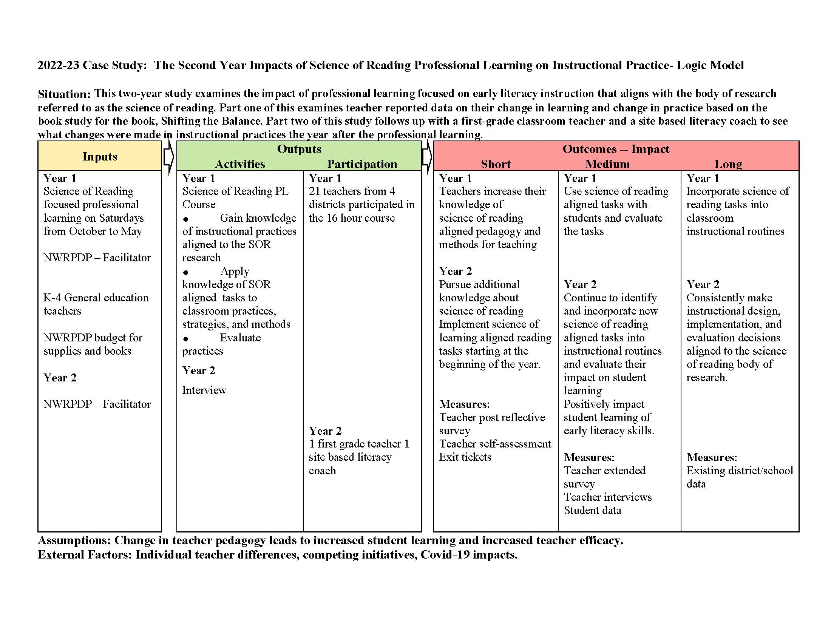
Figure 30: The Second Year Impacts of Science of Reading Logic Model

Early Childhood Years One and Two

Introduction
Renowned psychologist Jean Piaget famously said, “Play is the work of childhood.” This quote was later expanded by television personality Fred Rogers to say, “Play is often talked about as if it were a relief from serious learning. But for children, play is serious learning.” Both quotes are a perfect introduction to the 2022-23 project, Early Childhood Years One and Two. The project is a part of a larger, statewide effort to encourage developmentally appropriate practices from birth to grade three for Nevada children.

The design of the multi-year Early Childhood courses endeavored to help teachers deepen their knowledge of child development and grow their observational skills to notice student strengths, areas of need and to use that knowledge to move children forward in their development. The courses were designed to build upon each other, with the first one providing theoretical underpinnings and relevant research and the Year Two class moving toward classroom application of those principles. Fifty-three kindergarten teachers across 10 districts in Nevada completed the Year One Kindergarten Learning Series. Twenty of those teachers signed up for the Year Two course.
In both courses, participants were taught specific aspects of child development from birth to age eight. Intensive focus was placed on providing children with high quality materials, detailed, kid watching observation techniques, and teacher roles that effectively facilitated learning in a playful environment. Traditional academic skills were a major focus of the courses, but much attention was also given to what are sometimes called “soft skills” such as teamwork, problem solving, adaptability, critical thinking, and interpersonal competencies. These skills are sometimes assumed to be naturally developing and are not always directly taught despite being extremely important for success in employment as well as in one’s personal life. HR Magazine says, “being gifted at performing the technical aspects of a job can take an employee only so far. To become a stellar employee or an admired leader requires an arsenal of skills that are harder to measure but critical to success. Dubbed ‘soft skills,’ they are behaviors, personality traits and work habits, such as collaboration, critical thinking, perseverance and communication, that help people prosper at work.”
The overall goal of the courses was to build knowledge of child development in order to empower teachers to help students grow into well rounded, collaborative, academically proficient adults.

Instructional Context
These courses were offered in partnership with the State of Nevada, so they were offered statewide. The work truly began in 2013 with the Striving Readers Grant. Part of the work in that grant was to better align pre-k through third grade practices to create smoother transitions for students between grades and create better vertical alignment. That work later expanded to include birth to third grade as the importance of early childhood learning continued to be brought to the forefront in national discussions. NWRPDP began to offer the two courses in the 2020-2021 school year. The courses typically fill up within 24 hours of opening which the trainer believes speaks to the need for more professional learning specifically for early childhood educators.

Historically, participants have come from 10 different counties across the state. This year, we had participants from seven counties including Clark County, Douglas County, Washoe County, Carson County, Nye County, Lyon County, and Humboldt County.

Table 32: County Demographics
County | Enrollment | Schools | Asian | Black | White | Hispanic | Am In/AK Native | Two or More Races | Pacific Islander | FRL
Carson | 7222 | 12 | 133 | 63 | 3482 | 3471 | 174 | 380 | 19 | 5329
Clark | 314372 | 378 | 18584 | 50501 | 64984 | 149917 | 1009 | 24195 | 5182 | 301104
Douglas | 5331 | 17 | 81 | 19 | 3441 | 1306 | 151 | 318 | 15 | 1576
Humboldt | 3329 | 14 | 20 | 26 | 1802 | 1228 | 135 | 115 | 3 | 2086
Lyon | 9085 | 19 | 105 | 90 | 5378 | 2592 | 285 | 560 | 75 | 4804
Nye | 5873 | 28 | 64 | 237 | 3101 | 1919 | 68 | 419 | 65 | 5848
Washoe | 64990 | 113 | 2797 | 1777 | 26962 | 27626 | 763 | 4112 | 953 | 35312
Source: Nevada Department of Education Website

The adopted curricula, training, district provided materials and district expectations vary widely. All districts participated in the same statewide assessments and the resulting data collection that determines which students are put on watch lists for the Read by Grade Three initiative. All districts utilized the Nevada Academic Content Standards as their end of year expectations, but the teaching methods and materials were all different. The Year One course was comprised of four, three-hour virtual sessions, and four hours of asynchronous work. The Year Two course consisted of seven, two-hour virtual sessions.

Participants enrolled in this year’s cohort had an average range of experience from one year to 20 years in the profession. (See Table 2).

Table 33: Participants by County
County | Number of Teachers | Average Years of Experience
Carson | 1 | 1
Clark | 40 | 20
Douglas | 2 | 7
Humboldt | 1 | 11
Lyon | 2 | 15
Nye | 3 | 9
Washoe | 20 | 14
Charter | 1 | 5

Initial Data and Planning
Teaching young students requires different techniques, assessments, and supports than teaching older students. Participants described various reasons for wanting to take the courses. Many participants reported feelings of isolation and a desire to collaborate with colleagues that share the same values and teaching philosophy that they do. Others were upset by sweeping changes in which developmentally appropriate materials such as kitchen sets were taken out of classrooms, and they began to feel more and more like playful learning was being discouraged by administration teams. Still others agree with the research surrounding playful learning but wanted support in gathering materials, lesson planning, observation, and designing the learning environment. The variety of interests and goals challenged the trainer to design the class with both opportunities for instruction as well as time for discussion and collaboration. The trainer has found that choice boards are good tools to offer processing time as well as differentiation so that participants can get some whole group content and then have defined time to process the information given in class and decide as individuals what particular aspect of the content they want to explore further. The choice board offers articles, videos, blogs, websites, or simply additional time for discussion with other participants. The funding provided by the grant allowed for each teacher to receive a book to study throughout the classes, Choice Time by Renee Dinnerstein. Participants also received some classroom materials, such as books to be used as read alouds as well as building materials that supported the concepts taught in the classes. The Year One course was divided into four sessions: One: Building and Maintaining Relationships Two and Three: Navigating Play, and Four: Articulation and Advocacy. The book and the Year Two course were divided into six main sections: Dramatic Play, Art, Blocks, Science, Math, and Reading Nook.

Throughout the Year Two class, participants are asked to share photos, videos, and stories of their implementation of each type of play between sessions. There was an option to meet one on one with the trainer to address any additional questions, plan, assess, or co-teach utilizing the strategies taught in any of the sessions. The course also addressed the play continuum, types of play, and teacher roles during playful learning. The eventual goal of the Early Childhood courses was for teachers to implement purposeful play as a developmentally appropriate practice and to improve their ability to observe and guide students along the developmental continuum. The trainer planned to collect both quantitative and qualitative data from the Year Two class cohort using a post-reflective survey along with open ended, narrative questions.

Delivery of Services
The Year One course, Building and Maintaining Strong Relationships in Kindergarten was facilitated twice in the 2022-2023 school year, one cohort in the fall and another in spring. Session one focused on building relationships both among the participants in the cohort as well as strategies and techniques to build relationships between teachers and students in early childhood classrooms. The participants and the trainer worked together to learn to navigate the technology of Zoom meetings, Google Classroom and Digital Workbooks that made collaborative statewide participation possible.

Sessions Two and Three focused on Navigating Playful Learning including environmental design, classroom management and standards alignment. These sessions also emphasized the importance of setting up routines so that young students can begin to develop agency for their own learning as well as help clean and maintain areas of the classroom.

Session Four covered Articulation and Advocacy, stressing the importance of documentation of learning in the early childhood classroom so that the learning is visible to parents, administrators, and any other visitors to the classroom. Participants did some role-playing work with common scenarios and the trainer showed many examples of high-quality documentation of student learning.

The Year Two session entitled: Early Childhood Year Two, Play in Practice began in January 2023. Twenty participants returned to participate in the second offering of the series. This course was divided into seven sessions, each focused on a particular content area outlined in the textbook for the courses, Choice Time. Participants were asked to read a content chapter before class, participate in the synchronous activities about that content area, and then choose something they learned to try out in their classrooms. They were then asked to reflect on the experience and post evidence in the Google Classroom to share with the group. Evidence was comprised of pictures, videos, vignettes, and documentation examples (see figures 1 – 3 below.)

Each session in the Year Two course began with participants sharing successes and challenges from the learning they had acquired from the previous session. The trainers were very impressed with the variety of evidence that was presented as well as the deep reflection of the participants. An example of one of the documentation presentations can be found here. After the celebration and reflection time, a detailed developmental continuum from birth to approximately age eight was presented. Finally, participants were able to choose an area of deeper study from four possible options. In each session, they were given the option to work alone or in collaborative groups for 15 – 20 minutes then they returned and shared their learning as well as their plan for application of the learning in their classrooms with the larger group.

This general lesson plan was followed in each session covering the content area subjects of Dramatic Play, Art, Blocks, Science, Math, and the Reading Nook. At the final session, each participant received a class set of magnetic building tiles to begin their collection of developmentally appropriate materials that they can use while observing their students’ development and engaging them in high quality learning of the content areas we covered. The trainers also encouraged the integration of Science, Technology, Engineering, Art, and Mathematics learning (S.T.E.A.M.)

The regular celebration, reflection, and active choice for deeper learning opportunities allowed participants to collaborate with other teachers that shared similar interests and to ask individual questions of the trainers about how they might apply the learning from the session to their classroom and particular circumstances. According to the Learning Pyramid, “only 5-10% of content is retained from a lecture or reading. That’s the bad news. The good news is that people retain 75% when they practice what they’ve learned and 90% when they teach it! So, providing quality content is just the beginning.” (https://www.educationcorner.com/the-learning-pyramid.html). The trainer endeavored to increase the amount of information participants retained and utilized from the courses by providing a lot of time to reflect, practice, and collaborate.

Results and Reflection
At the final session in May, participants completed a retrospective survey using a Likert scale rating of one to five on several indicators regarding their knowledge of development within instructional content areas. A score of one indicated “not at all,” three indicated “somewhat,” and five “very.” Group scores for each indicator were averaged for pre- and post-implementation with the gain shown in the fourth column. Results shown below in Table Three indicate gains in the group’s overall understanding of early childhood development presented in the course. The data clearly indicates that participants increased their knowledge in all areas.

Table 34: Retrospective Survey Results
Statement | How knowledgeable about this development before? | How knowledgeable about this development after? | t-score | p-value
Child Development in Dramatic Play | 2.53 | 4.65 | -10.182 | < .001
Child Development in Blocks | 2.47 | 4.76 | -9.601 | < .001
Child Development in Art | 2.65 | 4.76 | -8.796 | < .001
Child Development in Math | 2.94 | 4.88 | -9.679 | < .001
Child Development in Science | 2.59 | 4.71 | -7.856 | < .001
Creating a Reading Nook | 3.18 | 4.76 | -9.194 | < .001
Teacher Roles | 2.65 | 4.65 | -6.469 | < .001
= 17
The participants were also asked to reflect in writing on their overall experience of the course. Bulleted below are some of the comments gathered in response to the following question: What resource(s) or information did you find the most helpful from this course?
The book, discussing with other teachers for ideas, etc.
The choice time book and all the guest speakers were amazing.
Interaction with teachers from other districts, materials provided.
All the resources shared with us were very helpful.
Learning how children develop through play socially, emotionally, and academically and how much it helps with behavior in the classroom. I had no idea there were so many different types of play prior to taking these courses but now I understand the different roles a teacher can play while children are engaging in play. I have used the open-ended questions this whole school year and love the output from students. I also loved seeing photos of other teacher's [sic] play stations and ideas throughout the course. The Google classroom was easy to navigate. I also liked the breakout rooms so teacher's [sic] could really discuss ideas and share during class.
I've used the Choice Time book as I have planned lessons/play. I also enjoyed the choice board and the time to explore different resources during our sessions. The information was very valuable and the collaboration with others was very helpful.
I LOVED seeing other colleagues incorporate what we learned. It gave me lots of ideas and also made me more willing/comfortable with incorporating some of the skills and concepts we learned into my own classroom. I also loved how willing everyone was to share their knowledge and resources. In addition, I absolutely enjoyed the guest speakers!!
I found all the information for each of the chapters helpful. The ideas from other teachers was [sic] helpful. Sometimes I was able to get another perspective about how someone else sees how to enrich the center. I gained many ideas from the other teachers.
This Early Childhood Kindergarten Series Year 2 class has been a game changer for me. I found all the information on child development and what is within developmentally appropriate stages incredibly helpful--the visuals you supply are awesome and inspiring. I loved learning about how these stages play out in various center activities and as the teacher what my role is to help deepen student learning and development through the stages. It was awesome to get a new lens to view my students and the things they do; I feel like I can be more okay with the various things students do naturally and offer them more opportunities to be independent, to trust my students and trust that this loosened approach does not mean I am losing control of my classroom but rather creating a rigorous student led classroom.
Participants were asked to reflect on learning throughout the course by contributing evidence of student work in the discussion stream. Below is some evidence of implementation that was submitted throughout the course. These reflections show that teachers were implementing the practices presented in the course and were closely observing students to determine what worked well, what the student needs were, and what would be a good next step for student learning.

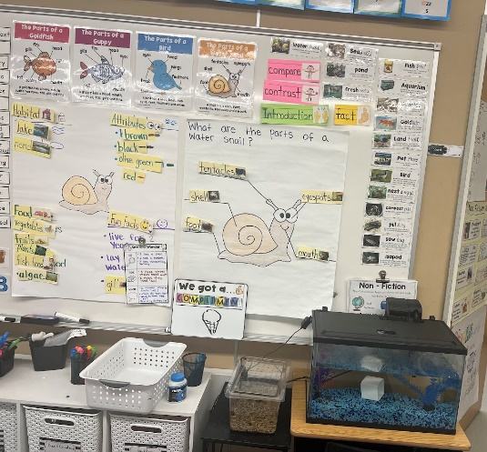

I tried "I see, I think, I wonder" chart with my students.
Figure 31: Implementation After the Session on Science
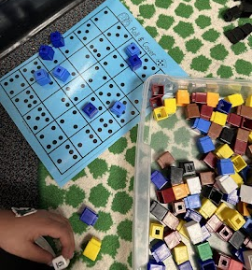

Decided to switch up my Work Places and put in some dice games to work on subitizing. Kids loved it and it really gave me an opportunity to see what the kiddos could do with dice.
Figure 32: Implementation After the Math Session
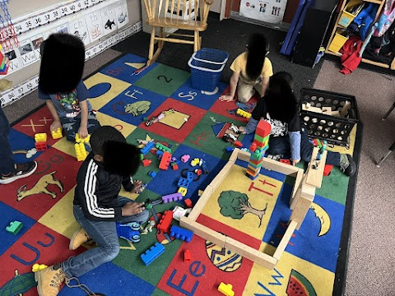

My block center where I asked students to recreate something from our technology unit for ELA. They came up with a rocket ship to Mars and a space elevator.
Figure 33: Implementation After the Block Session.

Conclusion
Early childhood is a time when so much learning happens. High quality instruction during this time really sets a child up for all their future learning in the content areas. Educators often begin their careers without the proper training or materials to successfully guide all students through the developmental continuum in order to take full advantage of the opportunities within early childhood. The NWRPDP Early Childhood Years One and Two cohorts provided support for new and experienced teachers to refine their practice and hone their observation abilities to skillfully determine the needs of the students in their classes and guide students toward proficiency in all content areas, providing and removing supports along the way. As Vivian Paley, a teacher-researcher puts it, “fantasy play is the glue that binds together all other pursuits, including the teaching of early reading and writing skills.” Skillful use of play to drive student learning is not easy to accomplish. These courses created a learning community where teachers learned more about child development and then worked together to utilize the resources in their classrooms to grow that development. The specific focus on early childhood development was welcomed by participants who are so often in training sessions revolving around tests in which their students do not participate. The Early Childhood community served as a positive environment with teachers statewide who were willing to take risks and endeavored to improve the learning outcomes of young learners. Year Two extended the theoretical overview and applied it to practical, everyday teaching. The eventual goal was to improve student learning by supporting teachers in the difficult but rewarding work of teaching young children.

References

Dinnerstein, R. (2016). Choice Time. Heinemann Educational Books.

Paley, V. (2004). A Child’s Work: The Importance of Fantasy Play. University of Chicago Press.

Thunder, K., Almarode, J. T., & Hattie, J. A. (2022). Visible Learning in Early Childhood.
Corwin.

Website: https://www.educationcorner.com/the-learning-pyramid.html

Website: https://www.shrm.org/hr-today/news/hr-magazine/summer2021/pages/why-soft-skills-are-important.aspx

Website: https://www.brainyquote.com/quotes/jean_piaget_751100

Website: https://www.brainyquote.com/quotes/fred_rogers_193081

Appendix A: Overview of regional services

Professional development services are reported in two formats: unduplicated counts which show how many teachers, administrators, paraprofessionals, and other educators were served in each county; and duplicated counts which reflect how many educators participated in trainings, many more than once. Tables 1 and 2 show these data in an overview format for the entire northwest region, broken down by elementary, middle, and high school for teachers. Administrator counts also are displayed along with a category of Others.
Table 35: Unduplicated Number of Educators Trained by the NWRPDP
District | ES Teachers | MS Teachers | HS Teachers | Administrators | Others* | Total by District
Carson | 153 | 28 | 34 | 14 | 23 | 252
Churchill | 27 | 8 | 8 | 2 | 1 | 46
Douglas | 128 | 32 | 37 | 13 | 11 | 221
Lyon | 98 | 55 | 48 | 13 | 8 | 222
Storey | 1 | 9 | 1 | 1 | 0 | 12
Washoe | 677 | 184 | 175 | 93 | 45 | 1,174
Totals | 1,087 | 317 | 309 | 138 | 88 | 1,939

Table 36: Duplicated Number of Educators Trained by the NWRPDP
District | ES Teachers | MS Teachers | HS Teachers | Administrators | Others* | Total by District
Carson | 246 | 48 | 46 | 23 | 30 | 393
Churchill | 37 | 10 | 10 | 4 | 7 | 68
Douglas | 296 | 58 | 70 | 18 | 17 | 459
Lyon | 269 | 120 | 90 | 25 | 13 | 517
Storey | 1 | 9 | 6 | 1 | 0 | 17
Washoe | 1,047 | 276 | 250 | 153 | 62 | 1,788
Totals | 1,899 | 522 | 479 | 226 | 129 | 3,255
*Others in Tables 1 and 2 include certified personnel who did not specify a grade level, substitutes, school counselors, district-level certified positions, and other participants such as paraprofessionals, and community members

A total of 2,489 educators, or 40% of the approximate 6,100 educators employed in the region (as reported by each district), participated in programs provided by the NWRPDP during 2022-23 (unduplicated count). In terms of how NWRPDP participants are broken down by district, in 2022-23, 10% of participating teachers and administrators were from Carson City, 11% were from Churchill County, 10% were from Douglas County, 8% were from Lyon County, 1% from Storey County, and 60% from Washoe County. Many educators attended programs on more than one occasion, resulting in a total of 4,913 contacts between the NWRPDP and educators during the year (duplicated count).
Type and Focus of Services - Regional Overview

The NWRPDP provides a variety of services for the six counties in the region. Figure 1 shows the breakdown in a visual format of the three broad types of services provided by regional trainers throughout the districts with a significant majority of services being in the form of instructional training and in-service classes for the 2022–2023 school year.
Figure 34: Types of Contact (Region)

Another measure of services is the focus of the services provided. This measure looks at the content of the services offered in the region (See Figure 2). The major areas of services provided in the region for the 2022–2023 school year were NVACS trainings in areas of NVACS Math, Science, and Literacy/English. The remaining areas of focus were diverse, and included professional learning opportunities in Family Engagement, Teacher Leadership, Social Studies, STEM, Computer Science, and Multicultural Education.

Figure 35: Content Area (Region)

Appendix B: Carson City School District Services Summary 2022-23

Carson City School District has 11 schools: six elementary schools, two middle schools, one comprehensive high school, one alternative high school, and one charter school. Carson has 7% of the schools in the NWRPDP Region, which includes 159 schools. Two full-time learning facilitators are housed in Carson.

Training focused mainly on the Nevada Academic Content Standards in Literacy/English, Math, Social Studies, and Science. Other professional learning included Teacher Leadership, Computer Science, and Gifted and Talented Education.

Participant Mean Ratings on Quality of RPDP Trainings
(Scale: 1 = not at all, 3 = to some extent, 5 = to a great extent) | CCSD | Region
The activity matched my needs | 4.49 | 4.63
The activity provided opportunities for interactions and reflections | 4.71 | 4.80
The presenter/facilitator’s experience and expertise enhanced the quality of the activity. | 4.73 | 4.78
The presenter/facilitator efficiently managed time and pacing of activities. | 4.72 | 4.77
The presenter/facilitator modeled effective teaching strategies. | 4.73 | 4.77
This activity added to my knowledge of standards and/or subject matter content. | 4.60 | 4.68
The activity will improve my teaching skills. | 4.61 | 4.70
I will use the knowledge and skills from this activity in my classroom or professional duties. | 4.66 | 4.73
This activity will help me meet the needs of diverse student populations (e.g., gifted and talented, ELL, special education, at-risk students). | 4.62 | 4.69

Number of Educators Trained by NWRPDP
 | Unduplicated | Duplicated
ES Teachers | 153 | 246
MS Teachers | 28 | 48
HS Teachers | 34 | 46
Administrators | 14 | 23
Others | 23 | 30
Totals | 252 | 393
Carson educators were 13% of the educators served in the region (Using the unduplicated regional count of 1,880 educators).

Figure 36: Type of Contact (Carson)
Figure 37: Content Area (Carson)

Appendix C: Churchill County School District Services Summary 2022–23

Churchill County School District has six schools: one PreK school, one Kindergarten-First grade school, one school for grades two-three, once school for grades four-five, one middle school, and one comprehensive high school. Churchill has 4% of the schools in the NWRPDP Region, which includes 159 schools. There is one full-time learning facilitator housed in Churchill County.
Primary areas supported by regional learning facilitators this year were the Nevada Academic Content Standards in Math and ELAD.

Participant Mean Ratings on Quality of RPDP Trainings
(Scale: 1 = not at all, 3 = to some extent, 5 = to a great extent) | ChCSD | Region
The activity matched my needs | 4.65 | 4.63
The activity provided opportunities for interactions and reflections | 4.84 | 4.80
The presenter/facilitator’s experience and expertise enhanced the quality of the activity. | 4.71 | 4.78
The presenter/facilitator efficiently managed time and pacing of activities. | 4.74 | 4.77
The presenter/facilitator modeled effective teaching strategies. | 4.74 | 4.77
This activity added to my knowledge of standards and/or subject matter content. | 4.77 | 4.68
The activity will improve my teaching skills. | 4.71 | 4.70
I will use the knowledge and skills from this activity in my classroom or professional duties. | 4.71 | 4.73
This activity will help me meet the needs of diverse student populations (e.g., gifted and talented, ELL, special education, at-risk students). | 4.74 | 4.69

Number of Educators Trained by NWRPDP
 | Unduplicated | Duplicated
ES Teachers | 27 | 37
MS Teachers | 8 | 10
HS Teachers | 8 | 10
Administrators | 2 | 4
Others | 1 | 7
Totals | 46 | 68
Churchill educators were 3% of the educators trained in the region (Using the Unduplicated regional count of 1,880 educators).

Figure 38: Type of Contact (Churchill)

Figure 39: Content Area (Churchill)

Appendix D: Douglas County School District Services Summary 2022–23

Douglas County School District has 14 schools: seven elementary schools, three middle schools, and four high schools. Douglas has 9% of the schools in the NWRPDP Region, which includes 159 schools. A full-time learning facilitator coordinated services for DCSD.
The majority of services provided this year were in support of the Nevada Academic Content Standards in Math and support new teachers to the district. Other professional learning included Nevada Educator Performance Framework, Assessment, Science, Multicultural Education, and Teacher Leadership.

Participant Mean Ratings on Quality of RPDP Trainings
(Scale: 1 = not at all, 3 = to some extent, 5 = to a great extent) | DCSD | Region
The activity matched my needs | 4.84 | 4.63
The activity provided opportunities for interactions and reflections | 4.95 | 4.80
The presenter/facilitator’s experience and expertise enhanced the quality of the activity. | 4.95 | 4.78
The presenter/facilitator efficiently managed time and pacing of activities. | 4.95 | 4.77
The presenter/facilitator modeled effective teaching strategies. | 4.95 | 4.77
This activity added to my knowledge of standards and/or subject matter content. | 4.84 | 4.68
The activity will improve my teaching skills. | 4.89 | 4.70
I will use the knowledge and skills from this activity in my classroom or professional duties. | 4.93 | 4.73
This activity will help me meet the needs of diverse student populations (e.g., gifted and talented, ELL, special education, at-risk students). | 4.92 | 4.69

Number of Educators Trained by NWRPDP
 | Unduplicated | Duplicated
ES Teachers | 128 | 296
MS Teachers | 32 | 58
HS Teachers | 37 | 70
Administrators | 13 | 18
Others | 11 | 17
Totals | 221 | 459
Douglas educators were 12% of the educators trained in the region (Using the Unduplicated regional count of 1,880 educators).

Figure 40: Content Area (Douglas)
Figure 41: Type of Contact (Douglas)

Appendix E: Lyon County School District Services Summary 2022–23
Lyon County School District has 17 schools in five communities (Yerington, Dayton, Fernley, Smith Valley, and Silver Springs): eight elementary schools, four intermediate schools, four high schools, one K-8 school, and one K-12 school. Lyon has 11% of the schools in the NWRPDP Region, which includes 159 schools.
The majority of services provided this year were in support of the Nevada Academic Content Standards in Math, Computer Science, STEM, Literacy & English, and Science.

Participant Mean Ratings on Quality of RPDP Trainings
(Scale: 1 = not at all, 3 = to some extent, 5 = to a great extent) | LCSD | Region
The activity matched my needs | 4.58 | 4.63
The activity provided opportunities for interactions and reflections | 4.78 | 4.80
The presenter/facilitator’s experience and expertise enhanced the quality of the activity. | 4.77 | 4.78
The presenter/facilitator efficiently managed time and pacing of activities. | 4.70 | 4.77
The presenter/facilitator modeled effective teaching strategies. | 4.79 | 4.77
This activity added to my knowledge of standards and/or subject matter content. | 4.72 | 4.68
The activity will improve my teaching skills. | 4.67 | 4.70
I will use the knowledge and skills from this activity in my classroom or professional duties. | 4.72 | 4.73
This activity will help me meet the needs of diverse student populations (e.g., gifted and talented, ELL, special education, at-risk students). | 4.61 | 4.69

Number of Educators Trained by NWRPDP
 | Unduplicated | Duplicated
ES Teachers | 98 | 269
MS Teachers | 55 | 120
HS Teachers | 48 | 90
Administrators | 13 | 25
Others | 8 | 13
Totals | 222 | 517
Lyon educators were 12% of the educators trained in the region (Using the Unduplicated regional count of 1,880 educators).

Figure 42: Content Area (Lyon)
Figure 43: Type of Contact (Lyon)

Appendix F: Storey County School District Services Summary 2022–23

Storey County School District has four schools: two elementary schools, one middle school, and one high school. The NWRPDP funded one classroom teacher as a part-time learning facilitator. Outside of her teaching responsibilities, she organized professional learning in the district. Storey has less than 3% of the schools in the NWRPDP Region, which includes 159 schools.
SCSD received services in support for Mindset/SEL.

Participant Mean Ratings on Quality of RPDP Trainings
(Scale: 1 = not at all, 3 = to some extent, 5 = to a great extent) | SCSD | Region
The activity matched my needs | 4.60 | 4.63
The activity provided opportunities for interactions and reflections | 5.00 | 4.80
The presenter/facilitator’s experience and expertise enhanced the quality of the activity. | 4.80 | 4.78
The presenter/facilitator efficiently managed time and pacing of activities. | 4.80 | 4.77
The presenter/facilitator modeled effective teaching strategies. | 5.00 | 4.77
This activity added to my knowledge of standards and/or subject matter content. | 4.80 | 4.68
The activity will improve my teaching skills. | 4.60 | 4.70
I will use the knowledge and skills from this activity in my classroom or professional duties. | 5.00 | 4.73
This activity will help me meet the needs of diverse student populations (e.g., gifted and talented, ELL, special education, at-risk students). | 5.00 | 4.69

Number of Educators Trained by NWRPDP
 | Unduplicated | Duplicated
ES Teachers | 1 | 1
MS Teachers | 9 | 9
HS Teachers | 1 | 6
Administrators | 1 | 1
Others | 0 | 0
Totals | 12 | 17
Storey educators were <1% of the educators trained in the region (Using the Unduplicated regional count of 1,880 educators).

Figure 44: Type of Contact (Storey)

Figure 45: Content Area (Storey)

Appendix G: Washoe County School District Services Summary 2022–23
Washoe County School District is the largest school district in the region with 107 schools: 65 elementary schools, 18 middle schools, 15 high schools, two schools for special populations, and seven charter schools. Washoe has 67% of the schools in the NWRPDP Region, which is 159 schools.
The majority of services provided this year were in support of the Nevada Academic Content Standards on Literacy/English, Math, Science, and Social Studies. Additional professional learning opportunities were provided in Teacher Leadership, Computer Science, and Multicultural Education.
Participant Mean Ratings on Quality of RPDP Trainings
(Scale: 1 = not at all, 3 = to some extent, 5 = to a great extent) | WCSD | Region
The activity matched my needs | 4.63 | 4.63
The activity provided opportunities for interactions and reflections | 4.81 | 4.80
The presenter/facilitator’s experience and expertise enhanced the quality of the activity. | 4.77 | 4.78
The presenter/facilitator efficiently managed time and pacing of activities. | 4.75 | 4.77
The presenter/facilitator modeled effective teaching strategies. | 4.74 | 4.77
This activity added to my knowledge of standards and/or subject matter content. | 4.65 | 4.68
The activity will improve my teaching skills. | 4.70 | 4.70
I will use the knowledge and skills from this activity in my classroom or professional duties. | 4.70 | 4.73
This activity will help me meet the needs of diverse student populations (e.g., gifted and talented, ELL, special education, at-risk students). | 4.66 | 4.69

Number of Educators Trained by NWRPDP
 | Unduplicated | Duplicated
ES Teachers | 677 | 1047
MS Teachers | 184 | 276
HS Teachers | 175 | 250
Administrators | 93 | 153
Others | 45 | 62
Totals | 1,174 | 1,788
Washoe educators were 62% of the educators trained in the region (Using the Unduplicated regional count of 1,880 educators).

Figure 46: Type of Contact (Washoe)
Figure 47: Content Area (Washoe)

